
Year 5
Science - Electricity

Key Vocabulary
circuit | A path that an electrical current can flow around
symbol | A visual picture that stands for something else.
Cell/battery | A device that stores energy as a chemical unit. A cell is a single unit. A battery is a collection of cells.
Current | The flow of electrons, measured in amps.
amps | How electric current is measured.
resistance | The difficulty that the electric current has when flowing around a circuit.
electrons | Very small particles that travel around an electrical circuit
voltage | The force that makes the electric current move through the wires.The greater the voltage, the more current will flow.
Key Learning
Explain the importance of major discoveries in electricity
2 2
Use recognised symbols when representing a circuit diagram.

Associate the brightness of a bulb or the volume of a buzzer with the number and voltage of cells used in a circuit.

Investigation
Compare and give reasons for variations on how components function, including the brightness of bulbs, the loudness of buzzers and the on/off position of switches.

Plan and conduct an investigation, record data and report findings.

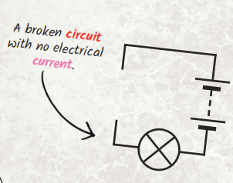

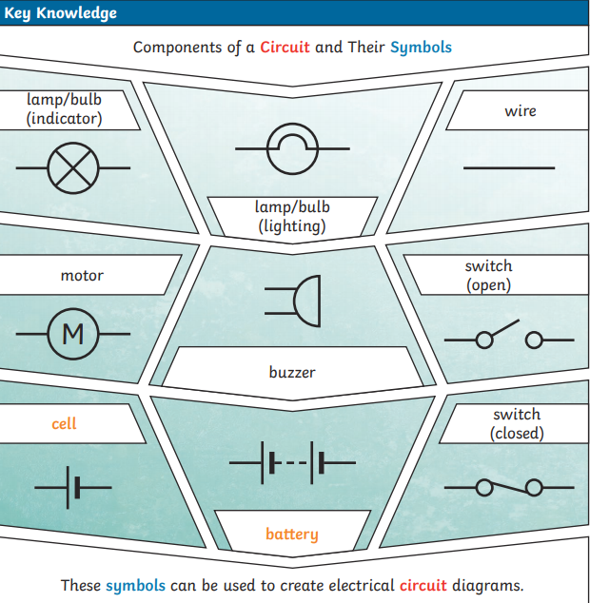

What will make a bulb dimmer or a buzzer quieter?
What will make a bulb brighter or a buzzer louder?
Can you draw an electrical circuit using scientific symbols?

Are you a Milecastle Megamind?

