
Year 5
Science – Humans and other animals

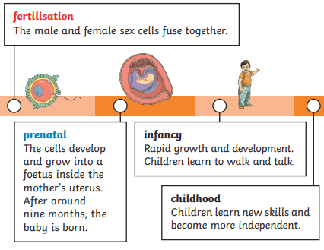
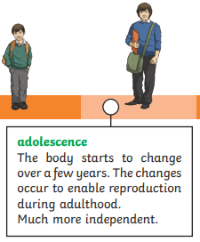
Key Vocabulary
adolescence | The social and emotional stage of development between childhood and adulthood
puberty | The physical stage of development between adulthood and childhood.
menstruation | When the female body discharges the lining of the uterus
adulthood | The stage of development when a human is fully grown and mature.
Life expectancy | The length of time on average that a particular animal is expected to live.
fertilisation | The process of male and female sex cells fusing together
prenatal | The stage of fertilisation from the time of fertilisation
gestation | The process of time when prenatal development takes place before birth
reproduce | To produce young
Asexual reproduction | A process where one parent produces new life
Sexual reproduction | A process where two parents – one male and one female-are required to produce new life.
Life cycle | The changes a living thing goes through including reproduction.
Key Learning
Humans timeline
Describe the changes as humans develop to old age.
Growth of babies
Describe the development of babies in their first year of life

Puberty
Compare the changes that take place in boys and girls during puberty
Changes in old age
Understand the changes that take place in old age.
Gestation periods
Compare the gestation periods of different animal groups
Life expectancy
Compare gestation periods and life expectancies in different animals

Are you a Milecastle Megamind?

What is gestation and how does it differ in different animals?
Can you explain how babies grow and develop?
Can you describe the different stages of human development?

