
Year 6
Science – Earth, Sun and Moon

Key Vocabulary
Axis | An imaginary line around which the earth rotates
constellation
Cosmic | Related to space
Earth | The planet on which we live on
Galaxy | A collection of star systems
Lunar | Relating to the moon
Orbit | The path of a celestial body
Phases of the moon | The different ways the Moon appears across a month
Planet | A celestial body that revolves around the sun
Rotation | To turn or spin
Satellite | Any celestial body orbiting around a planet or star
Solar System | A star and everything that tracks around it
Spherical | Shaped like a sphere
Sun | The star at the centre of a solar system
Tilt | The lean of the Earth at a 23.5 degree angle.
Universe | Everything that exists anywhere
Waning | The size of the moon appearing to go from large to small
Waxing | The size of the moon appearing to go from small to large
How are the seasons formed?

Are you a Milecastle Megamind?

Key Learning
The Earth is one of 8 planet in our solar system.
The Earth orbits the sun. It takes 365 ¼ days for the Earth to complete a full orbit of the sun. This is called a year.
The Earth rotates on its axis. It takes 24 hours for the Earth to complete a full rotation. This is period of time is a day.
Objects in space are spherical because gravity acts in all directs equally.
The moon orbits the Earth. During its orbit, it appears to change shape as increasing and decreasing amounts of the Moon’s surface reflects the sun’s light. It takes 28 days for the moon to complete a full orbit of the Earth.
Day and night changes as the Earth rotates on its axis. The side of the Earth which is facing the sun is in daylight and the side of the Earth facing away from the sun is in night.
The Seasons – When the northern hemisphere of the Earth is tilted away from the sun, the sun’s rays hit the Earth indirectly. This causes winter. When the northern hemisphere is tilted towards the sun, the sun’s rays hit the Earth more directly. This causes summer.
How are stars and planets different?

How is modern science helping us learn more about the Earth, Sun and Moon?

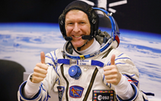 | Major Tim Peake (1972-  The first ESA astronaut to visit the International Space Station
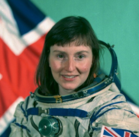 | Helen Sharman (1963-  A chemist who become the first British astronaut to visit the Mir Space Station in 1991



