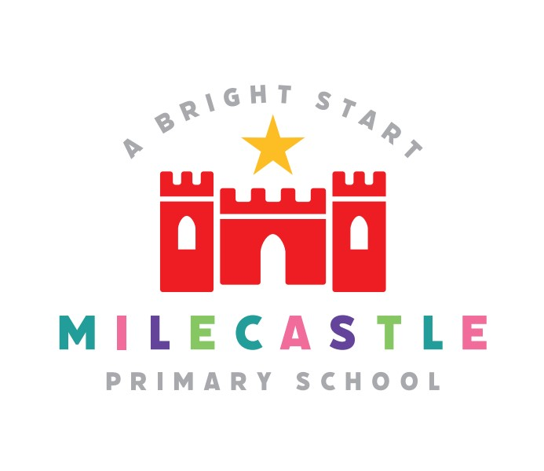
ASSESSMENT RESULTS END OF SCHOOL YEAR 2023
EYFS
 | 2023
GOOD LEVEL OF DEVELOPMENT | Number of children | % children
ALL | 17/30 | 56.7 %
BOYS | 10/17 | 58.8%
GIRLS | 7/13 | 53.8%

2023 Y1 PHONICS SCREENER
Class of 19 girls, 10 boys.
21/29 children 72.4% passed.

Breakdown 16/19 girls = 84.2% passed.
5/10 boys = 50%

N.B. 1 child did not sit. With child removed from data it increases to 75%. 9 children on SEND register plus 4 being closely monitored.

2023 Y2 PHONICS SCREENER RE-TEST
3 girls and 3 boys were re-tested.
50% passed.
Overall Phonics Expected standard (End of Key Stage 1) 89.7%. National is 88.6%.

N.B. score improvement sheet which shows all children who did not pass more than doubled previous score.

END KS1 ATTAINMENT TEACHER ASSESSMENT

SUBJECT | Reached expected standard  (school) | Reached expected standard  (national) | Greater depth  (school) | Greater depth  (national)
READING | 72.4% | 66.8% | 6.9% | 18.8%
WRITING | 65.5% | 60.1% | 0% | 8.2%
MATHS | 72.4 % | 70.4% | 6.9% | 16.3%

END KS2 ATTAINMENT
SUBJECT | Expected Standard (school) | Expected Standard  (provisional  national) | Greater depth (school) | Greater depth (national) | Average Scaled Score (School) | Average Scaled Score (National)
READING TEST | 83.3% | 72.6% | 20.8% | 29% | 106 | 105
WRITING Teacher Assessment | 75% | 71.5% | 8.3% | 13.3% | N/A | N/A
SPAG | 79% | 72% | 38% | TBC | 106 | 105
MATHS | 70.8% | 72.9% | 25% | 23.8% | 105 | 104
R,W and M | 62.5% | 59.5% | 12.5% |  | N/A | N/A

PROGRESS END KS1 2013 – END KS2 2023
Average progress is indicated with a score of 0 (zero). Better than average progress is indicated with a score of up to +10, and slower than average progress with a score of up to -10. The majority of schools have progress scores between -5 and +5.
SUBJECT | School Progress Score
MATHS | -0.19 (below national average 0.04)
READING | +0.14 (above national average 0.03)
WRITING | -0.77 (below national average 0.04)

