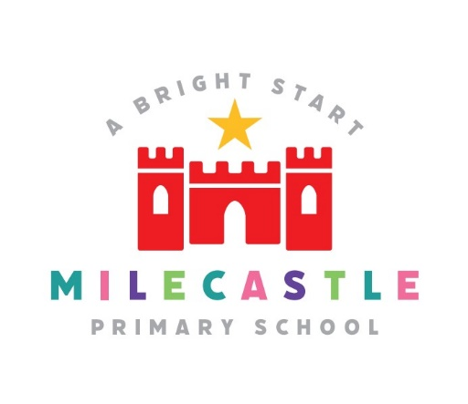

Milecastle Primary School

MFL Policy

Reviewed: June 2023

MILECASTLE PRIMARY SCHOOL
MFL POLICY
RATIONALE
At Milecastle Primary School we are keen to promote the study of a foreign language because of its increasing importance in the modern world. We want to embed language learning into our curriculum. This has been recognised in the National Curriculum where there is the statutory commitment to give every child between the ages of 7 and 11 the opportunity to learn a new language
The experience of learning and using a foreign language makes its unique contribution to the whole curriculum by taking children out of the familiar environment which is pervaded by English and allowing them to explore the life-style and culture of another country through the medium of its language. This in turn provides a satisfying, enjoyable and intellectually challenging experience for children in coping with a different linguistic medium.
The language we have chosen to study at Milecastle is French.

AIMS
- To enable children to understand and communicate in another language.
- To develop enthusiasm for language learning.
- To develop language skills and language learning skills.
- To give the children confidence in interacting with others.
- To increase the children’s European awareness.
- To awaken an interest in foreign cultures and life-styles.
- To develop the children’s understanding of themselves and their culture.
- To encourage tolerance and a willingness to work co-operatively.
- To enable children, who have the opportunity, to travel abroad with enjoyment, confidence and interest.
- To give a sound start for further development at Key Stage 3 and beyond.
- To continually review and modify the curriculum in the light of current research.

OBJECTIVES

The Learning Objectives comprise of three clearly progressive core strands of teaching and learning over the four years of KS2:
- Oracy (Speaking and Listening)
- Literacy (Reading and Writing)
- Intercultural Understanding

Pupils should be taught to:
- listen, understand and respond to spoken and written language from a variety of authentic sources.
- speak with increasing confidence, fluency and spontaneity, finding ways of communicating what they want to say, including through discussion and asking questions, and continually improving the accuracy of their pronunciation and intonation.
- can write at varying length, for different purposes and audiences, using the variety of grammatical structures that they have learnt.
- discover and develop an appreciation of the culture in the country of the language being studied.

In addition, two cross-cutting strands are included:
- Knowledge about Language
- Language Learning Strategies
These are of great importance in themselves as important tools for learning, providing a basis for children’s future development as language learners.

CURRICULUM PLANNING
Our curriculum is based upon the 2014 National Curriculum programme of study for MFL for KS2. See the Key Stage 2 Framework for Languages, pages 7, 8 and 9 for further details.
We follow the Primary French Project scheme of learning.

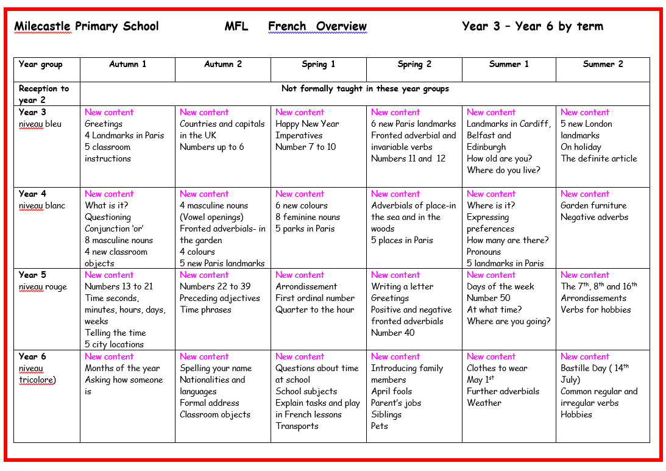
Overview of KS2 planning

CROSS CURRICULAR LINKS
Learning a language should be planned as an integral part of the whole curriculum, adding a new dimension, rather than as a ‘bolt-on’ extra as it can make a contribution to the learning of other subjects and, children can also develop their skills and understanding of their language through their work in other curriculum areas. Where there is a natural link the language should be included in a cross curricular approach. The following links are taught within the French lessons.
- English
Children acquire knowledge about language, development of speaking and listening skills, knowledge and understanding of grammar and sentence construction. Opportunities to

compare French with English are exploited through use of the French alphabet, phonemes, rhyming patterns, sound/spelling links, dictionary work, formation of structures (such as singular/plural, gender, negatives, question forms, position of adjectives, imperatives), intonation, dialogues, poetry, different text types e.g. fiction, non-fiction

- Maths
Children are taught to count, understand the French number system, write the date, identify days of the week and months of the year, tell the time, use money and currency, prices and costs.

- Science
Children identify different environmental factors in France compared to the U.K. They learn about parts of the body and life cycles.
- ICT
Children will access video/audio links of native speakers to enable them to hear French spoken from an authentic source.
- Geography
Children can locate France on a world map. They can identify major towns, cities, ports, seas, mountain ranges and can use compass points. They can make comparisons and develop a greater awareness of similarities and differences in relation to climate, language and culture.
- History
Children learn about Bastille day and it’s importance in French history. They learn about why, when and how it is celebrated in France today.
- Music
Children learn songs in the French.
- Technology/Art
Children design and make things e.g. bookmarks, birthday cards, Christmas cards.
- Art
Children learn about French artists as part of work in art across the school.
- P.E
Children learn to physically respond to instructions in French when playing classroom games such as ‘Jacques dit’.

- R.E
Children read and act out the Nativity play at Christmas in French.

- PSHE

Children acquire knowledge of other countries and cultures. They develop a sensitivity to difference and gain consideration of ‘otherness’ in the multilingual society. They learn respect for themselves and for others through learning to appreciate the cultural diversity within a multicultural society.

IMPLEMENTATION
- All pupils in year 3, 4, 5 and 6 will have regular timetabled French lessons

- Teaching of MFL should use a variety of techniques to encourage children to engage actively in learning: these include games, role play, use of puppets and action songs and rhymes. A kinaesthetic approach to teaching should be adopted to enable pupils to develop a positive attitude to learning a foreign language and to reinforce memory.
- There is a strong emphasis on speaking and listening skills before the introduction of reading and writing. This builds confidence and enjoyment of MFL so that children have concrete knowledge and understanding before the formal reading and writing stage.
Lessons will include opportunities for pupils to:
- Listen attentively to spoken language and show understanding by joining in and responding
- Appreciate stories, songs, poems and rhymes
- Speak in sentences
- Present information orally to a range of audiences
- Develop accurate pronunciation and intonation
- Describe people, places, things and actions orally and in writing
- Write phrases from memory
- Write at length
- Conjugate common verbs
- Understand basic grammar, including feminine and masculine forms
- Read carefully
- Use a foreign language mini dictionary or word bank
ASSESSMENT, RECORDING AND MONITORING
Teachers assess children’s knowledge and understanding of French throughout the lesson and formally on a termly basis.
Pupils demonstrate their MFL skills in a number of different ways. Teachers assess the progress of the pupils using the Progression of Skills document. Teachers make an overall judgement of the ability of the child at the end of the school year: working towards the expected standard, expected standard or greater depth. Planning and work scrutinies alongside lesson observations provide information to the overall effectiveness of the subject.

Pupils record their work in MFL books after an initial series of speaking and listening lessons, which introduce the new topic.

INCLUSION
All activities are differentiated to take account of every child’s needs. Every effort is made to present activities in such a way that they are equally interesting and accessible to all children no matter what their gender, ethnicity or impairment.

CONCLUSION

Learning a language enriches the curriculum, providing excitement, enjoyment and challenges for children, helping to create enthusiastic learners and to develop positive attitudes to language learning throughout life. The skills, knowledge and understanding gained make a major contribution to children’s oral and literacy development and to their understanding of their own culture and to those of others.

