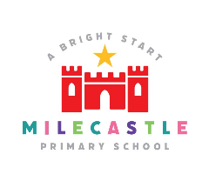

Milecastle Primary School
Geography Policy

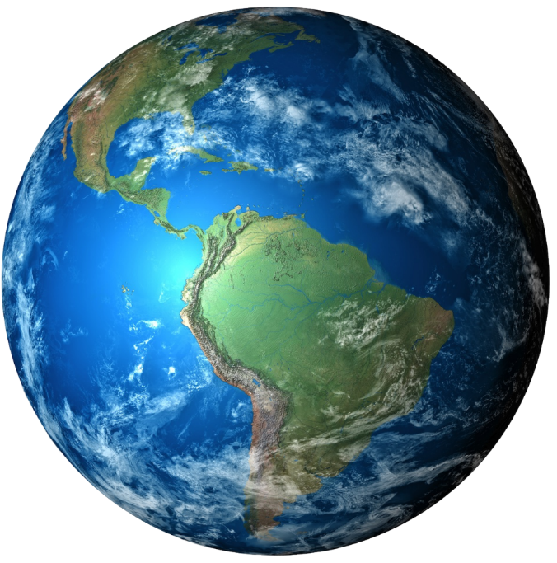

Reviewed: September 2023

MILECASTLE PRIMARY SCHOOL
GEOGRAPHY POLICY

RATIONALE
The study of Geography aims to inspire in pupils a curiosity and fascination about the world and its people that will remain with them for the rest of their lives. Teaching should equip pupils with knowledge about diverse places, people, resources and natural and human environments, together with a deep understanding of the Earth’s key physical and human processes. Geography is a focus within the curriculum for understanding issues relating to the environment and sustainable development. It inspires children to think about their own place in the world; their values, rights and responsibilities towards other people and their environment. Geographical knowledge, understanding and skills provide the frameworks and approaches that explain how the Earth’s features at different scales are shaped, interconnected and change over time.
AIMS
The teaching of Geography aims to enable pupils to:
- Develop contextual knowledge of the location of globally significant places, including their defining physical and human characteristics
- Understand the processes that give rise to key physical and human geographical features of the world
- Be competent in the geographical skills needed to collect, analyse and communicate with a range of data gathered through experiences of fieldwork
- Interpret a range of sources of geographical information, including maps, diagrams, globes, aerial photographs
- Communicate geographical information in a variety of ways, including through maps, numerical and quantitative skills and writing

Geographical Curriculum Planning
Geography is a foundation subject found in the National Curriculum. Objectives are selected based on the requirements of the National Curriculum. At Milecastle Primary School, we teach an ‘enquiry’ based curriculum with Geography being the main focus for one term in every year group. This is continued further through ‘enhancements’ in the other terms which support and continue to develop the teaching and learning of Geography. Pupils will have the

opportunities in other subjects to develop their geographical skills and their knowledge while making links between geography and other topics.
In Key Stage 1 and 2, pupils study Geography under four strands:
- Locational knowledge
- Place knowledge
- Human and physical geography
- Geographical skills and fieldwork

The progression of skills is clearly marked out over both key stages to ensure that all children meet every objective. Within the Early Years, we relate the geographical aspects of the children’s work to objectives within the Early Learning Goals which underpin the curriculum planning for pupils in this stage of education.

Cross-curricular Learning
Geography is further supported through the teaching of other subjects within school. Pupils have the opportunities to write as geographers in their topics and in their English lessons. The collecting and presenting of data and the use of grid references when reading maths supports the teaching of maths. Geography contributes greatly to the teaching of personal, social and health education through considering the impact humans have on their own environment and that of the wider world. Computing enhances the teaching of geography, wherever appropriate, in each key stage. This includes researching and collecting information from the internet and presenting and organising data.

Assessment, Reporting and Monitoring
Pupils demonstrate their geographical skills in a number of different ways. Teachers assess the progress of the pupils using the Progression of Skills document. Teachers make an overall judgement of the ability of the child at the end of the school year: working towards the expected standard, expected standard, greater depth within the expected standard which is reported to parents.
Planning and work scrutinies alongside lesson observations provide information to the overall effectiveness of the subject.

INCLUSION
All children regardless of race, gender or creed have equal access to geography. Suitable learning opportunities are provided by matching tasks to the ability of the child.
CONCLUSION
Children will develop an awareness of their locality and the wider world and how human and physical processes impact upon the environment.

