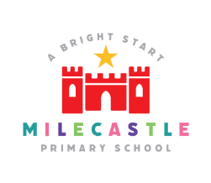
Maths

At Milecastle we believe that mastering maths is a journey and a long term goal, achieved through exploration, clarification, practice and application over time. At each stage of learning, children should be able to demonstrate a deep conceptual understanding of the maths topic and be able to build on this over time.

Our Intent
We intend on delivering a curriculum which:

- Allows children to be a part of engaging lessons that will give them a range of opportunities to explore mathematics following a mastery curriculum approach.
- Gives each pupil a chance to believe in themselves as mathematicians and develop the power of resilience and perseverance when faced with mathematical challenges.
- Recognises that mathematics underpins much of our daily lives and therefore is of paramount importance in order that children aspire and become successful in the next stages of their learning.
- Engages all children and entitles them to the same quality of teaching and learning opportunities so that they strive to achieve their potential.
- Makes rich connections across mathematical ideas to develop fluency, mathematical reasoning and competence in solving increasingly sophisticated problems.
- Provides opportunities for children to apply their mathematical knowledge to other subjects (cross-curricular links).
- Is in line with the expectations in the National Curriculum 2014.

Implementation
At Milecastle, we are developing a mastery approach in maths.
Our mastery approach to the curriculum is designed to develop children's knowledge and understanding of mathematical concepts from the Early Years through to the end of Y6.

Teaching and Learning, Content and Sequence

- In school, we follow the national curriculum and use the White Rose progression in skills as a
guide to support teachers with their planning and assessment. Tasks/activities will largely be

taken from White Rose scheme of learning, NCETM hub and maths shed. Staff can also source resources from other areas too.
- Our bespoke calculation policy is used within school to ensure a consistent approach to teaching the four operations over time and in consistency of representation.

- At the start of each new topic, key vocabulary is introduced and revisited regularly to develop language acquisition, which is embedded as the topic progresses.
- Children are taught through clear modelling and have the opportunity to develop their knowledge and understanding of mathematical concepts. The mastery approach incorporates using concrete resources, pictorial representation and abstract calculation to help children explore and demonstrate mathematical ideas, enrich their learning experience and deepen understanding at all levels.
- Children move through the different stages of their learning at their own pace.
- Children who have shown their understanding at a deep level within the unit, will have opportunities to apply these skills in a GREATER DEPTH activity. This should be challenging and ensure that children are using more than just one skill to be able to answer the mathematical problems.
- Reasoning and problem solving are integral to the activities children are given to develop their mathematical thinking.
- Resources are readily available to assist demonstration of securing a conceptual understanding of the different skills appropriate for each year group.
- Children are encouraged to explore, apply and evaluate their mathematical approach during investigations to develop a deeper understanding when solving different problems / puzzles.
- A love of maths is encouraged throughout school via links with others subjects, applying an ever growing range of skills with growing independence.
- Children with additional needs are included in whole class lessons and teachers provide scaffolding and relevant support as necessary. For those children who are working outside of the year group curriculum, individual learning activities are provided to ensure their progress.

How is maths organised across school?
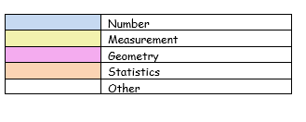
Curriculum overview

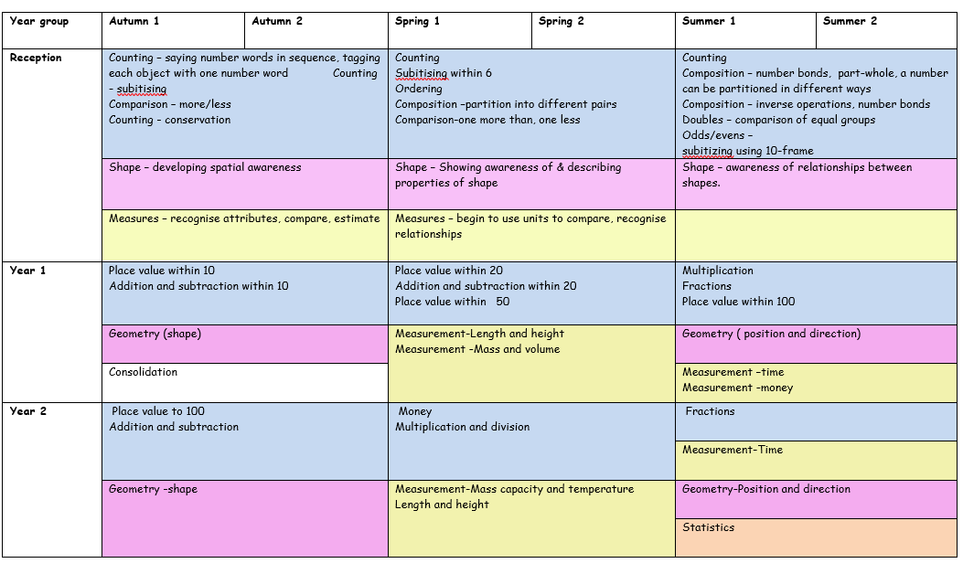
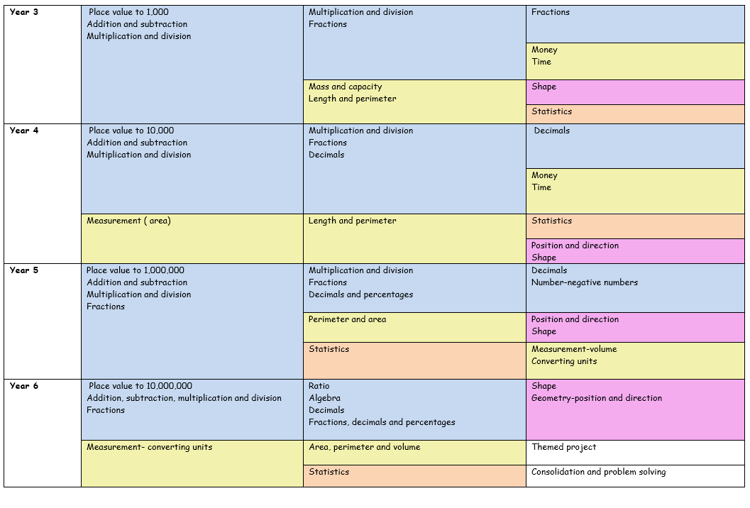

Maths in EYFS
At Milecastle, our curriculum map brings together NCETM guidance for EYFS, Maths Hub’s Mastering number programme and the progression suggested by White Rose. In daily planning we also draw on the research of the learning Trajectories for child development and use these to identify next steps. These resources are considered and adapted to fit the needs of learners. In Early years at Milecastle, we introduce maths through stories then interweave NCETM links and Mastering number activities to ensure that Early learning goals in maths are achieved.
At Milecastle, we believe that developing a strong grounding in number is essential so that all children develop the necessary building blocks to excel mathematically. In early years we provide a creative curriculum to enable children to count confidently, develop a deep understanding of the numbers to 10, the relationships between them and the patterns within those numbers.
By providing frequent and varied opportunities to build and apply this understanding - such as using a wide range of manipulatives, tens frames for organising counting, numicon, rekenreks and by fully utilising the outdoor area - children will develop a secure base of knowledge and vocabulary from which mastery of mathematics is built.
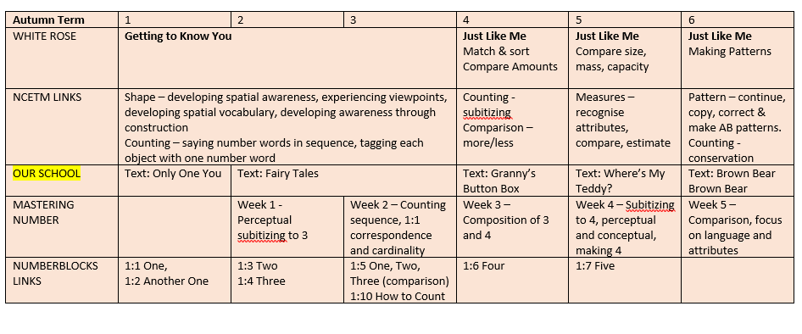
In addition, it is important that the curriculum includes rich opportunities for children to develop their spatial reasoning skills across all areas of mathematics including shape, space and measures. It is important that children develop positive attitudes and interests in mathematics, look for patterns and relationships, spot connections, ‘have a go’, talk to adults and peers about what they notice and not be afraid to make mistakes. Our aim is to create an interesting learning environment where children thrive and develop a love of mathematics.
How do we plan for maths?
Planning for progression and continuity
Objectives are taken from the National Curriculum document. Teachers use the ‘small steps’ document from the White Rose Maths Hub to help them with sequencing a series of maths lessons. This ensures continuity and consistency within and across year groups. Ideas, tasks and activities are also taken from the NCETM hub, maths shed and various other sites. Most lessons will include an element of fluency, reasoning and problem solving.

Planning for coherence
Lessons are broken down into a series of small connected steps where the majority of pupils move through the programmes of study broadly at the same time. Through the development of the small steps children begin to understand the new concept and begin to apply it to a range of contexts.
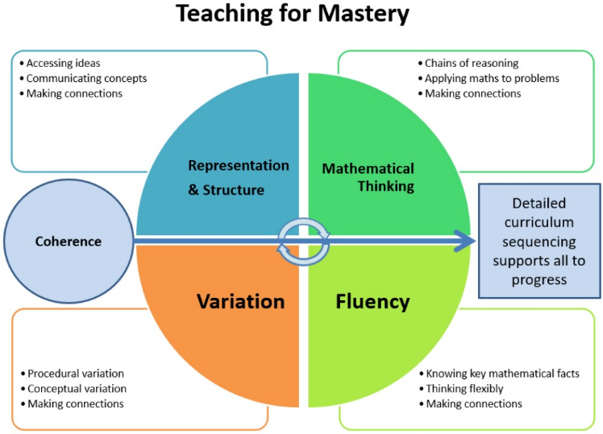
Planning for fluency
Teachers plan a short fluency session at the beginning of most lessons and an additional fluency session later in the day. Planning develops quick and efficient recall of facts and procedures and the flexibility to move between different contexts.
Planning for reasoning and problem solving/mathematical thinking
Teachers allow time for children to discuss, observe and to think about reasoning and problem solving. They are encouraged to share their mathematical thinking and to see mistakes as part of the learning journey. They are encouraged to be resilient and to persevere within the problem solving process.
Planning for representation and structure
Teachers plan to use a range of representations ( see calculation policy) which expose the mathematical structure being taught. Models, representations and images such as bar models and part whole models enable pupils to see the maths in a pictorial way which deepens understanding.
Planning for variation
Conceptual variation
This is how the teacher represents the concept being taught. Eg representing the same calculation in different ways in a bar model and in a part whole model.
Procedural variation
Procedural variation offers the opportunity for pupils to focus on relationships and make connections. Procedural variation provides a process for formation of concepts stage by stage through varying problems in a rich manner.eg when given a tens frame they can make the connections to create fact families. Often asking ,’What do you notice, what is the same and what is different?’ can help children to make links and connections.
Planning for CPA
Teachers at Milecastle plan, when appropriate, to use (CPA) concrete, pictorial and abstract representation to deepen understanding of mathematical concepts for children.

Concrete- children should have the opportunity to use concrete objects and manipulatives to help them understand what they are doing
Pictorial- alongside this, children should use pictorial representations. These representations can then be used to help reason and solve problems. This can include the ‘part/ whole model’ and ‘bar model approach’ which is helps children ‘to see’ the problem.
Abstract- both concrete and pictorial representations should support children’s understanding of abstract methods
Planning to create a vocabulary rich environment
Pupils are taught to use precise mathematical vocabulary which is then displayed on a working wall as an aid memoire
Pupils are encouraged to answer questions in full sentences using correct mathematical language.
Pupils are taught stem sentences to support and scaffold language use
Pupils are taught one daily maths lesson which will be approximately one hour and one 15 minute fluency session, usually after lunch.
Pupils in Reception and KS1 have additional mastering number sessions which are usually taught in the afternoon.

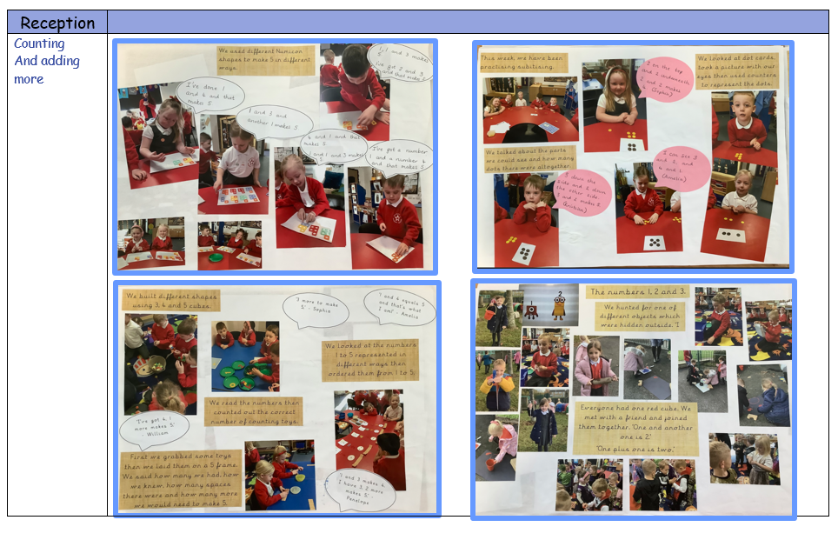
Calculation policy-addition
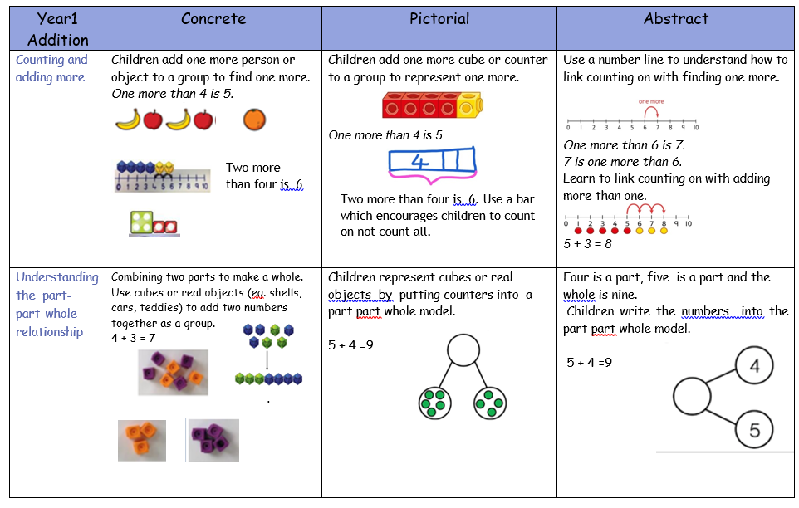

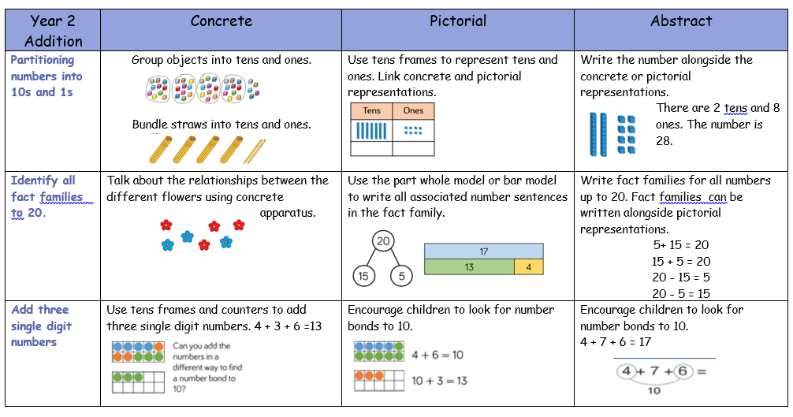

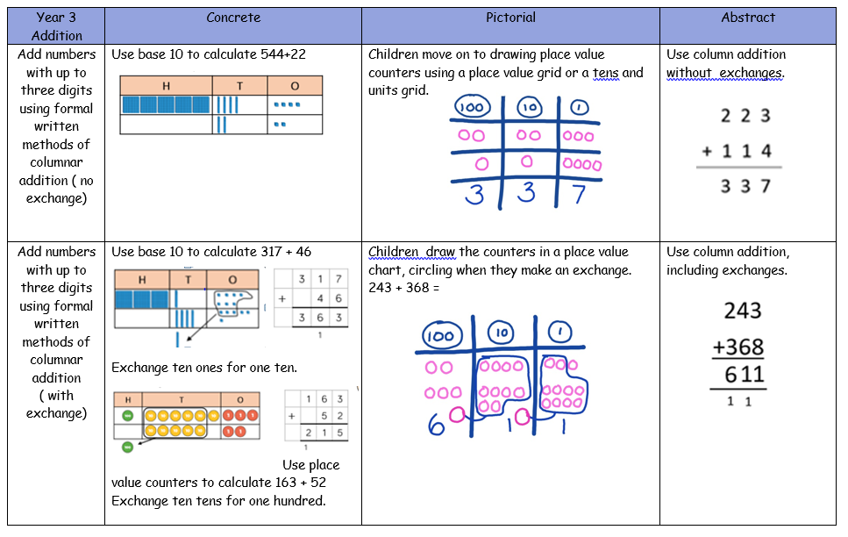

Progression documents
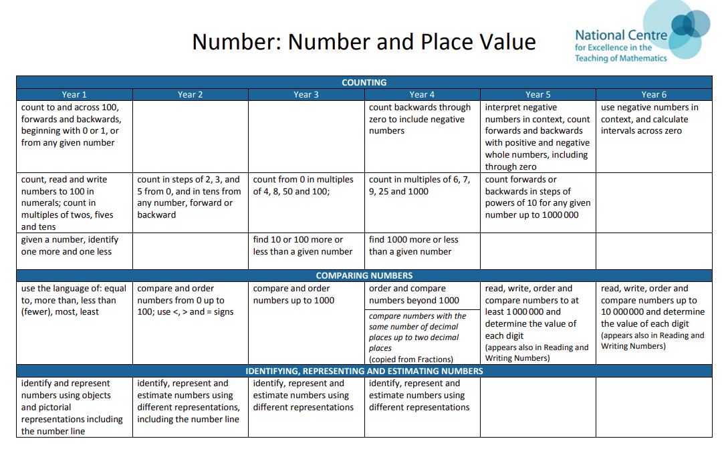
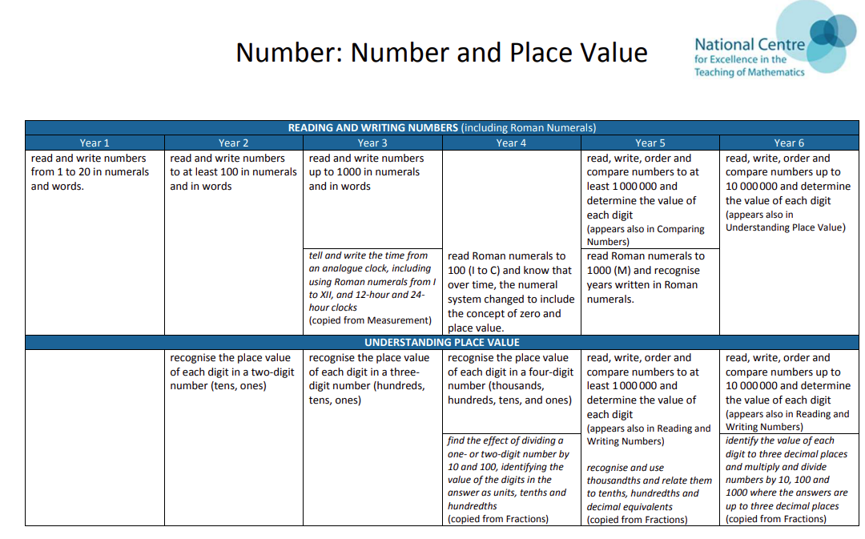

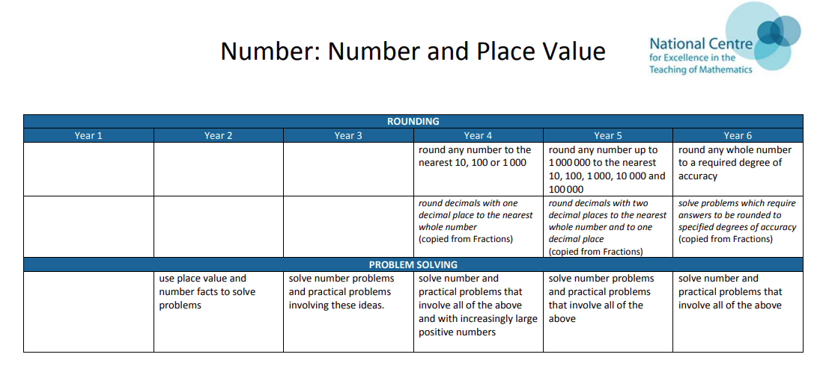
What does maths look like in the classroom?
Maths usually follows a similar format in all KS1 and KS2 classrooms. There will usually be a quick fluency/ oral and mental session which will be followed by a recap of previous learning. Learning within the lesson will be in small steps which progress throughout the duration of the session. Where appropriate there may be concrete, pictorial and abstract representations to deepen understanding. Most lessons will include an element of reasoning and problem solving. Children will be encouraged to talk about their learning and to explain their thinking using paired talk. They will be encouraged to use correct mathematical language and in some cases to recall stem sentences. There may be mixed ability pairs to encourage peer support or slower grasping children may be supported within the lesson using models, images and concrete resources. When available SEND children may be supported by an additional adult in the room. Children broadly follow the curriculum at the same pace with additional levels of challenge for deeper learning for faster grasping pupils. The professional judgement of the classroom teacher may, when appropriate, determine a different structure for the lesson.
In Early years, there is lots of counting and lessons are mostly practical and kinaesthetic. There are lots of opportunities for children to talk about their maths to each other and to the teacher. Lessons are engaging, fun and nurture an enjoyment of mathematics.
How is maths evidenced?
Maths is celebrated around the school through classroom working walls, in our Seesaw journals and through our class blogs. Maths is used in other curriculum areas such as science with many forms of
data analysis and in history when using timelines. We want children to enjoy maths and believe that this ultimately results in motivated and passionate learners.

Impact
Assessment and Feedback

- Children are given pre and post assessment tasks for each unit of work from the White Rose assessment materials. This provides evidence of progress made in each unit of work for both teachers and students. They are also used to inform future planning and used as additional evidence (alongside work in books) for schools internal tracking system.

- Feedback is given on children’s learning in line with our feedback policy. Formative assessment within every lesson helps teachers to identify the children who need more support to achieve the intended outcome and who are ready for greater stretch and challenge through questioning or additional activities.
- Staff voice gives teachers the opportunity to say what is working well and to express their training needs for the following year.

Successful teaching and learning in mathematics will ensure

- Children show confidence in believing that they will achieve.
- The majority of children achieve objectives (expected standard) for their year group.
- Children show a high level of pride in the presentation and understanding of their work.
- Children demonstrate a quick recall of facts and procedures. This includes the recollection of times tables.
- Children are able to independently apply their knowledge to a range of increasingly complex problems.
- Children are reasoning and explaining their mathematical thinking with increased confidence and accuracy.
- The flexibility to move between different contexts and representations of maths.
- The chance to develop the ability to recognise relationships and make connections in maths lessons.

The maths lead uses regular and robust monitoring including learning walks, book looks and pupil voice to gauge the impact of our maths curriculum and review the curriculum to ensure that it meets the needs of all learners.

