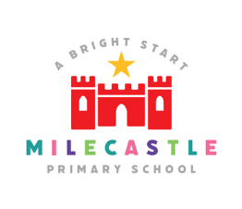
Art & Design

Through Art and Design children become aesthetically aware of their surroundings and can be involved in how they look. They learn to make to informed judgements and practical decisions. As well as become equipped to experiment, explore, take risks, invent and create. Art and design can enrich all other areas of the curriculum by adding a practical approach to learning as well as being a discrete subject. They learn how art has influenced the way in which people live and how it communicates different periods of history and is a means of learning about different cultures, which will drive children to be curious about respecting and connecting with others. By ensuring our Art and Design curriculum is flexible with content and outcome we give children the opportunity to be creative and to truly feel like they’re artists, craft makers and designers.

Our Intent
At Milecastle Primary School we want to develop an appreciation and love of art and design. We value Art and Design as an important part of the children’s entitlement to a broad and balanced curriculum. Art and Design provides the children with the opportunities to develop and extend skills and an opportunity to express their individual interests, thoughts and ideas.
We use art to stimulate creativity and promote imagination, providing children with the opportunities to communicate what they see and feel through a variety of materials, textures, colours and patterns. Art provides visual, tactile and sensory experiences that are important to help children gain an insight into the world around them. In addition, at Milecastle art is used to enrich other areas of the curriculum by adding a practical approach to learning. Children learn how art has influenced the way in which people live and how it communicates different periods of history as well as a means of learning about different cultures.

Implementation
The teaching and implementation of the Art and design curriculum at Milecastle Primary School is based on the National Curriculum and linked to topics to ensure a well - structured approach to this creative subject. In addition ‘super learning days’ allow the children to be immersed in art and design for a whole day helping to develop their skills, creativity and vocabulary.

Throughout a school year all children will develop skills within drawing, painting and sculpture which is progressive throughout the school. They will also become familiar with a range of artists, designers and craftspeople both local, national or international, living or dead, male and female.
Children are taught specific vocabulary related to art and are encouraged to talk about their art and the work of others in terms of line, colour, shape, pattern, texture and form. They are encouraged to make fair and thoughtful comments about the work of others. In the case of work by famous artists, children are asked to give considered and truthful opinions.
Foundation stage also follow this approach. Opportunities to be imaginative, explore different materials and develop their ideas is an important part of the Early Years Foundation Stage and therefore materials are accessible for children to develop and explore their ideas and to be imaginative much of the time. Children are encouraged to practise their handling, moving and control skills (for example, by painting or using clay).
Children are encouraged to refine or extend their art and design through staff talking to the children about their work as they are working. They will be encouraged to persist with an idea and to keep going if things become tricky.
Children are encouraged to work cooperatively and collaboratively on some larger scale pieces of work ensuring that all children’s ideas are valued.
From Year 1 have their own sketchbooks in which skills are practised, materials explored and ideas collected. Sketchbooks are used in other areas of the curriculum or on educational visits to collect ideas.
Where possible visits by local artists and visits to galleries and outdoor spaces are encouraged to provide further stimulation and excitement for work in art and design.
The 360 zone is an incredibly valuable resource for art. It can allow children to be immersed in a different world to stimulate creativity. It can also allow children to ‘step into a painting,’ becoming one of the subjects of the picture. This can be further developed using props (parasols, hats, scarves, coats etc. Enabling children to feel part of the picture and explore where they might have been, where they are going, what might they be saying etc. By enlarging pieces of art work it can also provide children with the opportunity to focus, more clearly on the techniques used by the artists.
In an increasingly digital world, children are also made aware of ways in which art can be created using a computer or iPad. Careers involving art are also explored, advertising, computer games, set design are just a few.

How is art and design organised across school?
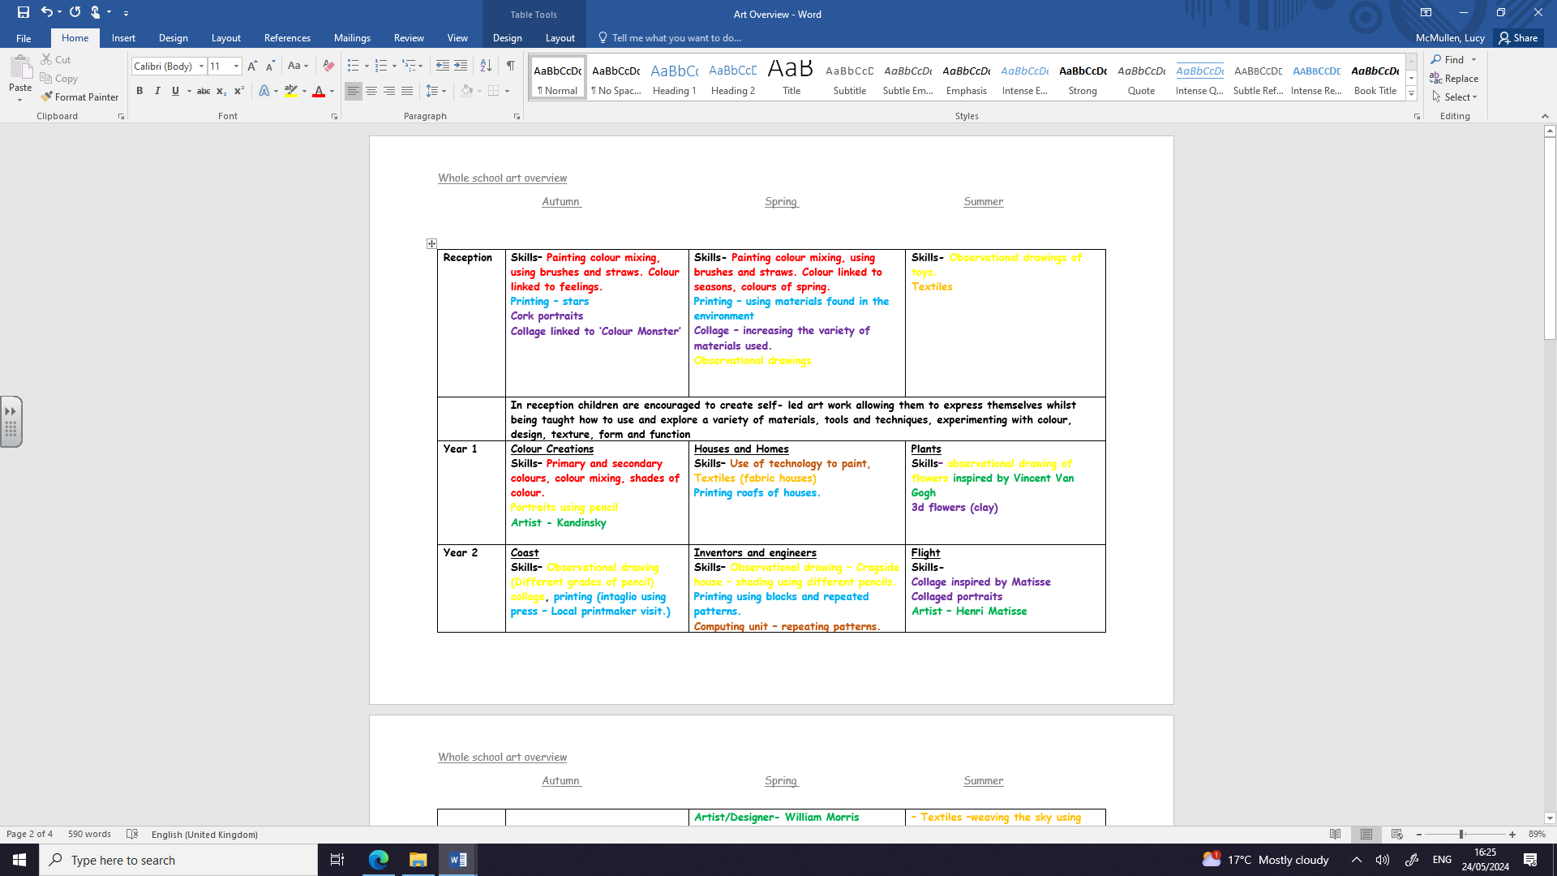

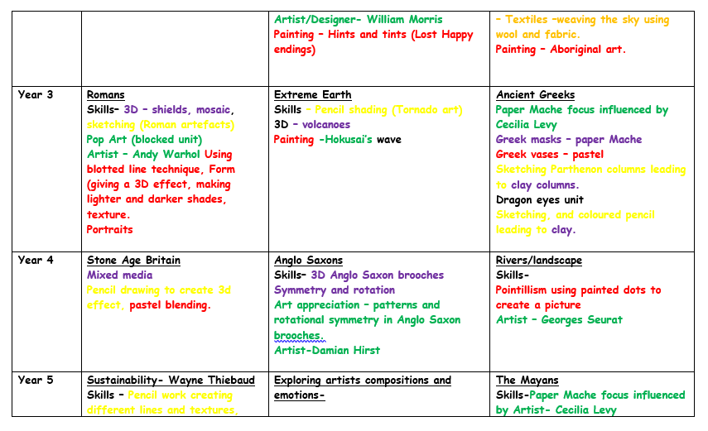

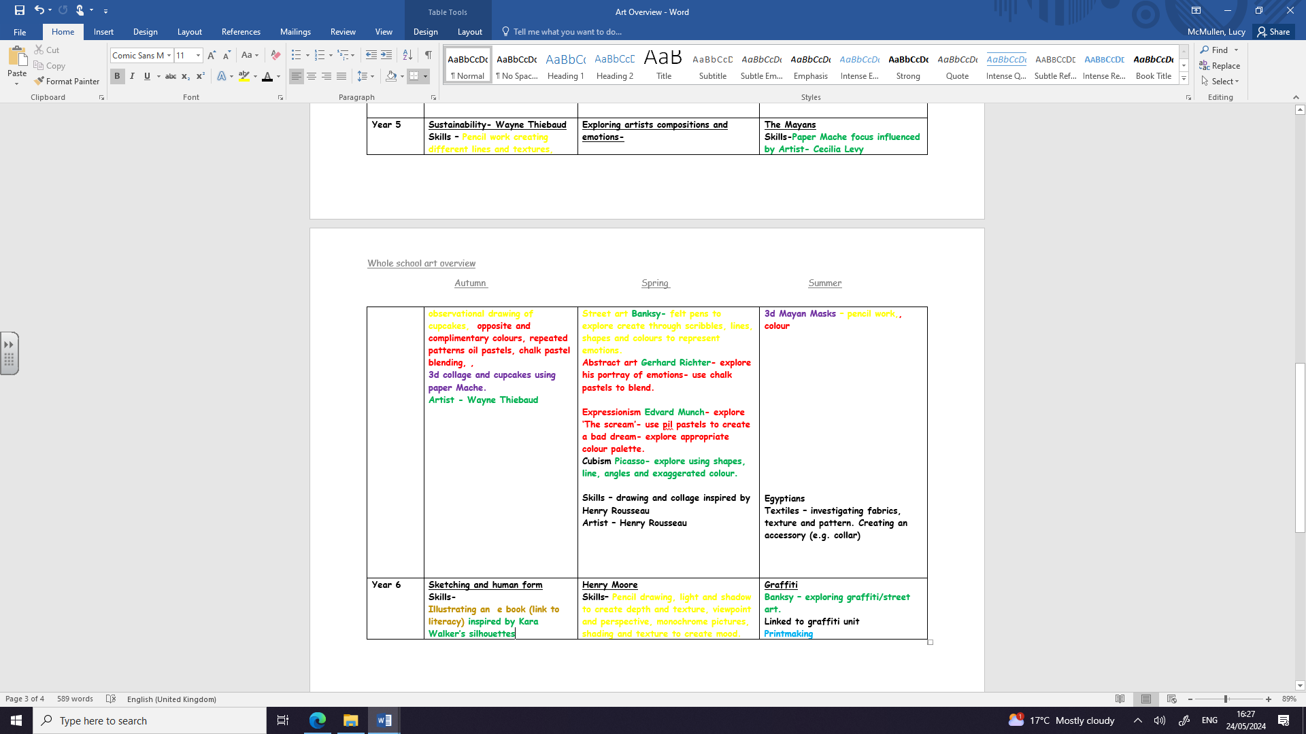

Art and design in EYFS
Expressive arts and design is one of the seven areas of the Early Years Foundation Stage and is used to develop a child's imagination, creativity and their ability to use media and materials. At Milecastle, we value the importance of providing children with regular opportunities to engage with arts, enabling them to explore and play with a wide range of media and resources. The quality and variety of what children see, hear and participate in is crucial for developing their understanding, self-expression, vocabulary and ability to communicate through using art as a foundation. Throughout the year in Reception, children will experience activities which involve them to draw, paint and print in addition to experimenting with textiles and collages and the skills required for each area. The teaching of these skills is embedded within our planning for each topic, along with the provision areas children have access to on a daily basis. Through carefully planned activities and high-quality provision, we aim to ensure all children meet their Early Learning Goal at the end of the year.
How do we plan for art and design?
Teachers are expected to teach the skills in the progression of skills document although the specific art work chosen can follow the interests of a specific cohort or a teacher’s special interest. Each year group’s art work will consolidate and build on skills and knowledge already taught. Substantive knowledge in art is based on the knowledge of the 7 elements of art: Line, shape, colour, form, value, texture, space. The children will work through a range of disciplines: drawing, painting, printing, texture, collage, 3D work and digital art in order to explore the 7 elements. Children are taught, through a structured approach to vocabulary in art, how to appraise art work using the correct terminology. Within each year group teachers will teach an aspect of drawing, painting and sculpture.(Painting includes printmaking and sculpture includes collage and textiles) (See art plan) Where possible art work is linked to either topic work or another curriculum area. Visits to galleries or outdoor art spaces are actively encouraged. Sketch books are encouraged not just in art lessons but in other areas of the curriculum and during visits to capture ideas and thoughts.

Substantive knowledge (the knowledge of known artists, their style and period of art) is taught through each year group exploring the work of at least one famous artist as well as local artists. Disciplinary knowledge in art (the interpretation of the elements and how they can be used and combined in order to create a specific and desired effect) is taught by enabling children to have the vocabulary to critically evaluate artists work; evaluating style and technique.
Art and design tends to be blocked so that children can become immersed in the whole process in a shorter space of time rather that weekly bites over a half term. Opportunities also occur during the year during which art becomes a focus, for instance MAD (Music, art, drama/dance) weeks, Christmas card making, whole school transition projects and Christmas entrance display. These opportunities are extra to the school art curriculum and raise the status of the visual arts as everyone is working together for a shared purpose.

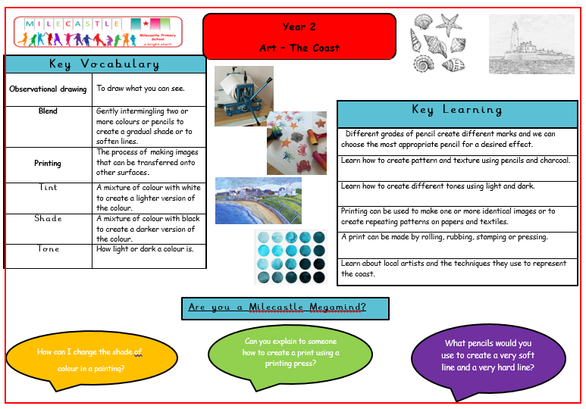
Knowledge organisers

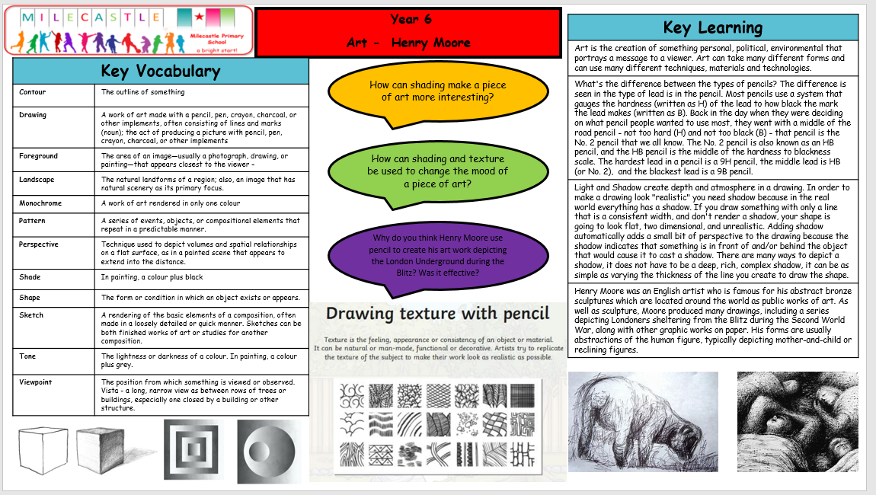
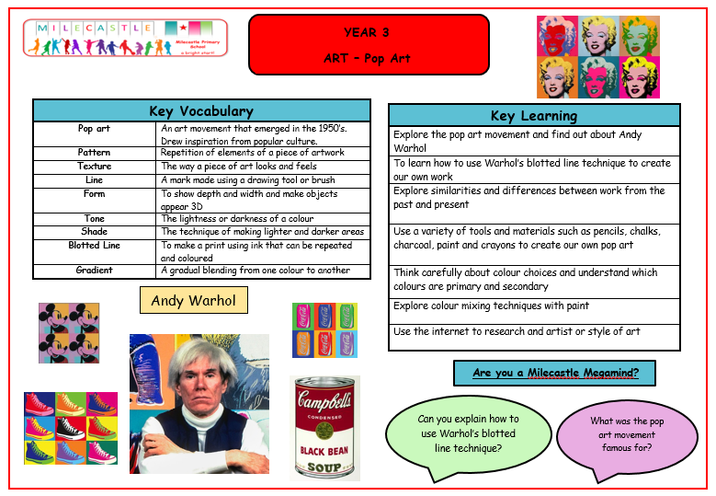

Progression documents
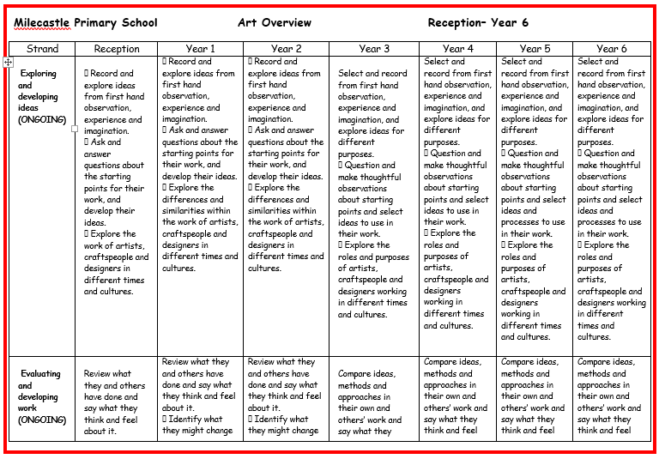

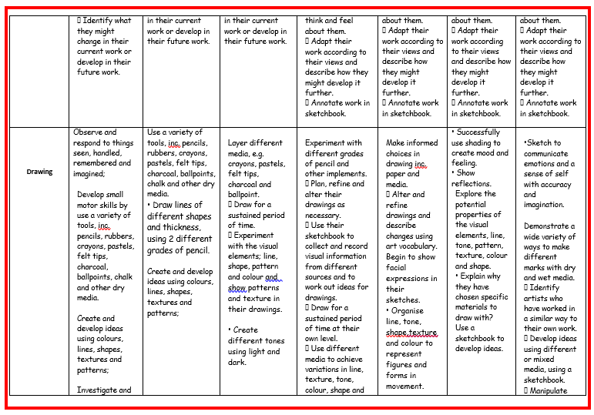

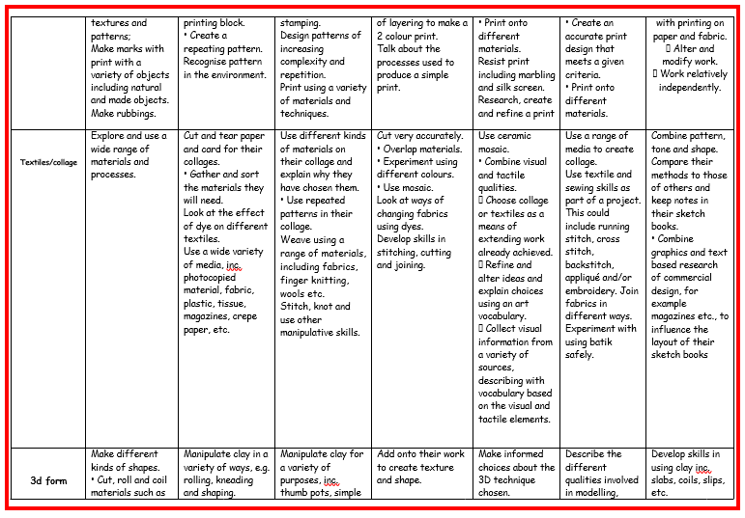
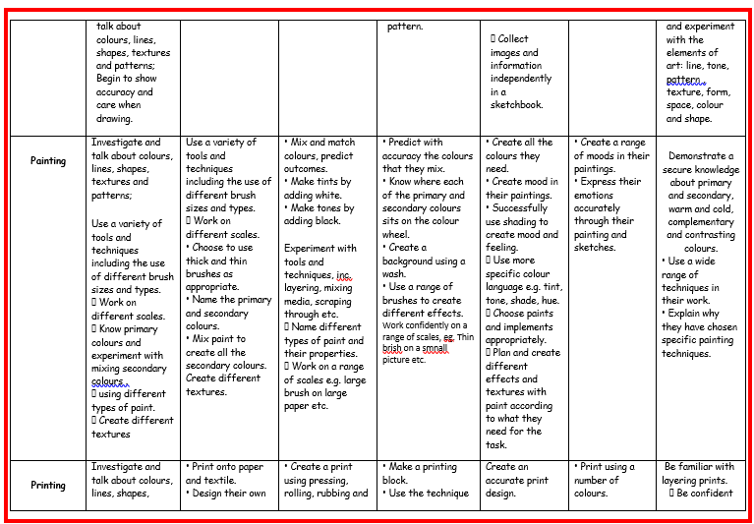

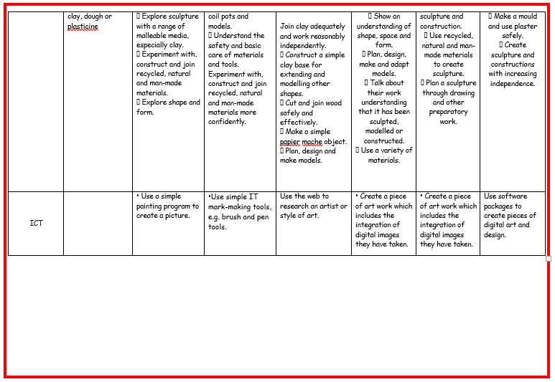

What does art and design look like in the classroom?
In reception, there are always art activities provided to enable children to explore themselves, developing their imagination, expressing thoughts and feelings and developing fine motor skills. In addition, specific art skills are developed through the children working in a small group with a teacher or teaching assistant.
In year 1 the class are given an initial stimulus and /or knowledge. The children then work with the teacher to develop this in small groups. In addition the children have art and craft time to work on their own self- guided projects choosing their own materials
From year 2 onwards children might begin a lesson with a stimulus, either a picture or sculpture, looking at work of another artist etc. They may begin in the 360 zone where tiny details in a painting can be seen, they may be asked to talk about their ideas together, brainstorm ideas about techniques, colours or meanings. They may be given small frames through which they can explore a tiny detail in a picture etc.
Teachers will often use the visualiser to show the children a particular technique.
Depending on the nature of the task children will either work independently as a whole class or in groups or pairs. The teacher will either move around the room helping children to extend their learning or work with groups on a specific adult guided skill.
At the end of a lesson children may have the opportunity to talk about their work or teachers may extend the children’s knowledge further by looking at other works by an artist they are studying etc

- How is art and design evidenced?
Art and design is evidenced in many ways. The corridors are full of children’s art work and in Reception an exciting and varied floor book is kept. The art coordinator speaks to Reception children who will always gladly explain and show the art work they have been doing using prompts from the floor book. Children keep a record of their work through either physical portfolios or e portfolios on See Saw. They also keep sketch books to record their ideas and to try out and practice skills. This enables the children to assess their own progress as well as being able to talk about their progress with their teachers or the art coordinator. Children are assessed formatively. Where possible, teachers and support staff go alongside children whilst they are working to question and make suggestions about how progress can be made. Through discussion of images teachers can teach and assess the specific art vocabulary used by the children. Knowledge organisers are also used by the children and staff to consolidate and assess children’s learning.

Impact
The children at Milecastle Primary School have very positive attitudes to art and design. This is evident in their approach to the subject and through the way they talk about it. The children have a sense of pride in their work through having it displayed creatively in the classrooms, in the corridors and on the school blog.
Teaching staff assess the children’s work formatively after each unit of work basing their judgements on the progression of skills document. In addition, they help them improve and evaluate their own work through the use of supportive questioning whilst the children are working.

The art and design coordinator monitors the impact of art and design and the progression of skills through planning and work scrutinies as well as pupil voice.
Within the art curriculum at Milecastle Primary School there is an emphasis placed on individuality and children are allowed, where possible, to explore art using their imaginations.
By the end of their time at Milecastle children will have embedded the key art and design skills needed to allow them to produce inventive pieces of art of which they are proud.

