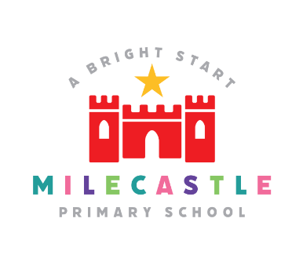

Computing
A high-quality computing education equips pupils to use creativity to understand and change the world. Computing has deep links with mathematics, science, and design and technology, and provides insights into both natural and artificial systems.

Our Intent
At Milecastle, we believe that computing is an essential part of the curriculum. It is a subject that not only stands alone but is woven through the curriculum and should be an integral part of all learning. Computing plays a significant part in everyone’s daily life and children should be at the forefront of new technology and given the confidence to use it. It is our intention to provide every possible opportunity to allow our children to become independent, resilient and responsible digital citizens. We strive to give the children the knowledge they need to make their own good decisions and take responsibility for their actions in an increasingly digital world.
We recognise that technology can allow pupils to celebrate their learning in creative ways such as blogging, digital display boards and Seesaw. We teach children to celebrate their own and each other’s work and how to respond respectfully and with kindness. We also understand the accessibility opportunities technology can provide for our pupils and our curriculum includes opportunities for children to work both collaboratively and independently on tasks and challenges.
We encourage staff to try and embed computing across the whole curriculum to make learning creative and accessible. We want our pupils to be fluent with a range of tools to best express their understanding and hope by Upper Key Stage 2, children have the independence and confidence to independently use technology in exciting and innovative ways.

Implementation
We teach computing as a bespoke subject with weekly lessons from reception onwards. We follow the Purple Mash curriculum, teaching computing skills in a carefully planned progression where each year builds on the skills taught in the last. Purple Mash separates the computing curriculum into three main areas:
- Computer Science
- Digital Literacy
- Information Technology

Teachers also seek out opportunities across the curriculum to apply the knowledge and skills our pupils have learnt in creative, purposeful and fun ways. We utilise technology for activities such as research, coding, augmented reality and sharing and presenting the children’s work. We showcase our work via class blogs and displays.

How is computing organised across school?

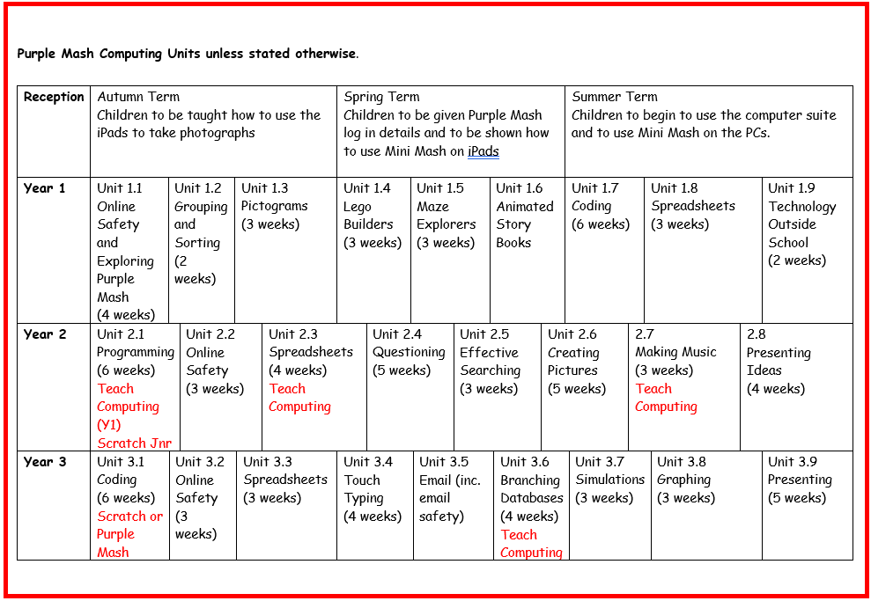

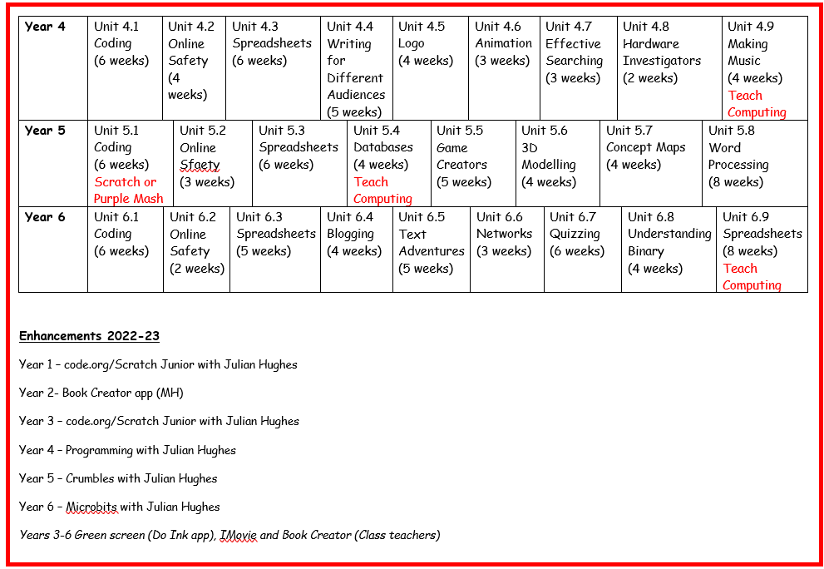

Computing in EYFS
Although computing is not explicitly taught in EYFS, we aim to ensure that children are prepared to begin their KS1 computing journey by the end of reception. Children in reception are taught about resilience and perseverance in the face of a challenge. This helps children when they encounter barriers in coding and need to debug. They are taught about health and wellbeing and sensible amounts of screen time. This ensures that they develop healthy relationships with technology and encourages a balanced lifestyle.
Reception staff ensure there are many opportunities to develop small and gross motor skills and that the children can use a range of equipment competently, safely and confidently. Children at Milecastle are encouraged to try new activities and show independence. They are also taught the difference between right and wrong and to try to behave accordingly.
Children in reception have the opportunity to use iPads and programmable toys such as BeeBots. In the summer term they are given their unique password to Purple Mash to allow them to explore ‘Mini Mash’ which helps to prepare them for the Year 1 curriculum in Purple Mash.

How do we plan for Computing?
At Milecastle children are taught one discrete computing lesson every week. Staff can also use the iPads for other areas of the curriculum at any time during the week
As a school, we have chosen the Purple Mash Computing Scheme of Work from Year 1 to Year 6. The scheme of work supports our teachers in delivering fun and engaging lessons which help to raise standards and allow all pupils to achieve to their full potential. We are confident that the scheme of work more than adequately meets the national vision for Computing. It provides immense flexibility, strong cross-curricular links and integrates perfectly with the 2Simple Computing Assessment Tool.
The Purple Mash curriculum ensures that skills and knowledge in computer science, information technology and digital citizenship are revisited and built upon year on year. Class teachers can use the scheme flexibly and move units around within their year group to match topics and other curriculum areas.
In addition to our Purple Mash curriculum, children at Milecastle are provided with additional computing activities throughout the year. We utilise local experts to deliver bespoke sessions using new and exciting technology such as Crumble Bots and Microbits. Children in Year 6 also take part in workshops at a local secondary school to complete physical computing challenges.
Knowledge organisers
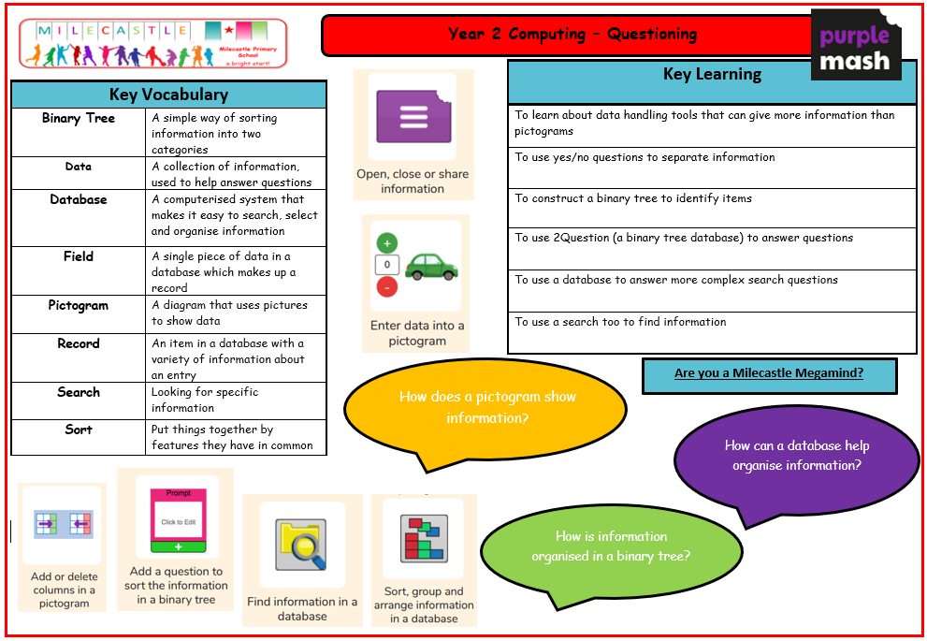

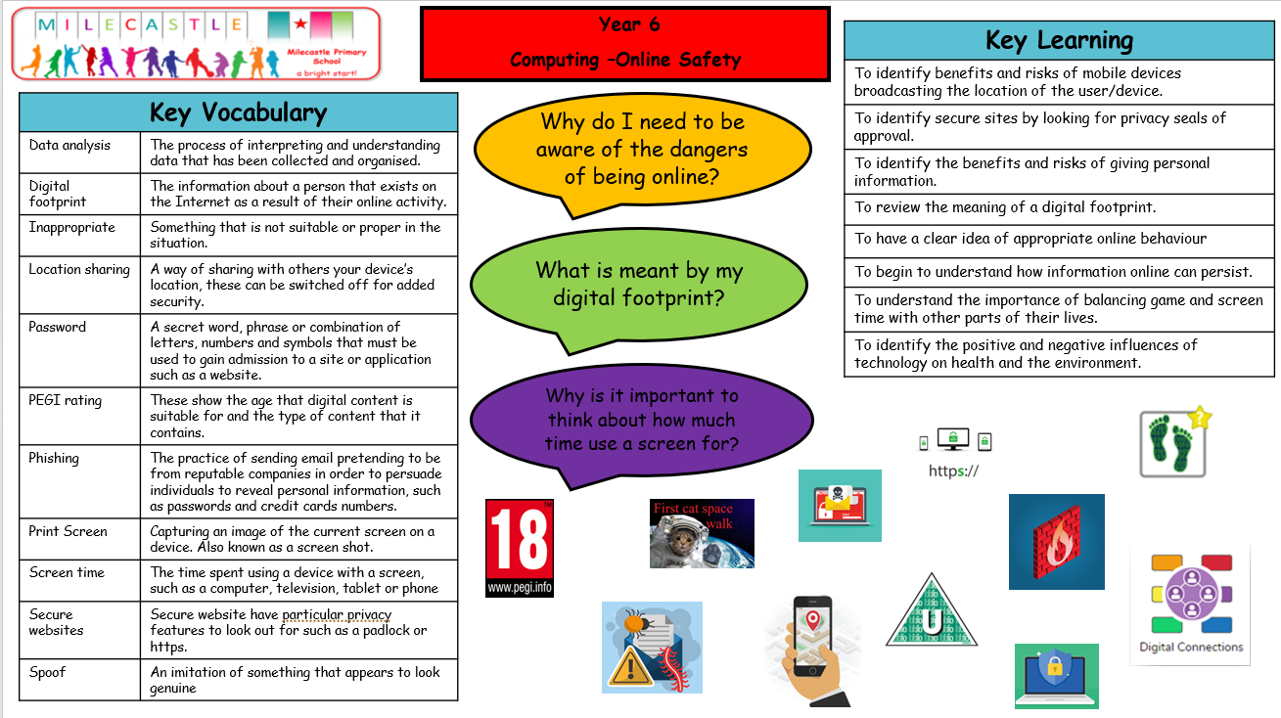

Progression documents

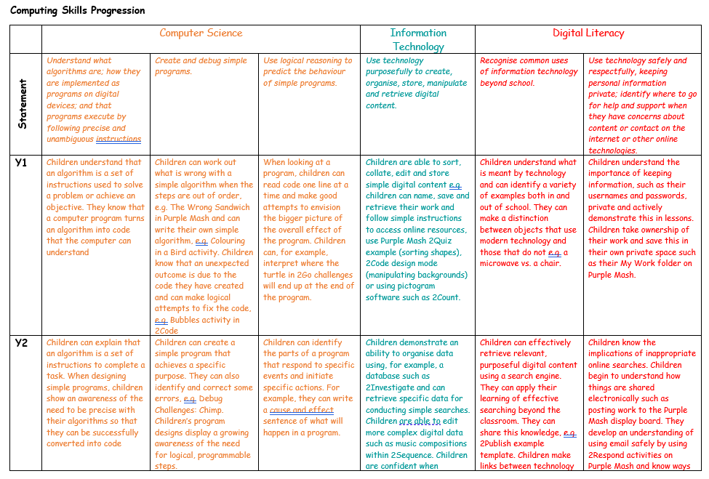

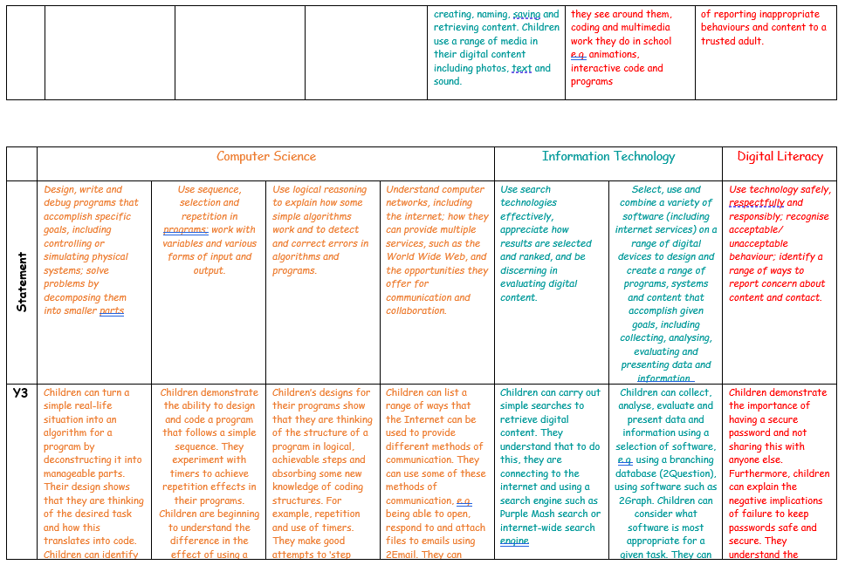
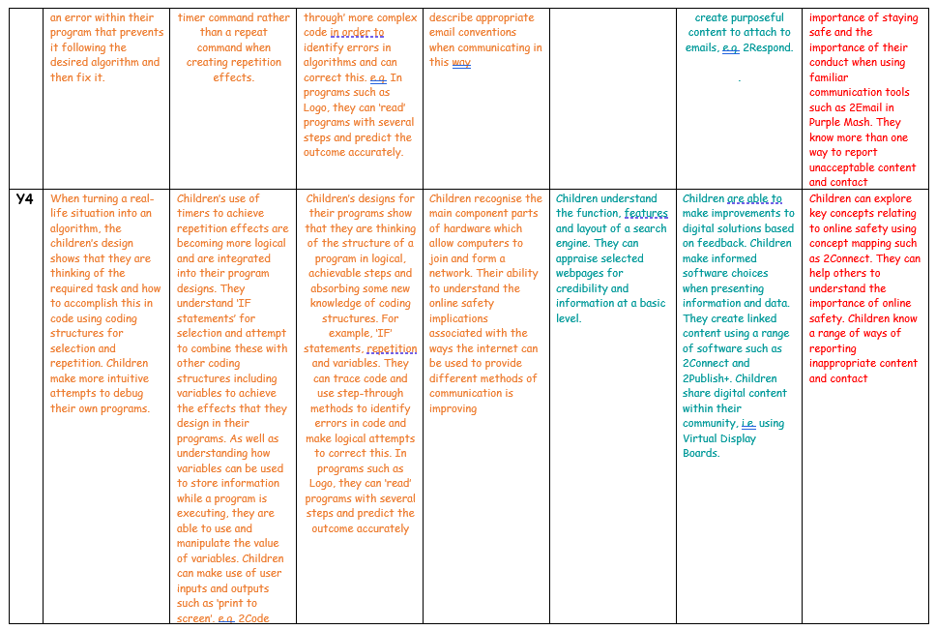

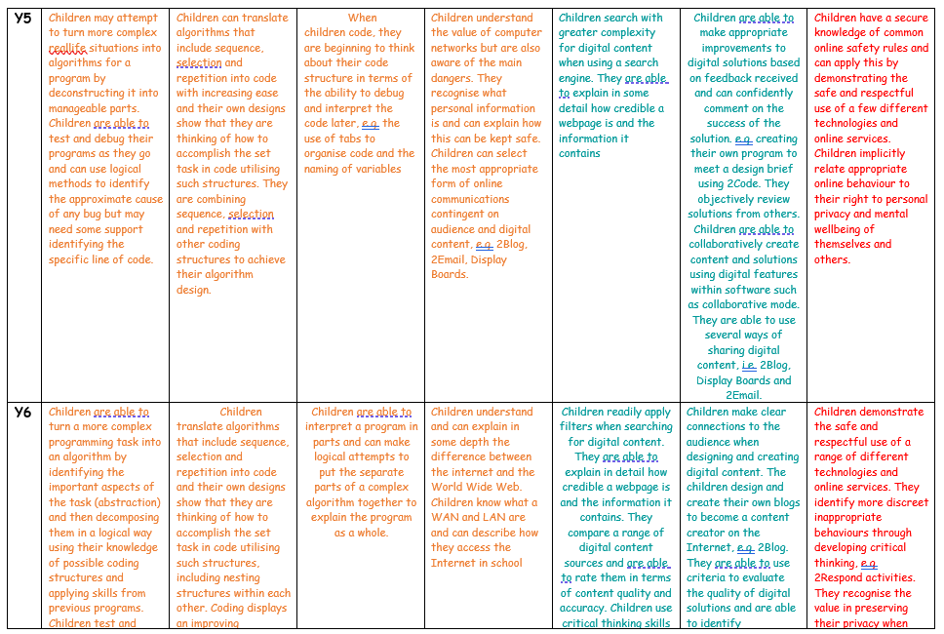
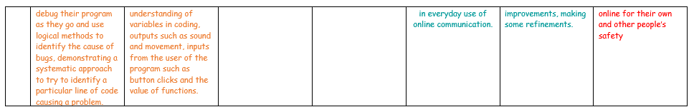
What does computing look like in the classroom?
Children are taught at least one discreet computing lesson each week. This can either take place in the computer suite using PCs or in classrooms using iPads. The lesson may also be an ‘unplugged’ lesson which does not require any technology. These lessons are used to introduce key concepts in hands on a practical way.
A typical computing lesson starts with a recap of previous learning. This may be from a previous lesson or a previous unit taught in the year group before. Purple Mash PowerPoint slides introduce the new vocabulary and terminology that will be used in that particular lesson and teachers spend some time explaining this. Teachers may begin a unit by utilising the Purple Mash Quiz for each unit to be completed as a pre assessment.
New knowledge and skills are taught by modelling and through worked examples. The lessons are broken up into small parts and the children are asked to complete a task at each part of the lesson. These tasks are often set as 2Dos so that they can be accessed quickly by the children and differentiated by the teacher where necessary. There are extension tasks available for more confident children.

At the end of the lesson the teach will recap the vocabulary and concepts taught in that lesson. The children will then save their work and hand it in if appropriate. Often, good examples children’s work is celebrated and displayed on the board for the children to see and discuss.
How is computing evidenced?
Computing at Milecastle is mostly evidenced on Purple Mash. The children have their own individual accounts which means they can save their work at the end of each lesson. Teachers can then open the work, set judgements and leave comments. When children complete a pre or post assessment for each unit the data is stored for each class. This is used to inform the teacher’s assessment. For more practical lessons photographic evidence is sometimes more appropriate. Photographs are shared on the class blogs or on SeeSaw.

Impact
We encourage our children to enjoy and value computing in school. We want learners to discuss, reflect and appreciate the impact computing has on their learning, development and well-being. Finding the right balance with technology is key to an effective education and a healthy life-style. We feel the way we implement computing helps children realise the need for the right balance and one they can continue to build on in their next stage of education and beyond. The way pupils confidently showcase, share, celebrate and publish their work using Purple Mash, Office tools, Seesaw and a variety of other programs will be part of how we show the impact of our curriculum. Progress of our computing curriculum is demonstrated through outcomes and recorded on our Purple Mash platform.

