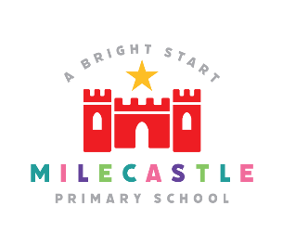
MFL French

Definition: The ability to communicate in another language and to provide an opening to other cultures.

Our Intent
Learning a foreign language is a liberation from insularity and provides an opening to other cultures. At Milecastle Primary School we aim to provide a high-quality languages education which fosters pupils’ curiosity, deepens their understanding of the world and develops a sense of global citizenship. We aim to provide opportunities for pupils to develop their listening, speaking, reading and writing skills in French and to express themselves with increasing confidence, independence and creativity. They explore similarities and differences between French and English and begin to understand the structure of the French language. Through a mostly kinaesthetic approach, we aim to nurture an appreciation and love of languages and other cultures which will lay the foundations for further study at key stage 3. Learning a modern foreign language is a lifelong skill for education which provides additional opportunities in employment and leisure and greater social mobility on an international level.

Implementation
At Milecastle, we teach French in all KS2 classes who have regular timetabled lessons. Planning is based upon The Primary French Project scheme of learning for MFL, which encompasses all objectives from the National Curriculum documentation 2014. Teaching enables pupils to understand and communicate ideas, facts and feelings in speech and writing which are based around termly topics. Lessons are focused on familiar and routine matters, using children’s knowledge of phonology, grammatical structures and vocabulary. Teaching is mostly kinaesthetic and encourages children to learn in a fun and engaging way. An appropriate balance of spoken and written language is delivered throughout each year group which includes songs and rhymes. To ensure high standards of teaching and learning in MFL, we implement a curriculum that is progressive and cyclical throughout KS2. MFL teaching at Milecastle Primary School involves adapting and extending the curriculum to match all pupils’ needs.

How is MFL organised across school?
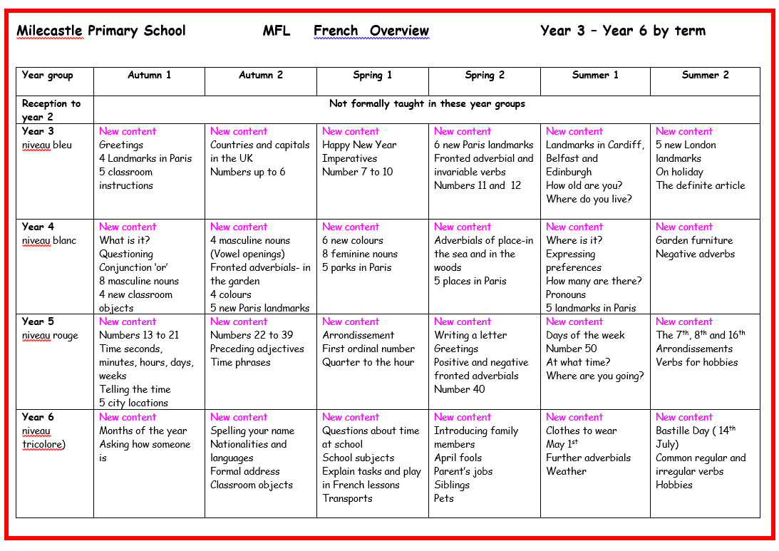
How is MFL taught in EYFS?
MFL is not formally taught in early years
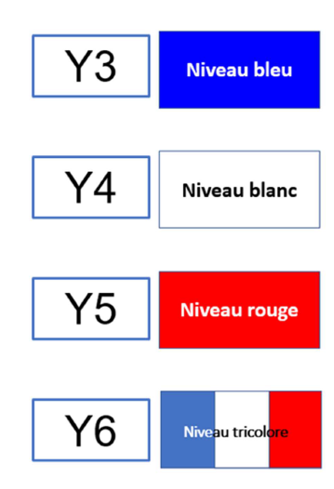
How do we plan for MFL?
At Milecastle we follow the Primary French Project scheme of learning.
Each niveau (level) is aligned with the KS2 PoS for Languages, and the KS2 PoS for English.
The materials have been designed to include essential subject knowledge, progression of language acquisition skills, knowledge of French culture and excellent models for pronunciation and intonation.
All material is age-appropriate with interactive slides, stories, rhymes and songs.
There are 6 short interactive lessons each half term for every KS2 class.

Knowledge organisers
Knowledge organisers support pupils learning by providing key vocabulary and phrases with picture prompts as an aid memoire.
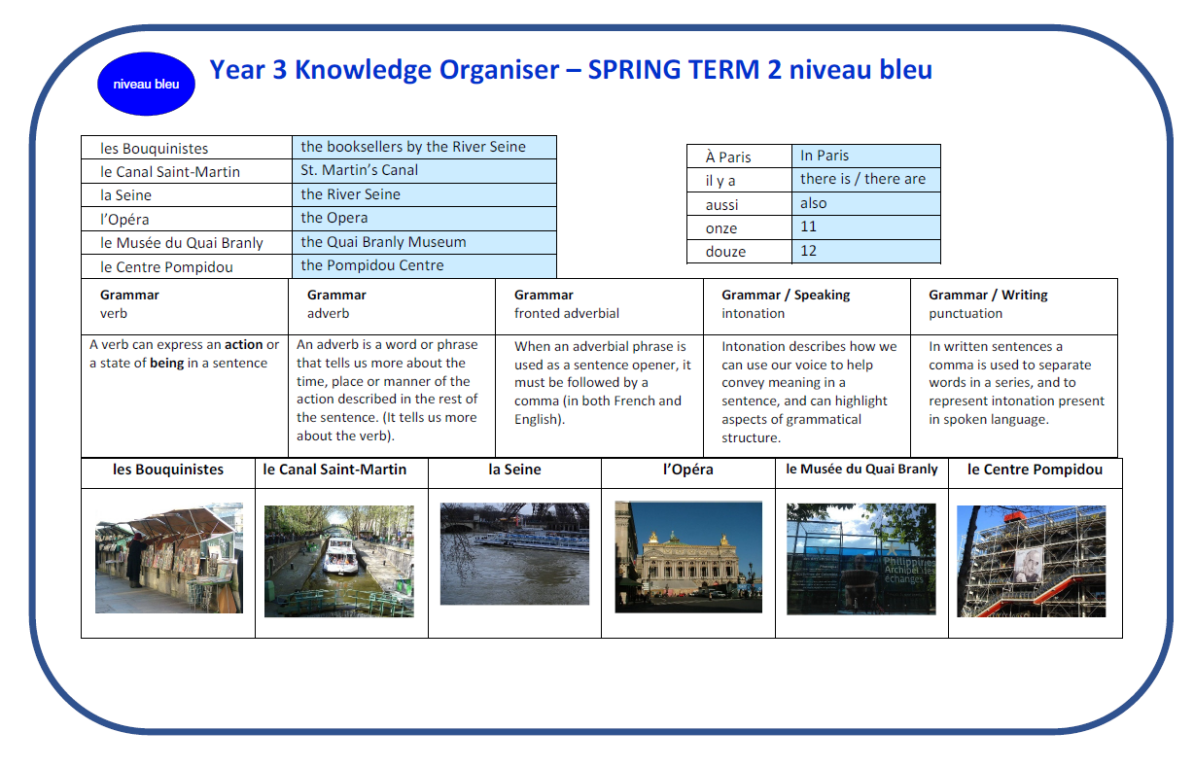
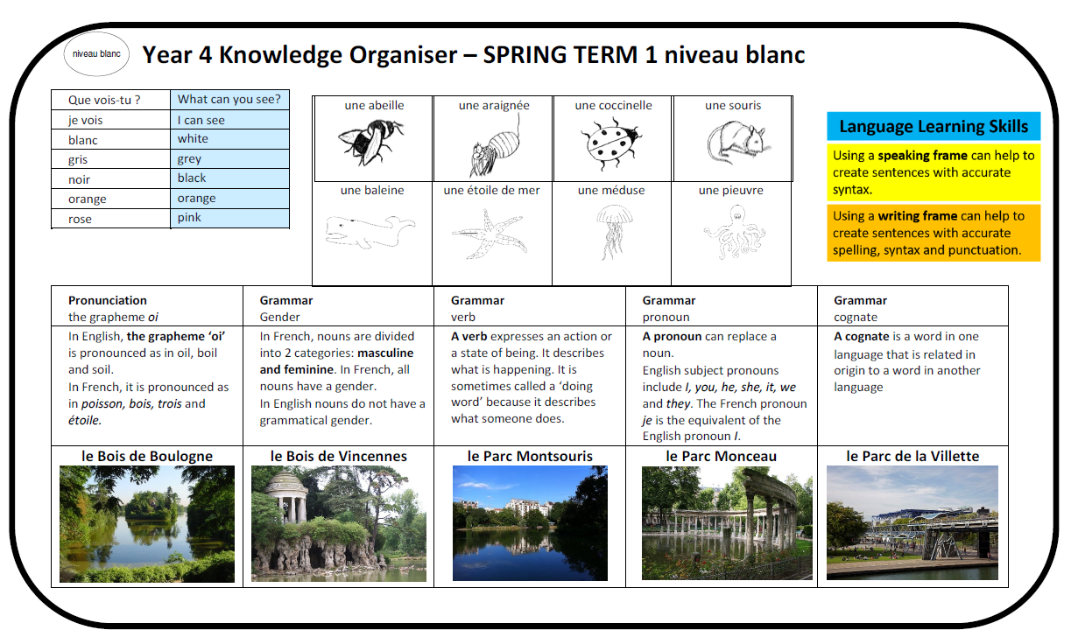
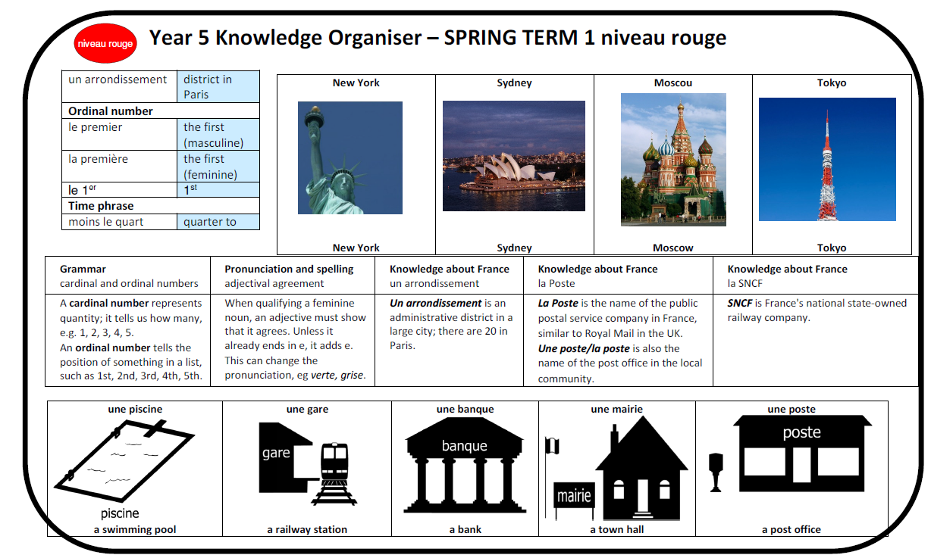
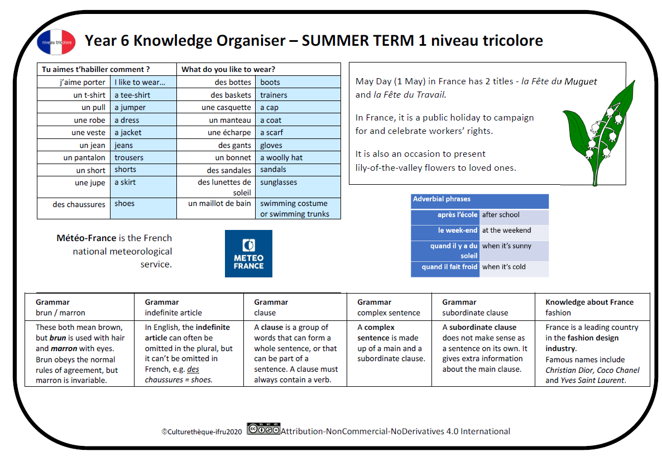

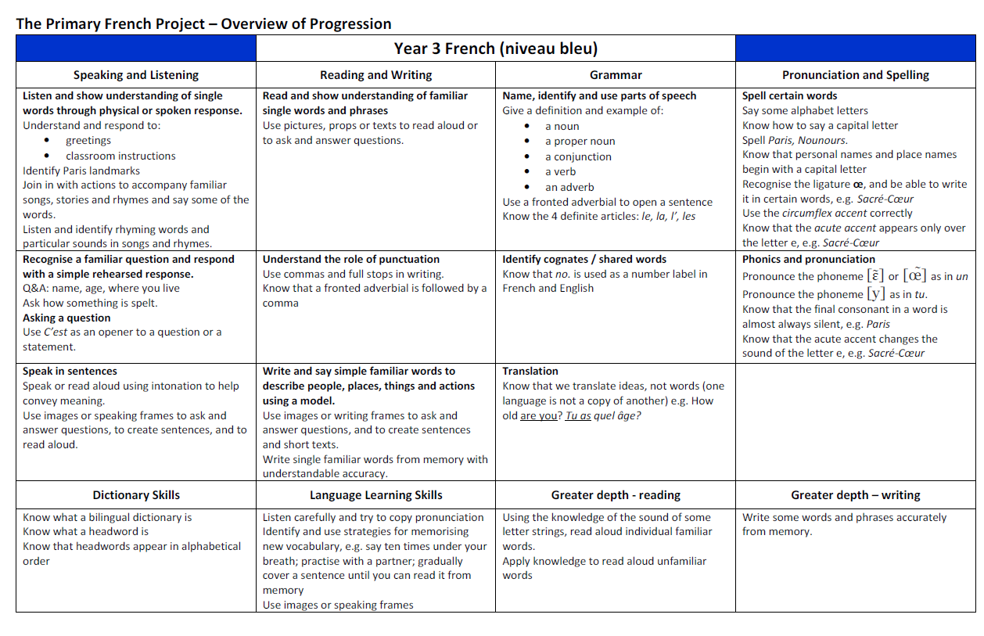
Progression documents
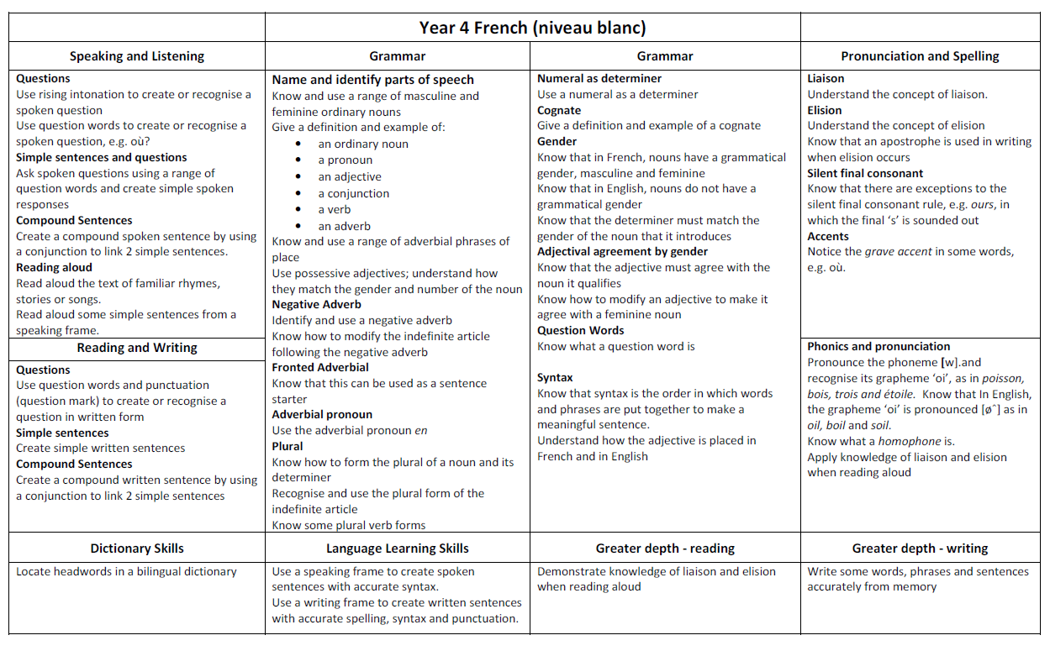

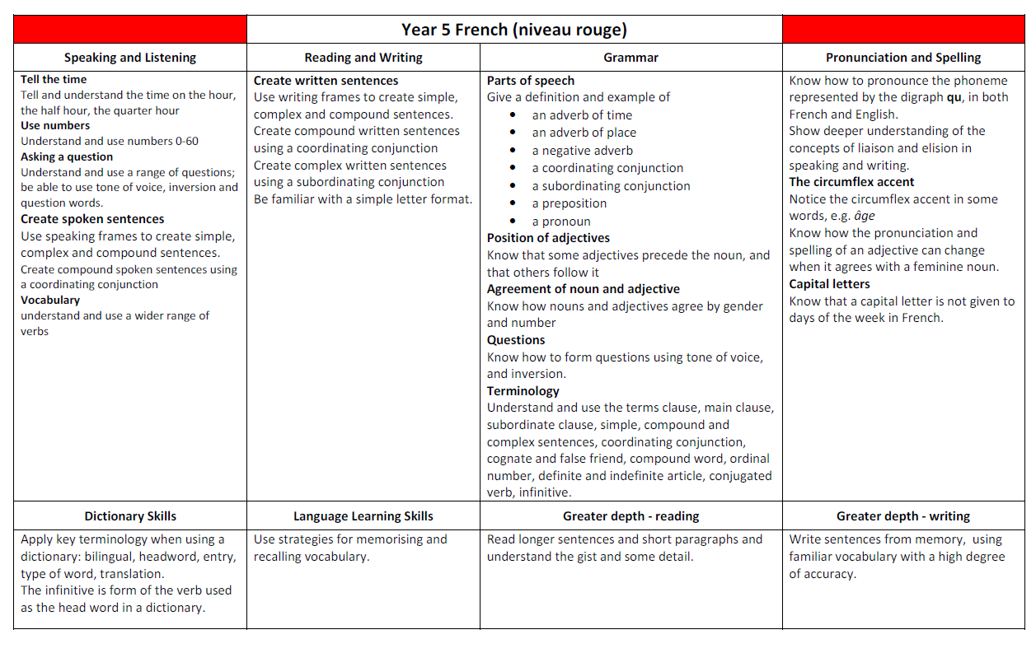
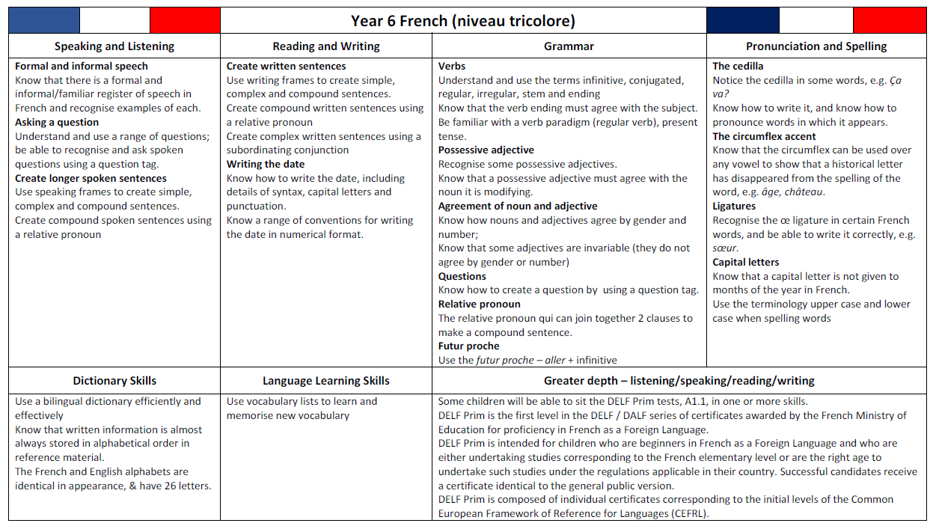

What does MFL look like in the classroom?
Much of the learning is interactive and kinaesthetic.
Pupils learn through whole class interaction, paired discussion, songs, stories and rhymes.
Pupils begin each half termly unit with a short interactive lesson where they will practise listening to and speaking new and revisited vocabulary, phrases and sentences.
Pupils will learn in a whole class, teach do style of pedagogy and will also practise with talk partners using prompts to aid discussion. Near the end of the half termly unit they will be given the opportunity to write in French relating to the focus for that particular term.

How is MFL evidenced?
Class blogs and seesaw journals show evidence of MFL teaching in the classroom. Milecastle Primary celebrate different cultures through ‘Culture week’ where each class investigate the language and culture in a chosen country.
Children are formatively assessed throughout the course of a unit. At the end of each half termly unit there are optional short assessment tasks to evidence a summative judgement. Children are deemed to be either working towards the expected standard, working at the expected standard or working at greater depth within the expected standard. To support their judgements teachers can refer to the progression of skills and content documents for their particular year group. These documents ensure that the skills and content being taught are built upon year on year and that there is a clear progression of skills as a child passes through school.

Impact
Children’s knowledge and skills will develop progressively as they move through the school.
The successful approach to the teaching of MFL at Milecastle results in fun, engaging, high-quality language learning, that enables children to read, write, listen to and speak in French. It lays the foundations for understanding a different culture, a different language and to compare it to their own. Children will have a greater awareness of the world we live in and will be empathic global citizens of the 21st century.

