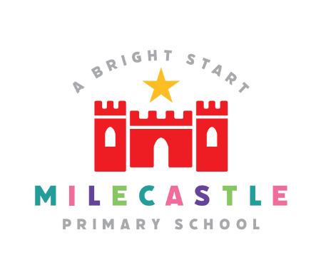
Geography
Geography is the study of places and the relationships between people and their environments.
Our Intent
At Milecastle Primary School, our geography curriculum is designed to develop the children’s curiosity and fascination about the world and its people that will remain with them for the rest of their lives. Children will become independent learners as they develop the skills they need to investigate a range of places – both British and abroad - to help develop their knowledge and understanding of the Earth’s physical and human processes. Pupils will consider how the Earth is changing and the impact we, as humans, are having on those changes. The pupils will engage in respectful discussions which allow them to express their own opinions while considering those of others. Our pupils will make enquires about their local area and compare it to other places in the world. We aim to develop the children’s ability to apply geographical skills and to be able to communicate them confidently.
Implementation
To ensure continued high standards of teaching and learning within the Geography curriculum we have embodied a progressive curriculum throughout school. Geography is taught throughout the school year to allow knowledge to be built upon and previous knowledge to be recalled. Links are made between new and previous topics and vocabulary built upon. Teaching is supported through education visits and guest speakers/ experts in school. Geography lessons are planned to build the children’s understanding progressively from their local area and slowly into the wider world.
At Milecastle Primary School we follow the National Curriculum. By the end of year 6, children will have explored the geography of a number of places around the world. They will have conducted investigations through fieldwork and made comparisons with other areas, including that of their own locality. The acquisition of knowledge and skills is supported through educational visits and guest and expert speakers in school.

How is Geography organised across school?
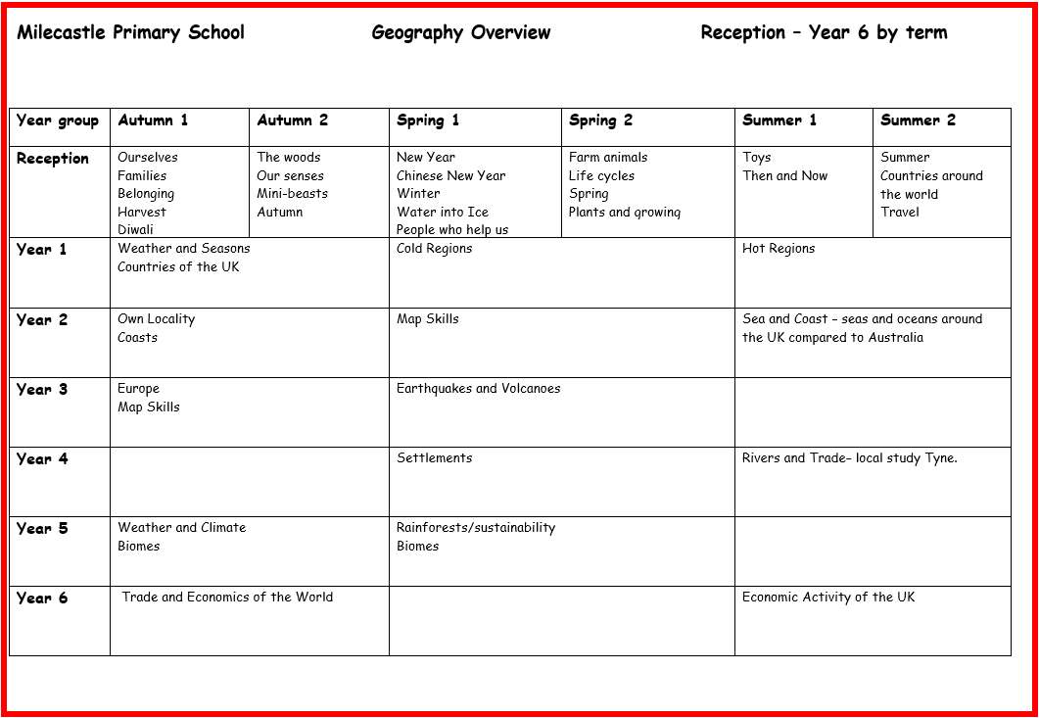
Geography at Milecastle is centred around four main concepts: human impact, weather and climate, space and locational knowledge. Each topic builds on these concepts and ensure clear progression across school.

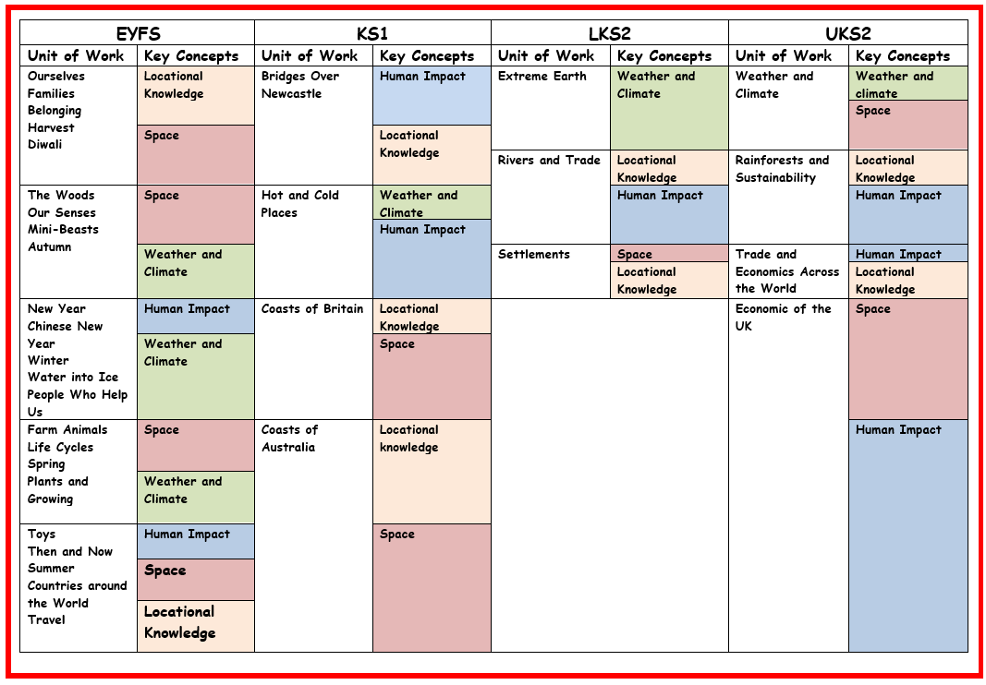

Geography in EYFS
Geography is a very important part of the EYFS curriculum at Milecastle Primary School. It is essential for the development of understanding of the world and through their experiences at this early stage of their learning they develop a sense of the world around them. They explore places which are familiar to them. They begin by looking at what is most local to them and expand outwards to different environments such as commercial areas, farms and nature reserves. Conversations and exploration happen continuously and pupils are encouraged to explore the world around them through their play and links to their topics. Work is recorded in floor books which reflect the exciting adventures of reception class
How do we plan for Geography?
Geography at Milecastle is carefully planned to ensure that pupils grow progressively into geographers. Topics are selected to support the National Curriculum and the rich and diverse geography of the local area supports the planning, teaching and understanding of the topics covered through enhancing and bringing to life our geographical concepts. Our four key concepts, human impact, weather and climate, space and locational knowledge are woven through the curriculum which build on previous knowledge and enhance understanding. Substantive knowledge (geographical knowledge) is mapped out through the key concepts. Pupils are encouraged to make links with their previous learning as they embark on a new topic.
Key facts and vocabulary are displayed on knowledge organisers which pupils refer to in order to develop and embed their substantive knowledge. Where relevant, links are made
with the rich local geography of the North East. Pupils investigate physical geography, identifying the key, natural features and phenomenon of a location. They are taught the names of countries, continents, rivers, oceans, rainforests and mountain ranges. They learn about the impact humans are having on the world, both positive and negative and consider how living in the United Kingdom is similar and different to living in other areas of the world. The rich variety of local, geographical attractions are used to expand their learning experiences.
Knowledge organisers
Knowledge organisers map out the key knowledge the pupils will learn in that topic and will help them to answer the overarching enquiry question. They include key facts and vocabulary which they will be exposed to over the course of that unit of work.

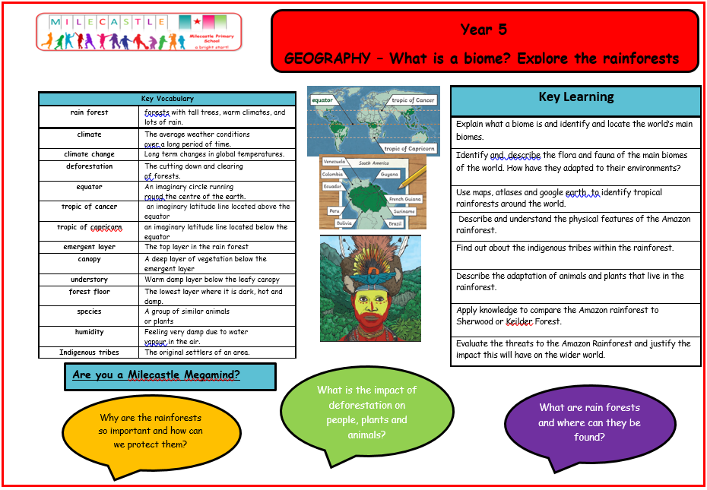

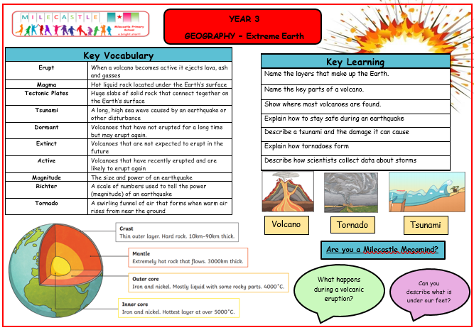

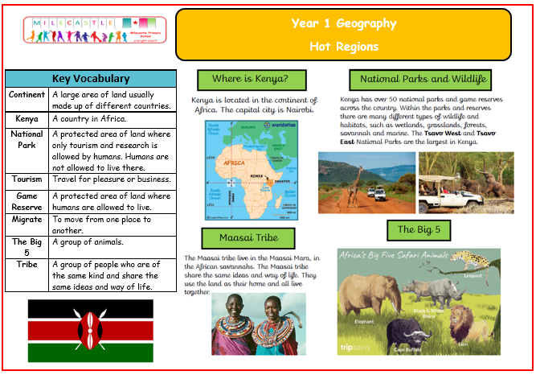

Progression documents
Our progression documents map out the key disciplinary knowledge for geography and how it is built upon, year on year. This ensures that pupils are continually making progress in geography each year.
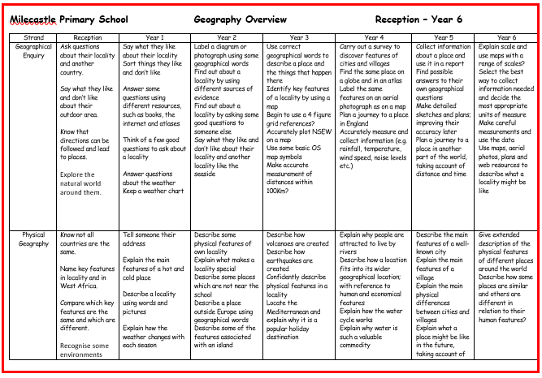

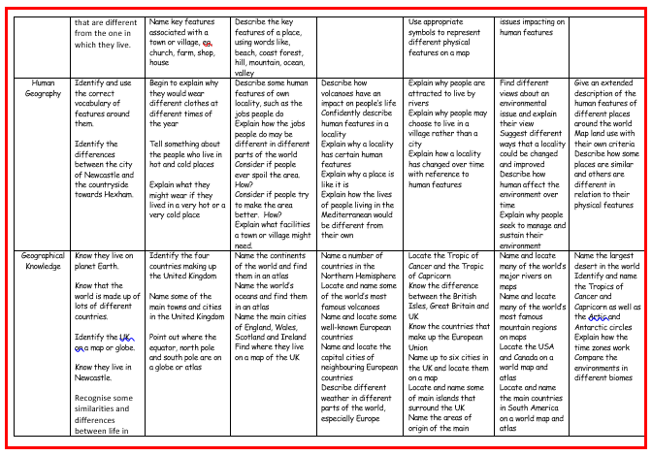

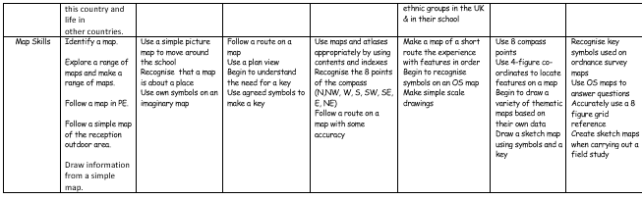

What does Geography look like in the classroom?
Geography is taught regularly in the classroom. Areas of study begin with an enquiry question. It is through their geographical investigation throughout the unit of work which will lead to the question being answered at the end of the unit. Key vocabulary is explicitly taught and initial links are made to previous learning. At the start of each lesson, knowledge is retrieved from the previous lesson. Knowledge organisers are used to support this and guide the retrieval and acquisition of facts. New knowledge and skills are taught through researching open-ended enquiry questions, information gathering from high-quality texts, using and investigating a range of sources such as atlases and the internet, talking and writing like geographers. Fieldwork skills are developed throughout all year groups. Fieldwork lessons may include collecting and analysing data and conducting and recoding observations. Geography lessons should be fun and interactive with pupils drawing conclusions and answering questions based on the information they have evaluated.
How is Geography evidenced?
Geography is evidenced in a range of different ways. Within books, there will be a clear learning question which identifies either a substantive knowledge or disciplinary knowledge focus for the lesson. Pupils may present their work in a range of different ways: written explanations, drawing and diagrams, tables and data. Alternatively, work may be evidenced through photographs and displayed on the class blogs. Pupils talk confidently about the work they have produced in lessons and use the work in their books and photographs on the blog to enthusiastically share their knowledge.
Impact
Children are formatively assessed throughout the course of a unit. At the end of the year evidence is gathered to formalise a summative judgement. Children are deemed to be either working towards the expected standard, working at the expected standard or working at greater depth within the expected standard. To support their judgements teachers can refer to the progression of skills and content documents for their particular year group. These documents ensure that the skills and content being taught are built upon year on year and that there is a clear progression of skills as a child passes through school.
Through a well-rounded and balanced curriculum, children will have developed the geographical knowledge and skills to help them explore, navigate and understand the world around them and their place in it. Children’s knowledge and skills will develop progressively as they move through the school, not only to enable them to meet the requirements of the national curriculum but to prepare them to become competent geographers in the future. Pupils at Milecastle Primary School enjoy their geography lessons. They develop an understanding of how the world works and how it has and is changing. They understand how humans influence the changes and formulate opinions supported by evidence. Our pupils understand that we have only one world and it is our responsibility to preserve it for the future. Pupils speak passionately about issues affecting the world. They draw links between what they are learning and personal experiences they have had.

