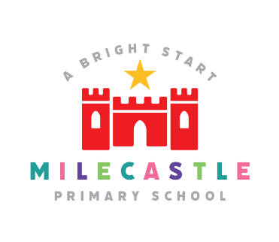
HISTORY

History is the study of the past, in particular the changes over time, that have occurred within human society.
Our Intent
At Milecastle Primary School, we aim to deliver a history curriculum which is fully inclusive. We aim to provide a broad and balanced curriculum which encompasses British Values, the school values and ensures progressive development of historical disciplinary and substantive knowledge. Our History curriculum should inspire pupils to have a curiosity about Britain’s past and that of the wider world; know and understand about significant aspects of the history of the wider world, including that of ancient civilizations; changes in and beyond living memory; and learn about the lives of significant individuals of the past. We want our pupils to be tolerant and respectful when learning about the past. Pupils should enjoy learning about history. They should develop and apply their enquiry and deduction skills, evaluating evidence from the past and drawing informed conclusions. As they progress through school, pupils will develop their independence in finding out about the past and will want to delve deep into the topics. Our pupils should become true historians. Experiences should come not just from the classroom but through education visits and guest speakers.
Implementation
To ensure continued high standards of teaching and learning within the history curriculum we have embodied a progressive curriculum throughout school. History topics flow throughout the year allowing pupils to build on previous knowledge and recall past learning regularly. Topics are linked together and flow. Additional links are made with other areas of the curriculum when appropriate. Pupils are given the opportunities to examine and evaluate artefacts, make comparisons with other periods of time. Teaching is supported through educational visits and guest speakers/ experts in school.
At Milecastle Primary School the history curriculum is based upon the National Curriculum, which provides a broad framework and outlines the knowledge and skills taught in each key stage.

How is History organised across school?
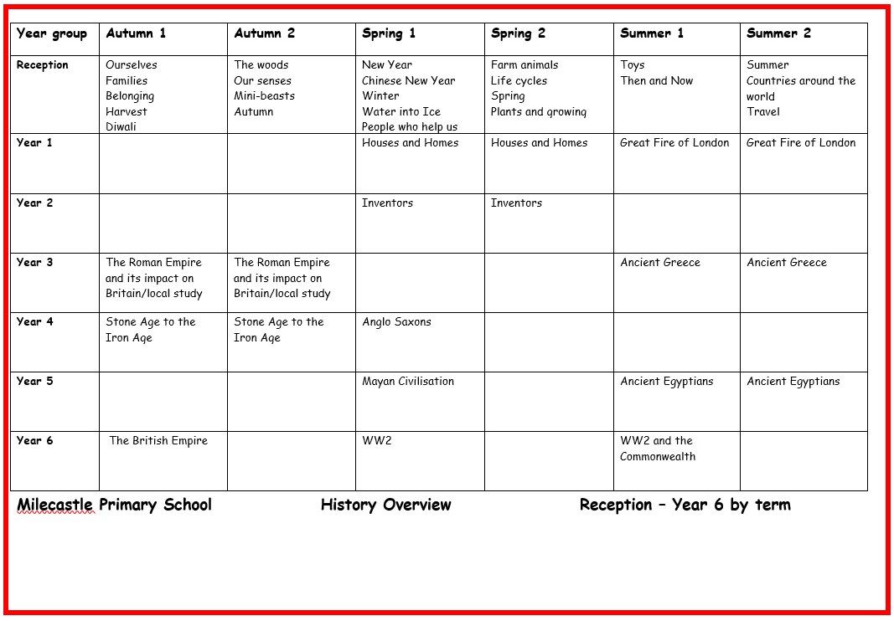

History in EYFS
History is a very important part of the EYFS curriculum at Milecastle Primary School. It is essential for developing their understanding of the world and they learn through experiences which helps to introduce the concepts of time and change. Through their play and the telling of stories, pupils become familiar with historical terms such as ‘past’ and ‘present’ while learning how to order and sequence events. Through exploring their own history and that of their families, they develop their vocabulary and start to make comparisons between ‘now’ and ‘then’. Stories are carefully chosen to help them explore the present and the past and develop the foundation of historical vocabulary.
How do we plan for History?
The areas of study have been arranged in a very considered way. Key Stage 1 look at significant events from British history as well as their own local history. In Key Stage 2, history is arranged in chronological order and with topics with similar themes linked together. Pupils study a range of different civilizations and look at how one period of time has influenced another. Key concepts such as trade, invasion and settlement are woven through the curriculum which builds on previous knowledge and understanding.
Substantive knowledge (historical knowledge) is mapped out through the key concepts. Pupils are encouraged to make links with their previous learning as they embark on a new topic.

Key facts and dates are displayed on knowledge organisers which pupils refer to in order to develop and embed their substantive knowledge. Where relevant, links are made
with the rich local history of the North East. Pupils are taught how the invaders and settlers of the past helped to develop their area and the rich variety of local, historical attractions are used to expand their learning experiences.
Chronological understanding is key and pupils are taught to place events and periods of time they are learning about on a timeline to establish context.
Disciplinary knowledge (key historical skills) are taught within the history lessons. The teaching of these skills will equip the children with the tools needed for the study of the past as a discipline – the process of historical enquiry, devising and investigating questions about history and the use of evidence.

Knowledge organisers
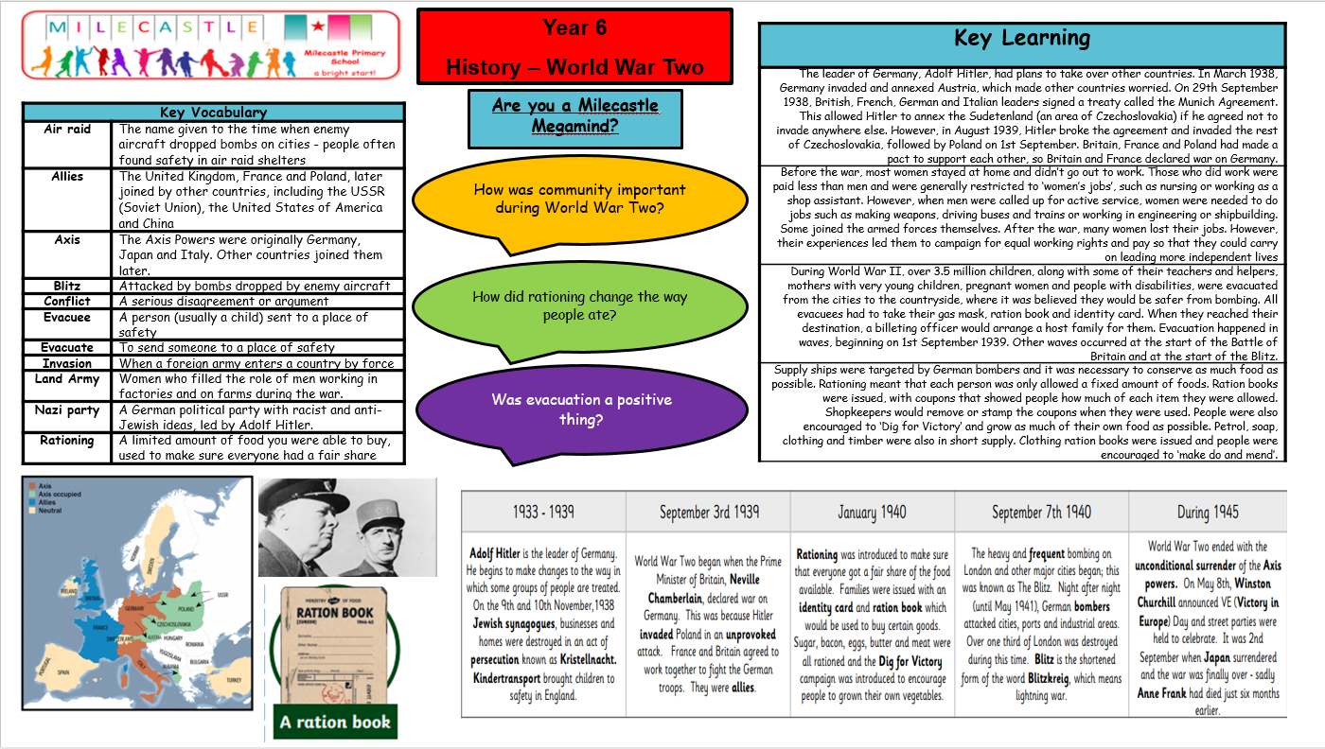
Knowledge organisers map out the key knowledge the pupils will learn in that topic and will help them to answer the overarching enquiry question. They include key dates, facts and vocabulary which they will be exposed to.

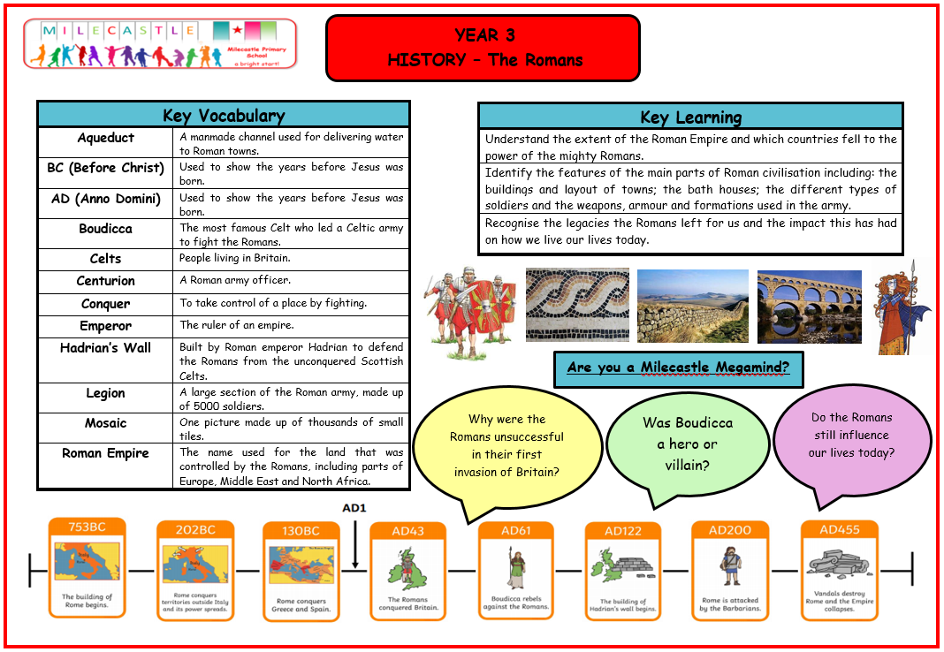
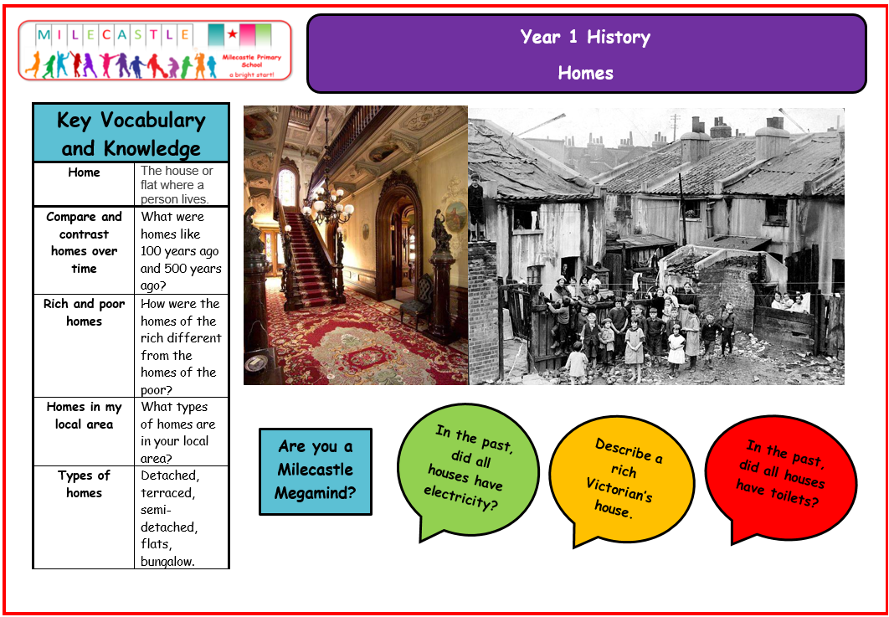

Progression documents
Our progression documents map out the key disciplinary knowledge for history and how it is built upon, year on year. This ensures that pupils are continually making progress in history each year.
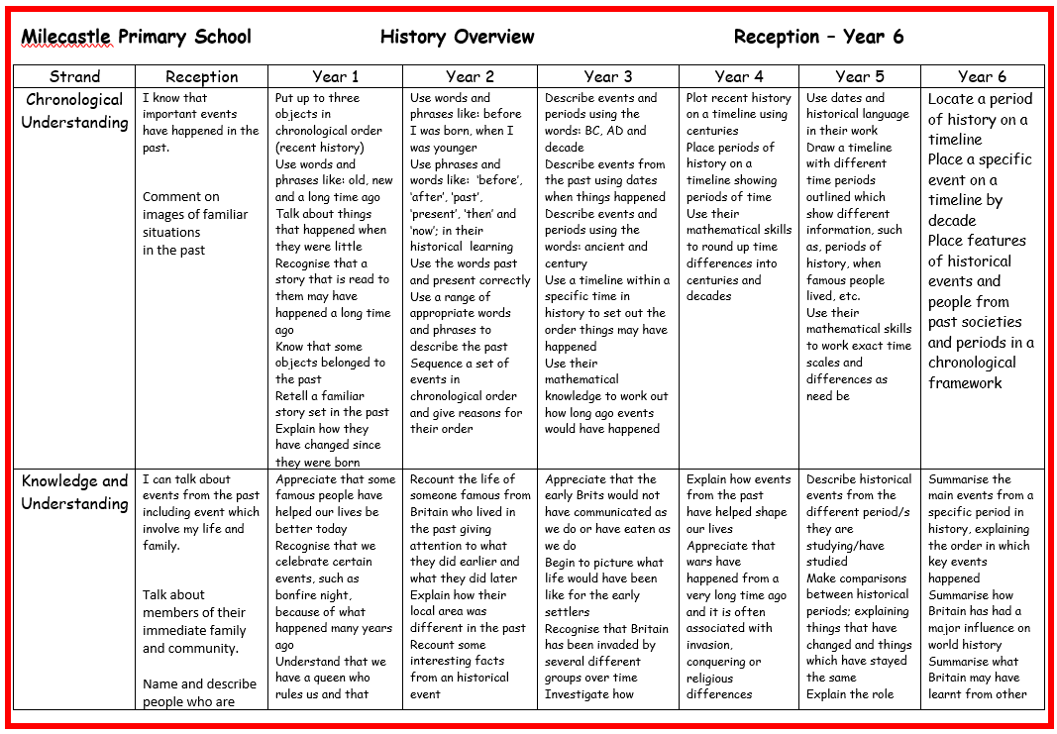

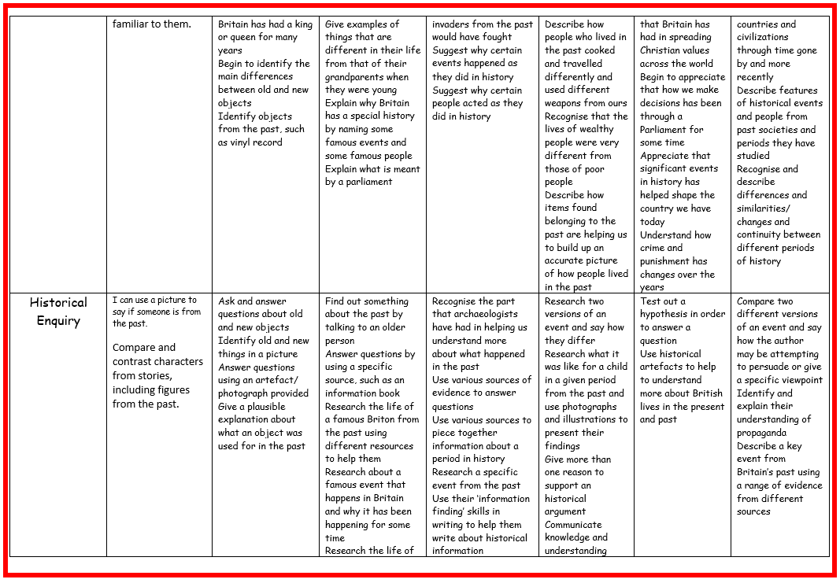

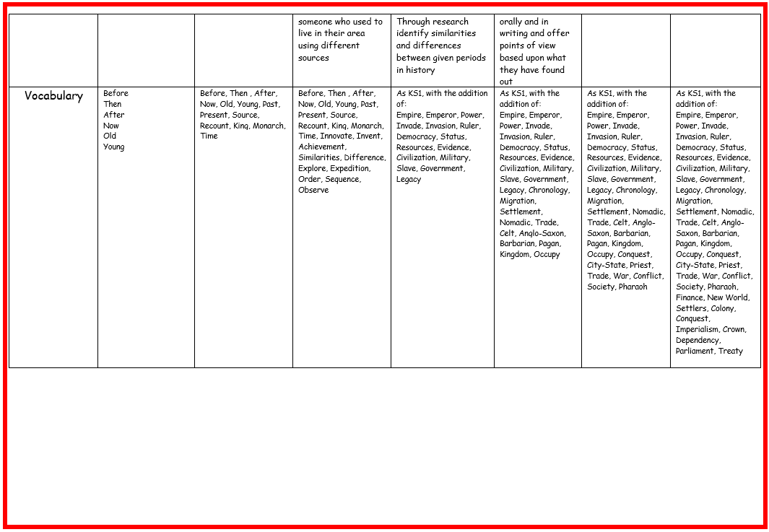

What does History look like in the classroom?
History is taught regularly in the classroom. Areas of study begin with an enquiry question. It is through their historical investigation throughout the unit of work which will lead to the question being answered at the end of the unit. Key vocabulary is explicitly taught and initial links are made to previous learning. At the start of each lesson, knowledge is retrieved from the previous lesson. Knowledge organisers are used to support this and guide the retrieval and acquisition of facts. New knowledge and skills are taught through researching open-ended enquiry questions, information gathering from high-quality texts, using and investigating a range of primary and secondary sources, talking and writing like historians. History lessons should be fun and interactive with pupils drawing conclusions and answering questions based on the information they have evaluated.

How is History evidenced?
History is evidenced in a range of different ways. Within books, there will be a clear learning question which identifies either a substantive knowledge or disciplinary knowledge focus for the lesson. Pupils may present their work in a range of different ways: written explanations, drawing and diagrams, tables and data. Alternatively, work may be evidenced through photographs and displayed on the class blogs. Pupils talk confidently about the work they have produced in lessons and use the work in their books and photographs on the blog to enthusiastically share their knowledge.

Impact

Children are formatively assessed throughout the course of a unit. At the end of the year evidence is gathered to formalise a summative judgement. Children are deemed to be either working towards the expected standard, working at the expected standard or working at greater depth within the expected standard. To support their judgements teachers can refer to the progression of skills and content documents for their particular year group. These documents ensure that the skills and content being taught are built upon year on year and that there is a clear progression of skills as a child passes through school.
The children at Milecastle Primary enjoy learning about history and key events and periods of time which have helped to shape our modern day world. Through their history curriculum, pupils are able to ask questions and use evidence to formulate answers to their questions. They evaluate events from the past and draw links between them and other periods of time. Through the use of the rich history of the North East, history is brought alive for the pupils. They make links with what they learn in class to their own history or that of their families. Class discussions highlight the enthusiasm pupils have for the subject and their desire to bring artefacts in from home further highlights their love for the subject. Our pupils produce work which make links between history and other areas of the curriculum and can critically analyse evidence. Pupils can ask questions and answer them, challenge the ideas of others and make informed, balanced judgements. By the time our pupils come to the end of their time at Milecastle Primary School, they have developed many of the skill needed to be a historian. By the end of year 6, children will have chronological understanding of the history of Britain and of the wider world. We will have drawn upon the rich history in our local area in order to help give context to the topics we have taught. Visits to local historical sites help the subject come alive for the pupils. Pupils will be tooled with the skills they need to be active historians.

