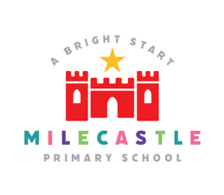
Music
Definition:
“Music is a universal language that embodies one of the highest forms of creativity. A high quality music education should engage and inspire pupils to develop a love of music and their talent as musicians, and so increase their self-confidence, creativity and sense of achievement.” National Curriculum, 2013
Our Intent
At Milecastle Primary School we strive to make music an enjoyable experience. We aim to develop children’s understanding and appreciation of a wide range of music in order that they may broaden their own musical interests and increase their ability to make judgements of musical quality. Through teaching about rhythm and melody we encourage the children to sing with confidence and expression. Through teaching the skills needed to make music; pulse, rhythm, pitch and tempo, dynamics, timbre, structure, texture, all children will learn to play a variety of both tuned and un-tuned instruments and will be able to follow simple musical notation. Through music we also aim to develop skills, attitudes and attributes that can support other subject areas and that are needed for life and work. These include listening skills, the ability to concentrate, creativity, intuition, aesthetic sensitivity, perseverance, self- confidence and sensitivity towards others.
Implementation
Music is a highly creative subject where children develop their own musical ideas. Creativity in music is encouraged through children’s improvisations and compositions when singing and playing instruments. They make connections between ‘new’ and ‘old’ learning, solve problems and think critically to develop and improve their ideas.
At Milecastle Primary School music is taught primarily through the ‘Charanga’ scheme. This scheme teaches skills progressively and exposes children to a wide range of musical styles, genres and traditions. Through ‘Charanga’ children have the opportunity to listen to and appraise different forms of music, learn to sing songs and learn to play both tuned and un-tuned instruments. They also have the opportunity to compose for a range of purposes either by playing instruments or by the use of computer programmes or apps. In addition, they may choose pieces of existing music to accompany and enhance a powerpoint presentation, movie or slide show they have created themselves. In reception, children are encouraged to experiment with different materials to create their own sounds and instruments, both in the classroom and outdoors. Children are encouraged to

evaluate their own work and the work of others by giving honest, fair and kind feedback. They practice skills of composition, playing and singing, refining their compositions and practising songs and tunes they find difficult. They learn, in music, that we only improve through practice.
Teachers are also encouraged to link music to their topic work. This can be done using a variety of additional resources including ‘Ten Pieces’, ‘Sing Up’, BBC’s ‘Bring the Noise”, ‘Classical 100’ and other on line resources. Music is used regularly in literacy lessons as a backdrop to writing and in dance in order to elicit and develop movement responses.
Our curriculum is enriched through additional music support provided by the Newcastle Music Service and other providers providing whole class instrumental tuition. Children also have the opportunity to learn new instruments through peripatetic teachers and workshops. Children have the opportunity to sing regularly both in the classroom and during assemblies and they perform to parents and carers and the wider community during class showcases, Christmas performances and other school events. Older children regularly take part in local music events such as ‘Holocaust Day Memorial services’ and ‘The Big Gig.’
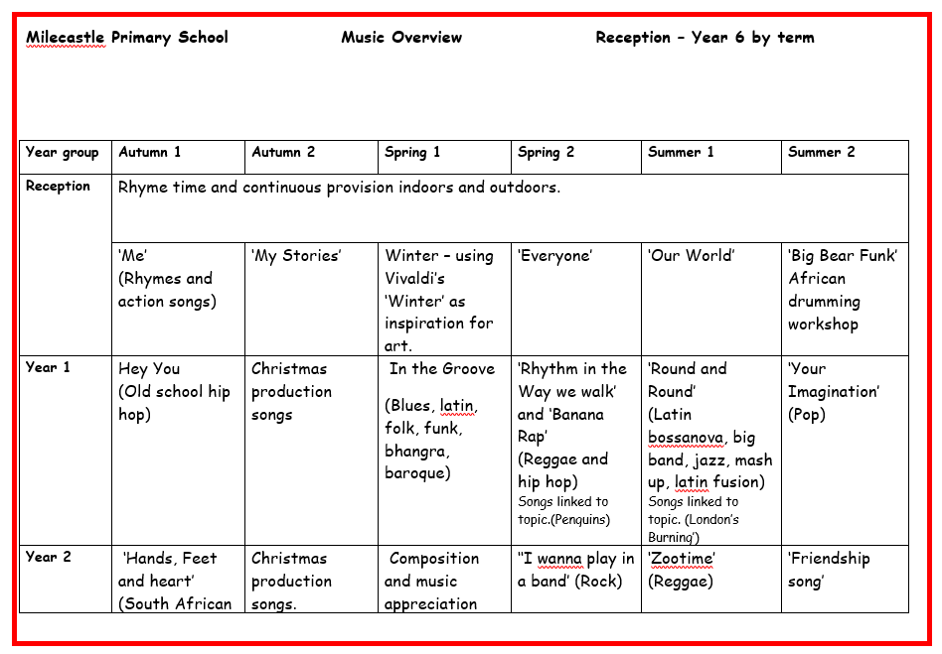
How is Music organised across school?

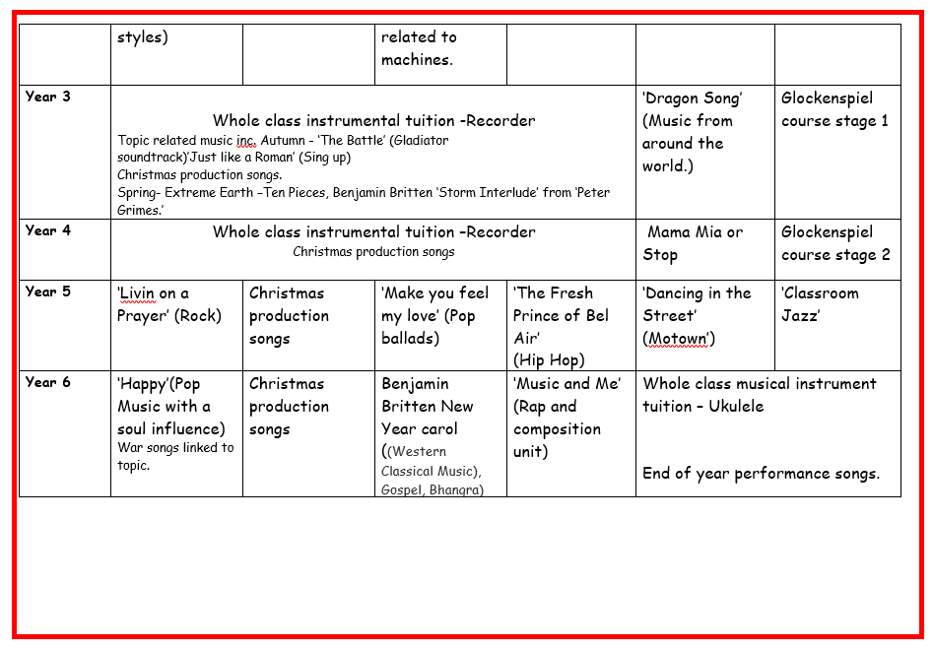
Music in EYFS
Within EYFS, children access the music curriculum through the Early Years curriculum. It is where we start our integrated approach to musical learning, laying down the foundations for KS1 and KS2 where we learn more about the interrelated dimensions of music (pulse, rhythm, pitch and tempo, dynamics, timbre, structure, texture), singing, moving and playing instruments and that they are all linked. Children sing, move and learn rhymes every day during rhyme time. They listen with attention to sounds and learn songs and rhymes and respond to what they have heard either through talk, movement or art. They have the opportunity to make their own music both indoors and outside exploring sounds made, not only by instruments, but by tapping, blowing or plucking everyday items.
The skills involved in listening to and performing music help our children to develop the self-esteem, self-discipline, creativity and co-operation necessary for success, consequently impacting their school journey from an early age. Through using music as a platform to increase their confidence and sense of achievement, it contributes to pupils developing the knowledge and cultural capital they need to succeed later in life.
Short structured lessons are also taught using the Charanga scheme, which concentrate on pulse, rhythm and pitch through a progressive, cross curricular, topic based approach. In the summer term, Reception also take part in an African drumming workshop linked to their topic.

How do we plan for Music?
At Milecastle children are taught one discrete music lesson every week . The Charanga scheme is used across the school ensuring continuity and progression of skills.
Each Unit of Work comprises the of strands of musical learning which correspond with the national curriculum for music
: 1. Listening and Appraising
2. Musical Activities a. Warm-up Games
b. Optional Flexible Games
c. Singing
d. Playing instruments
e. Improvisation
f. Composition
3. Performing
The scheme is also enhanced by whole class instrumental teaching and cross curricular music experiences and singing.
Musical teaching and learning is not neat or linear. The strands of musical learning, presented within the Charanga lesson plans and the on-screen resources, are part of the learning spiral. Over time, children can both develop new musical skills and concepts, and re-visit established musical skills and concepts. Repeating a musical skill doesn’t necessarily mean their progress is slowing down or their development is moving backwards! It's just shifting within the spiral. For the children to master their skills, it means both a deeper understanding of musical skills and concepts and learning something new. All musical learning in the scheme is built around the Interrelated Dimensions of Music: pulse, rhythm, pitch, tempo, dynamics, timbre, texture, structure and notation. These dimensions are at the centre of all the learning.
Knowledge organisers
Knowledge organisers are available for teachers to use on the Charanga website for each unit of work.

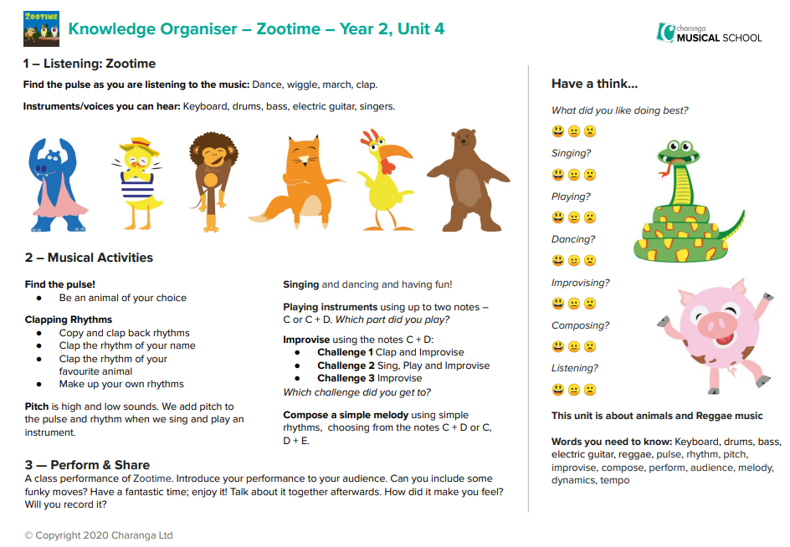

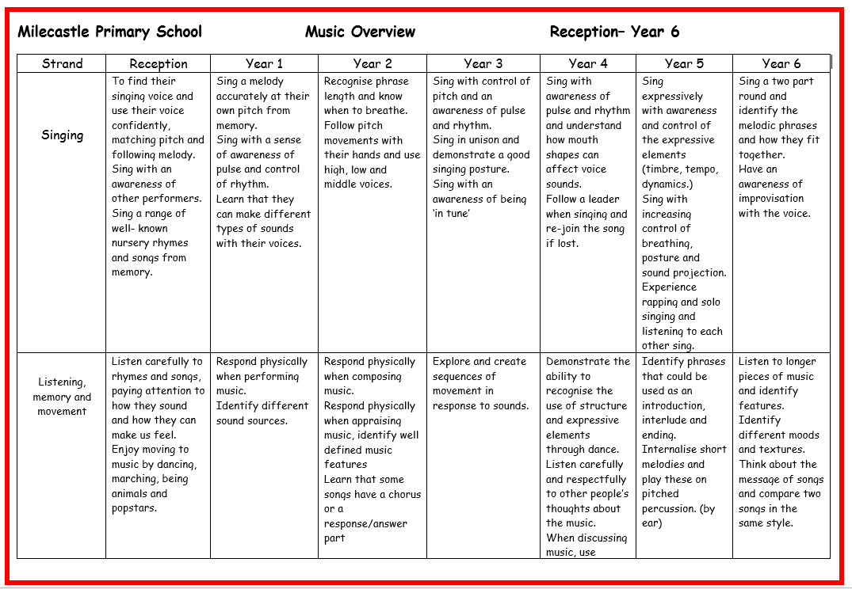
Progression documents

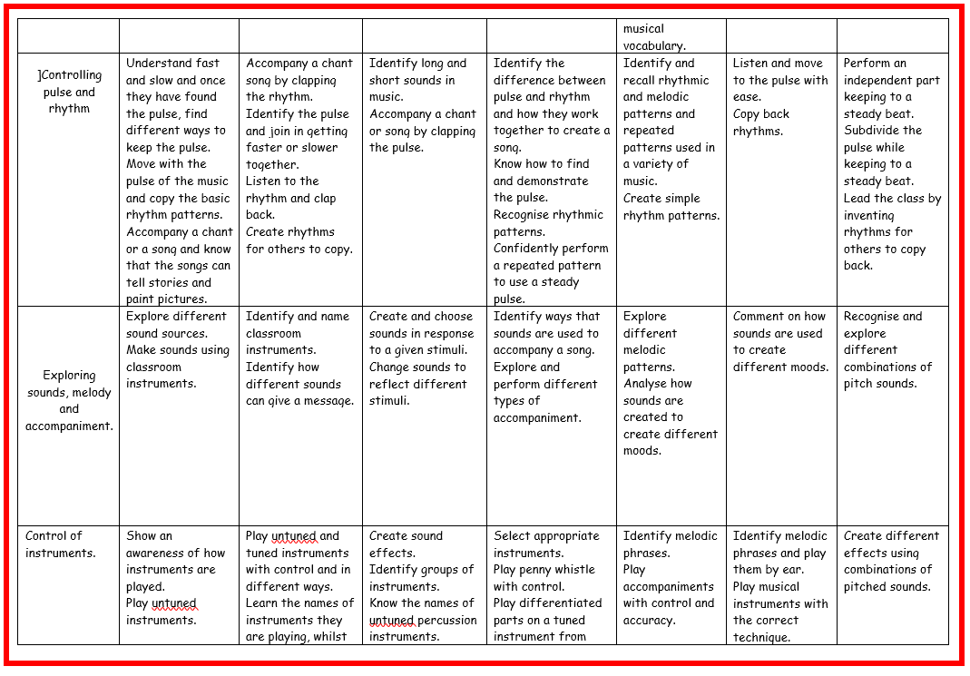
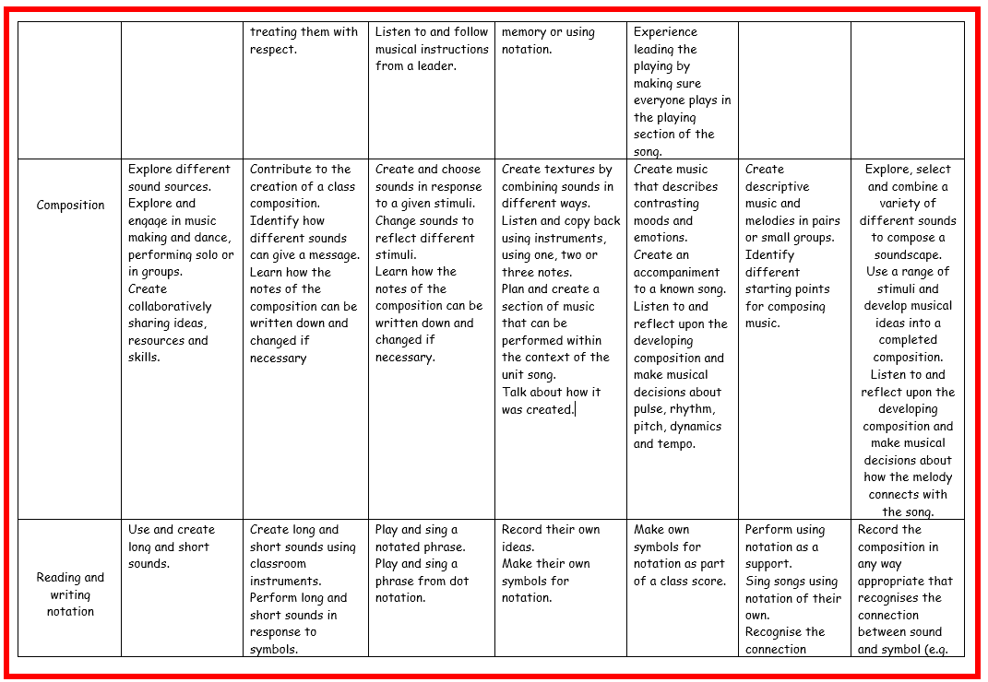

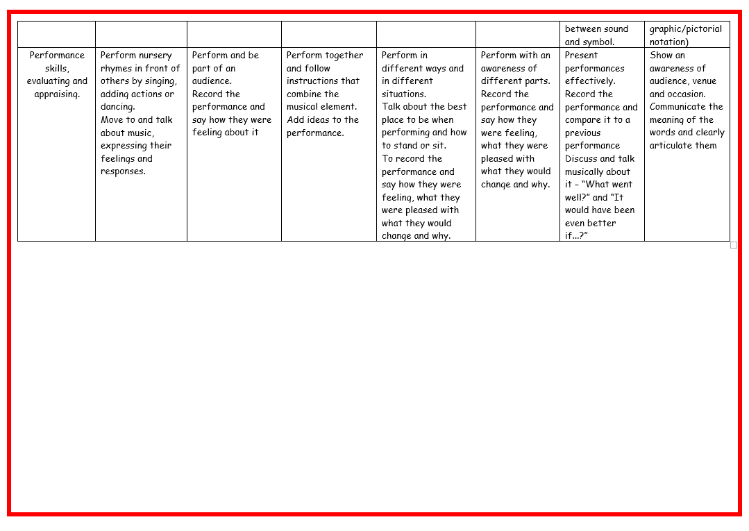
What does music look like in the classroom?
Throughout the school children listen to a variety of music from different periods, cultures and styles. They are made aware of how music has progressed and changed through the years and learn to respond verbally to music through the use of appropriate technical vocabulary. Teachers also use music to enhance literacy, history, art and dance lessons. Dance enables the children to listen to repeated phrases, rhythms, changes in pitch and tempo as well as allowing an alternative way to respond to music.
In a typical lesson children will spend some time listening and appraising a piece of music, developing musical skills (pulse, rhythm, pitch and tempo, dynamics, timbre, structure, texture), singing, playing instruments, either tuned, un-tuned or digital. In some lessons children will be composing using either body percussion, instruments or digital sounds. Children may follow or make their own rhythm grid to help organise sounds or they may follow formal notation, introduced at the end of Key stage 1.
In years 3,4 and 6 children will learn to play an instrument. Currently recorder is taught in years 3 and 4. Ukulele is taught in year 6. Whilst learning to play the instrument children will use all of the dimensions of music including musical notation.
How is music evidenced?
Blogs and whole school displays are used to show case evidence of Music engagement and enjoyment.

Impact
- The children at Milecastle Primary School enjoy music. This is evident in the way that they talk about it. Teaching staff assess the children’s work formatively after each unit of work basing their judgements on the progression of skills document for music. Where possible, teachers and support staff go alongside children whilst they are working to question and make suggestions about how progress can be made. Teacher assessments for each unit of work are available on the Charanga website. Children’s passports of their musical journey are available on the Charanga website so that children can reflect on their own progress. The music coordinator monitors the impact of music and the progression of skills through planning scrutinies and pupil voice. Whilst in school, children have access to a varied programme, which allows them to discover areas of strength, as well as areas they might like to improve upon. Music also develops an understanding of culture and history as well as ethnicities from across the world. Children are able to enjoy music, in as many ways as they choose- either as listener, creator or performer. They can understand the parts of music which, when put together, create a complete piece. They can sing and feel a pulse. They have an understanding of how to further develop skills less known to them, should they ever develop an interest in their lives and know that there are many career paths they can take in which music would be a part. Children realise that music can be an outlet for dealing with emotions and provide an alternative tool for regulating their mental health.

