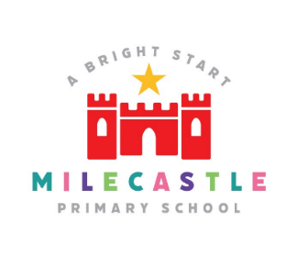

Physical Education
Physical Education is the planned, progressive learning that takes place in school curriculum timetabled time and which is delivered to all pupils. This involves both ‘learning to move’ (i.e. becoming more physically competent) and ‘moving to learn’ (e.g. learning through movement, a range of skills and understandings beyond physical activity, such as co-operating with others).
The national curriculum for physical education aims to ensure that all pupils:
- develop competence to excel in a broad range of physical activities
- are physically active for sustained periods of time
- engage in competitive sports and activities
- lead healthy, active lives.
Our Intent
At Milecastle Primary School physical education is an integral part of our curriculum that is inclusive and engages all pupils. Children develop the knowledge, skills and competence to excel in a broad range of sports and physical activities. We aim to deliver high-quality teaching and learning opportunities that enables all children to achieve their personal best. In both lessons and competitive sport we teach children to transfer the ‘Milecastle Values’ to all sporting activities, ensuring they do their best, demonstrate resilience and display good sportsmanship. We aim for all children to be physically active for sustained periods of time and be able to make informed decisions to lead healthy and active lives. Swimming is an important life skill, we aspire for all children to leave primary school being able to swim at least 25 metres.

Implementation
- PE at Milecastle Primary School provides challenging and enjoyable learning through a range of sporting activities including; invasion games, net & wall games, strike and field games, gymnastics, dance, swimming and outdoor & adventure.

- The long term plan sets out the PE units which are to be taught throughout the year and ensures that the requirements of the National Curriculum are fully met.

- Pupils participate in two high quality PE lessons each week.
- Children are encouraged to participate in the varied range of extracurricular activities. Break and lunch time sport activities are available each day and children can attend after school sport clubs at least twice a week.
- Children are invited to attend competitive sporting events within the local area. This is an inclusive approach which endeavors to encourage not only physical development but also mental well-being. These events also develop teamwork and leadership skills and are very much enjoyed by the children.
- Each year a small group of KS2 children are invited to become Sports Leaders for the school. They develop into sporting role models for the younger children, assisting with break and lunch-time activities, our annual Sports Day and other sporting activities.
- Children participate in taster workshops/days covering a variety of sports throughout the year. For example, new age curling, skipping, hoola hooping and archery. Again, providing the children with an opportunity to develop, improve their fitness and to try something new.
- Children in Year 5 learn to swim during the spring term. Any children who are unable to swim 25m by the end of this period have the opportunity to ‘catch up’ in Year 6.
- All children take part in whole school running opportunities such as the London Mini Marathon, our school annual run and The Golden Mile. All classes use ‘Go Noodle’ and ‘BBC Super Movers’ during the day and as part of lessons to help meet the government target of all children being active for at least 30 minutes a day at school.
- Where possible inspirational visitors such as Olympic athletes visit school to excite and encourage the children to become more active.

How is physical education organised across school?
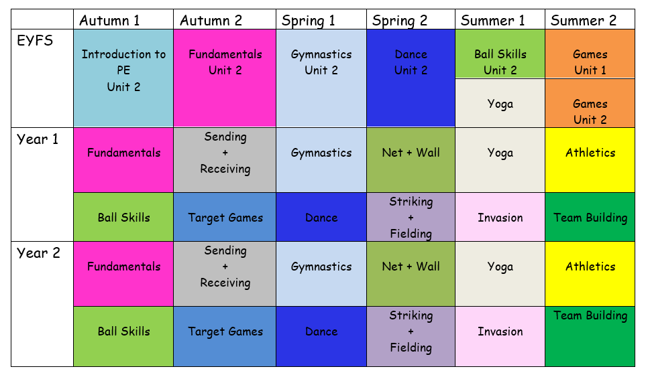

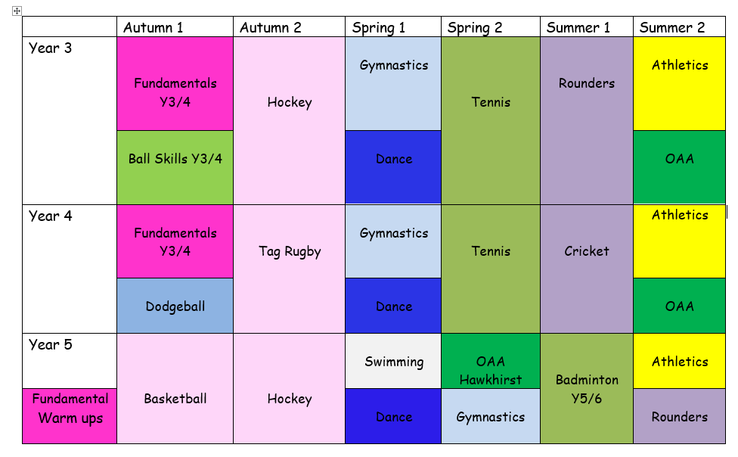

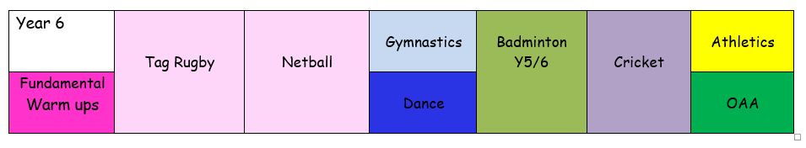

Physical Education in EYFS
To have the best chances of establishing and maintaining physically active lives both across a broad range of activities and in the long term, it is important that pupils develop secure foundations for movement. At Milecastle, we ensure our pupils develop adequate levels of fundamental movement skills in the early years. Our EYFS curriculum allows for children to experience movement, interaction and engagement through structured play. They are given opportunities to understand rules and boundaries, using a variety of equipment working both independently and with others. The curriculum has also been carefully sequenced to bridge the gap between play and the KS1 National Curriculum for Physical Education.
How is physical education planned for?
At Milecastle, the children have 2 hours of taught physical education a week. Each year group is assigned allocated slots on the PE timetable. We follow a scheme called Get Set 4 PE which has been developed by teachers for teachers.
In Early Years the units have been written around the 3 prime areas: communication and language, physical development and personal, social and emotional development. Teaching the introduction to PE unit first gives the children opportunities to learn how to safely use

a new space, adhere to set rules and move around others, with and without equipment. This unit is then followed by fundamental movement skills.
These skills underpin all the activities in the EYFS units. The units allow the children to develop their fundamental skills in isolation and in simple combination. In dance, children are given the opportunity to move energetically and in time to music. In gymnastics children have opportunities to develop strength, balance, and coordination. Finally the games and balls units provide opportunities for the children to master basic movements such as throwing and catching as well as manage their emotions, learn how to play within rules, understand what a team is and how to play with others. It provides a foundation for all games activities in KS1 and KS2.
In KS1 we teach the children to participate in team games that are divided into invasion games, net and wall games and target games. Children learn both attacking and defending physical skills. They are given opportunities to develop their knowledge of attacking and defending principles to enable them to transfer this knowledge in a variety of situations, with a variety of rules and using a variety of equipment. This prepares children to apply their understanding of attacking and defending and use of simple tactics in more challenging situations in KS2 where they will also need to competently apply physical skills and abide by the rules of the given game.
In KS2 progression of skills and knowledge is further developed and reinforced through the games units, where an activity is used, not as an isolated unit, but as a vehicle to teach National Curriculum outcomes via its principles of attacking and defending, application of skill with rules and boundaries of the given game. Teaching a variety of units in the same game area across the key stage allows children to improve understanding by applying their knowledge with different sets of rules and using different equipment. For example, teaching children to place an object away from an opponent will give them more success at scoring points, which can be applied to all striking and fielding games such as cricket and rounders.
Progression documents
Our progression documents (see below for examples) map out the skills and knowledge (declarative and procedural) for physical education and how it is built upon year on year. Declarative knowledge in physical education is the factual knowledge concerning movement, rules and tactics, strategies, health and participation. Procedural knowledge can be viewed as the know-how to apply the declarative facts. PE Ofsted 2022. Our curriculum is designed to create opportunities for children to transfer and build on their declarative knowledge, procedural knowledge and physical skills of the National Curriculum through the units of work. By applying learning in different environments, children are using this embedded knowledge not just responding with recall.

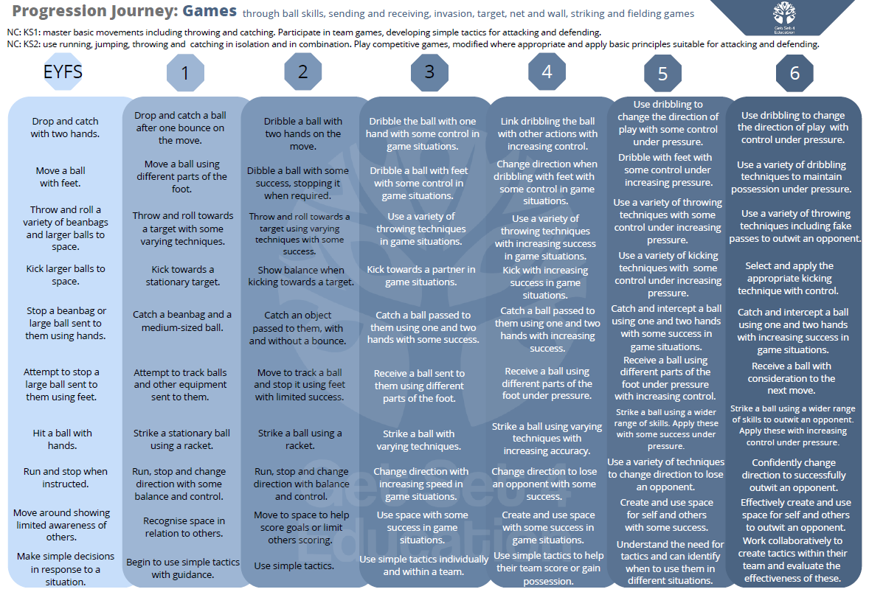

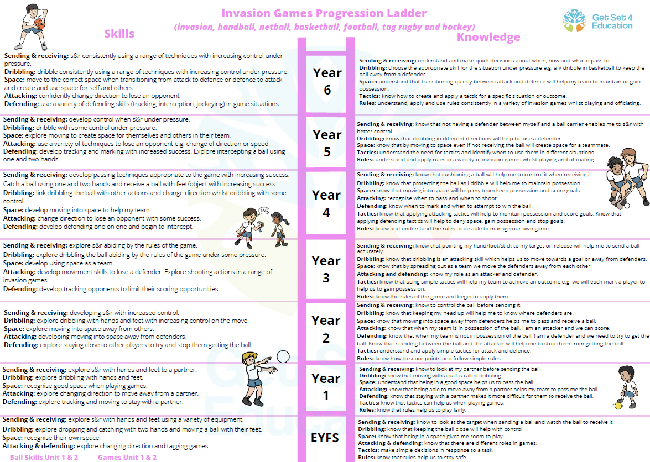

What does physical education look like in action?
Every PE lesson follows the same 3 part format. The start of the lesson will begin with a warmup and introduction. The warmup activity will either be a focus on fundamental skills or link directly to the main teaching that day. The warmup will usually last approximately 10 minutes. The next part of the session focuses on skill development. This will involve demonstration of skills required, practise of those skills and/or application of those skills usually through a series of simple games and activities. This part of the lesson can last approximately 30-45 minutes (depending on the age of the children). A plenary/cool down concludes the lesson. This will last approximately 5 minutes. The plenary will involve the children to reflect on what they have been learning about and will include a series of carefully thought out questions by the class teacher. It could also include a brief discussion about what the children will be learning in the next lesson.
How is physical education evidenced?
Blogs and whole school displays are used to show case evidence of P.E engagement and enjoyment.

Impact
Assessment

- The overall objectives of the National Curriculum form the basis against which assessments are made and used to inform future planning for activities in P.E.
- Teacher assessment is a continuous process. Teachers assess regularly throughout the lesson and adapt their lessons and tasks as appropriate. At the end of each unit taught, staff make a note of the children who are working towards or are working above the expected level for that unit. This information is used to tweak future planning and also to inform the next class teacher of the children who will require additional support or further challenge.
- Newcastle P.E and School Sport Service make formal assessments of children’s fundamental movement skills once a year. Teachers use these assessments to inform their planning in order to ensure progression of skills.
- Class teachers ensure that they liaise closely with external providers to ensure that planning and assessment information is shared after each session.

At Milecastle Primary School, our curriculum aims to improve the wellbeing and fitness of all children, not only through the sporting skills taught, but through the underpinning values and disciplines PE promotes. Children enjoy PE and we hope they continue to develop a love of sport, and physical activity, that they pursue outside of school and in future life outside of primary school. Our impact is therefore to motivate children to utilize not only the values upheld at Milecastle but also the values that underpin all sport in an independent and effective way in order to live happy and healthy lives.

