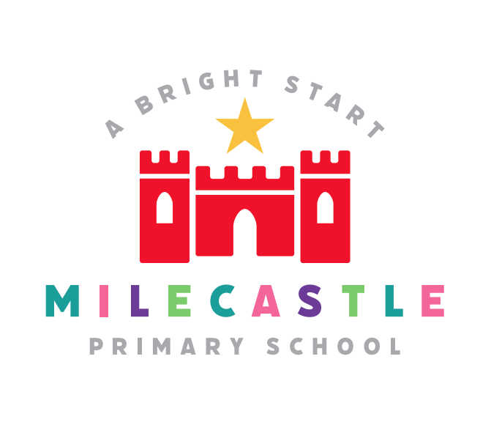
PSHE
Definition:
PSHE promotes self-esteem and respect for oneself and others. It aims to equip pupils with the skills and knowledge they need to make positive, healthy and responsible choices about their physical and emotional well-being and that of others. It provides children with fundamental building blocks to enable them to identify the characteristics of positive relationships, with particular reference to friendships, family relationships and relationships with other children and adults. It provides information to help pupils make informed decisions and judgements about their own and other peoples’ rights and responsibilities as citizens.
Our Intent
PSHE at Milecastle Primary School promotes self- esteem and respect for oneself and others. We aim to equip children with the skills and knowledge they need to make positive, healthy and responsible choices about their physical and emotional well- being and that of others. We aim to provide children with fundamental building blocks to enable them to identify the characteristics of positive relationships, with particular reference to friendships, family relationships, and relationships with other children and with adults. We provide information to help children make informed decisions and judgements about their own and other people’s rights and responsibilities as citizens in a diverse society in addition to giving them an awareness of the value of money and career options. We encourage our children to develop a sense of self- worth by playing a positive role in contributing to school life and the wider community.
Implementation
At Milecastle Primary School we deliver the PSHE curriculum by utilising first-hand experience and sharing good practice and it is every staff member’s responsibility to do this by being a role model and having high expectations of Milecastle children.

All staff actively promote, ‘Random Acts of Kindness’ through our ‘Everyday Magic’ ethos and celebrate these with the children through being asked to put a ‘star in the jar’. Stars are counted each week and the class with the highest number of stars at the end of each half term is provided with a treat of their choice. Parents are also encouraged to become involved by highlighting acts of kindness at home and allowing them to place a star in the jar at school.

PSHE is also delivered as a discrete subject together with National Curriculum subjects and circle time activities. Our PSHE curriculum has been developed using a question - based approach beginning in Foundation stage with ‘what?’ and ‘who?’ questions and building throughout key stage 2 with ‘why?’ and ‘how?’ questions. As far as possible these questions are linked to each term’s overarching enquiry question or science and take into account the children’s development and maturity. Our curriculum helps children to think through the consequences of their actions and those of others. They learn to make the right choice. This is highlighted particularly through our ‘1 Decision’ PSHE programme, through the use of role play and by being given group challenges during which the children work together for a desired outcome.

Self- esteem is developed through a range of activities and positive reinforcements such as praise, sharing success, stickers, certificates and team points. Children’s contributions are encouraged and valued and circle time rules reinforce this. The wishes of children to remain quiet during circle times are also respected. Emphasis is given to the expression of attitudes, values and feelings and the whole school strives to maintain a safe, positive and caring ethos.

Relationships and sex education is taught sensitively reflecting the age and maturity of the children within an environment that allows children to express their feelings without fear of evaluation or judgement in both spontaneous and planned discussions. Children are encouraged to consider the consequences of their actions on themselves and others. Parents are informed of materials used with the children. They are informed whenever specific lessons relating to sex education are going to be taught and invited into school to view materials and discuss the content of the lessons. Parents are informed that relationships education is compulsory but that they have the right to withdraw their children from sex education.

PSHE is an important part of school assemblies and collective worship where children’s spiritual, moral, social and cultural curiosity is stimulated, challenged and nurtured. Weekly class assemblies aim to explore overriding concepts identified by the class teachers, which are interwoven through their termly topic. (For example, democracy, beauty, resilience, segregation, change and compassion.)

How is PSHE organised across school?
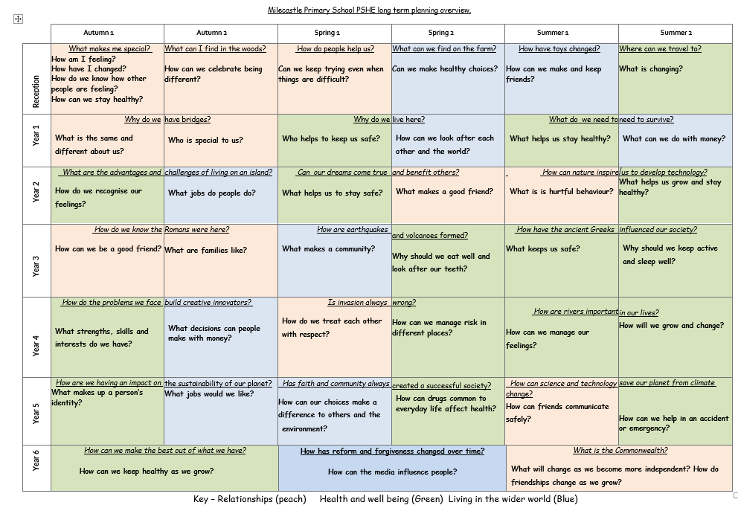
Our PSHE scheme is based upon the PSHE Association’s model. The sequence of skills/learning is in a sequenced, spiral programme in which topics are revisited in order to develop and deepen children’s understanding. The topics build on previous learning.

PSHE in EYFS
In Reception PSHE is paramount and from the start children are taught how to play, learn and share together. They are also taught basic hygiene as well as turn taking etc. However, specific PSHE lessons are also taught.
How do we plan for PSHE?
Our PSHE curriculum has been developed using a question - based approach beginning in Foundation stage with ‘can’, ‘what?’ and ‘who?’ questions and building throughout key stage 2 with ‘why?’ and ‘how?’ questions. As far as possible these questions are linked to each term’s overarching enquiry question or science and take into account the children’s development and maturity. It builds links across the whole school, home, the community and health professionals. It is linked closely with the school values, character education, citizenship and British values.

- Resources are utilised as appropriate to stimulate, aid and reinforce. ‘Skills for Life’ and ‘1Decision’ are used as core resources although other suggestions are provided for staff depending on their class’s particular needs or cohort of children. The PSHE programme is flexible and responds not only to the needs of the children at a particular time but also reflects local and national needs. The curriculum is based on PSHE association’s model and is divided into the three key areas: relationships, living in the wider world and health and well- being. Mental well- being as well as physical well- being is a priority and emotional regulation is now taught and developed at the start of each academic year providing children with ‘back pack ‘skills to use when needed.
- Relationships education is embedded in the PSHE curriculum. This includes relationships between friends and families. Children explore different kinds of families from an early age, reflecting the range of family units in and around school. Story books are available for use in PSHE to reflect different kinds of families and relationships.
- Sex education is taught in key stage 2 beginning with puberty in year 4, reinforced in year 5 and then reproduction is taught in year 6 in conjunction with the science curriculum. Materials are reviewed annually and chosen depending on the maturity of the particular children. Parents are informed and are given the option to remove children from these lessons. They are also invited into school to view the materials the children will see
Progression documents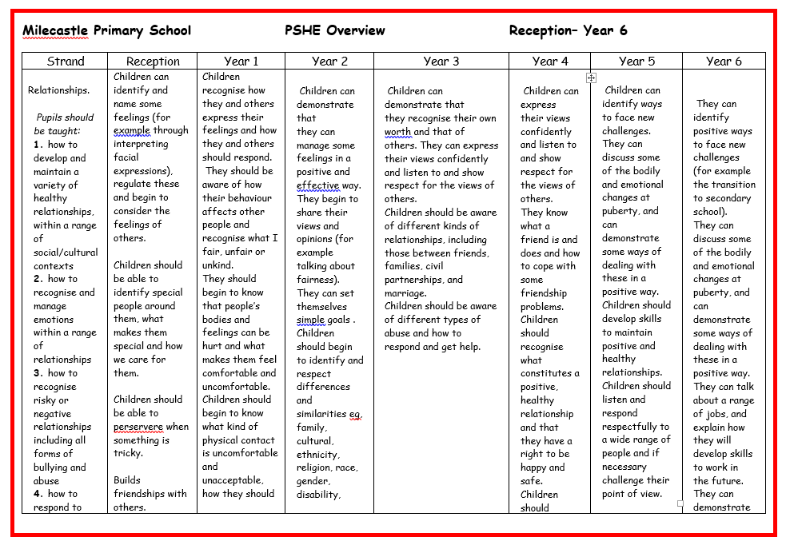

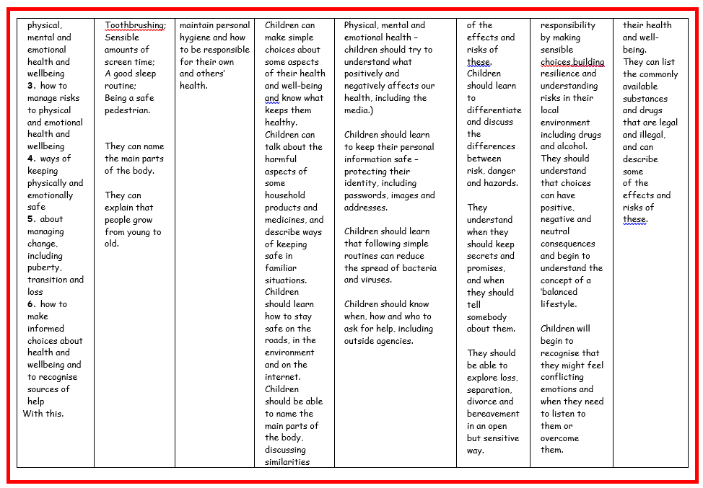
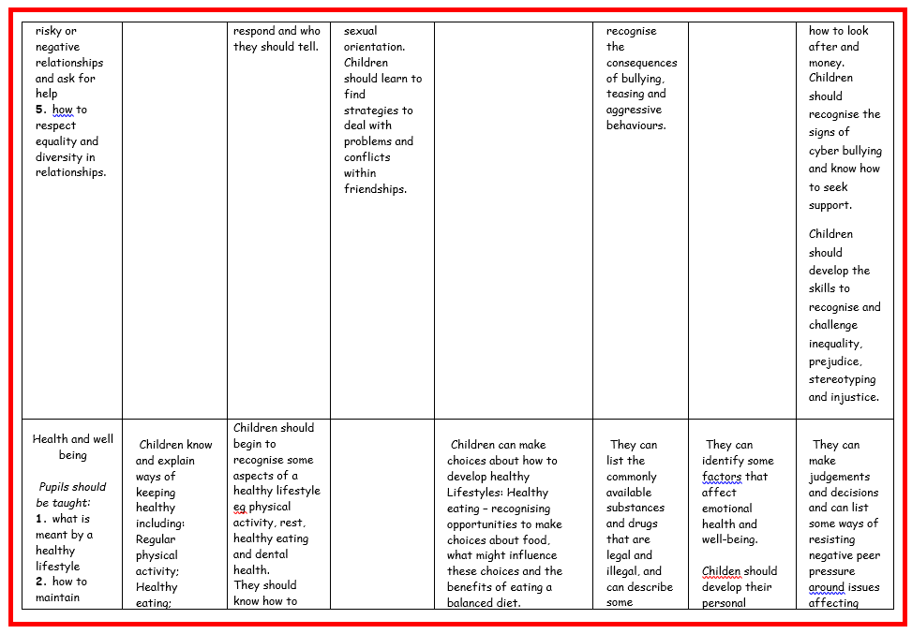

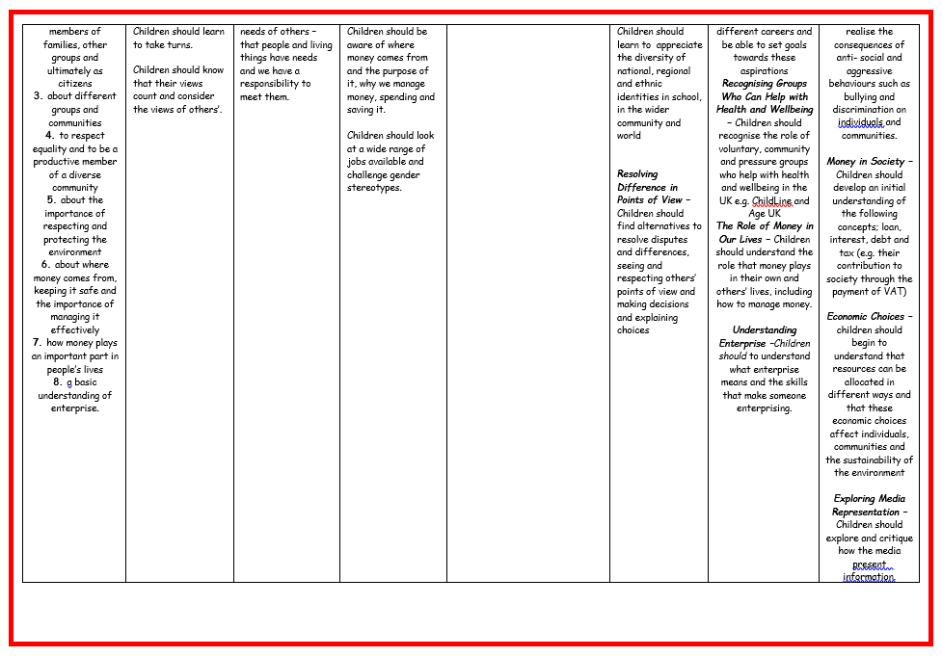
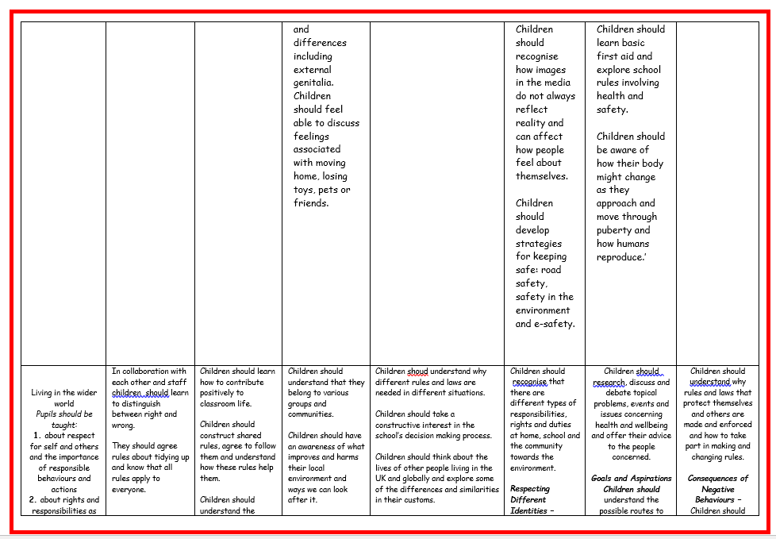

What does PSHE look like in the classroom?
Children are usually seen discussing openly, all contributions are valued and children are listening to each others’ opinions. A variety of techniques are used to engage children in their learning. This may include circle times, group work, drama, creating comic strips, making posters/ leaflets etc. games, mindfulness activities or using ICT to create adverts etc.
How is PSHE evidenced?
PSHE is evident throughout the school in the way that the children interact with each other, with adults and with visitors they meet both in school and during educational visits.
The introduction of the “Everyday Magic’ project in 2018 has become embedded into the school’s ethos and is evident throughout school, at home and in the wider community in the kindness shown towards others by Milecastle children.
Blogs regularly show PSHE work in the class rooms and around school. From September floor books will be used to evidence each unit of work in each class.

Impact
The children at Milecastle know how to stay safe and know how to keep healthy and the majority of children are active and choose to eat a balanced diet.
The school holds Healthy School Status, which helps maintain good practice and presents opportunities to review curricular and non-curricular activities against nationally agreed criteria. We also hold Healthy School Plus status, allowing us to focus on the specific issue of keeping children active during playtimes and lunchtimes, a specific health related issue that we identified as requiring development.

The PSHE coordinator monitors the development and implementation of PSHE through lesson observations, planning scrutinies and pupil voice. In addition, the coordinator uses data from the Newcastle Health Related Behaviour survey, completed by years 4 and 6 to assess the impact of PSHE teaching and to gauge where further teaching or resources need to be placed.
Assessment in PSHE is formative although baseline assessments for each unit are encouraged.
Circle time, quizzes, concept maps, discussion images, and debates are some of the ways in which teachers can assess children’s understanding and learning of concepts and issues taught.
Our most recent OFSTED report (October 2019) states:

‘Milecastle Primary School values – such as resilience, kindness and honesty – are taught across all subjects. Pupils show their understanding of these values within lessons. They support and respect each other and adults. They behave well in lessons and around school at different times of the day. Staff have high expectations for all pupils. ‘

