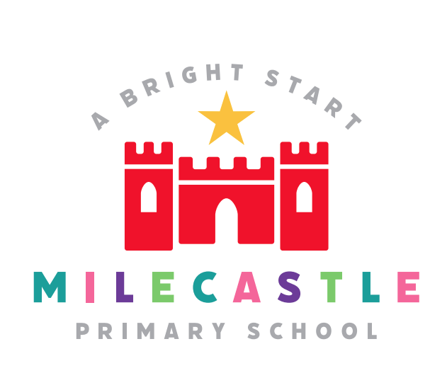
RE
The study of Religious Education encourages a deepening interest in and enriching experience of the world around us. The emphasis is upon the fundamental ideas, concepts and questions which human life and experience raise and which religion tries to answer.
Our Intent
At Milecastle Primary School, we believe that it is vital for all our pupils to learn from and about religion, so that they can understand the world around them. Through Religious Education (R.E.), pupils develop their knowledge of the world faiths, and their understanding and awareness of the beliefs, values and traditions of other individuals, societies, communities and cultures. We encourage our pupils to ask questions about the world and to reflect on their own beliefs, values and experiences. Our R.E. curriculum is enhanced further with trips to places of worship in our local area. We use the agreed Newcastle Council R.E. syllabus as the basis for our curriculum.
Religious Education is taught throughout the school in such a way as to reflect the overall aims, values and philosophy of the school. At Milecastle, R.E. plays an important role, along with all other curriculum areas, particularly P.S.H.E and S.E.A.L, in promoting the spiritual, moral, social and cultural development of our children.
Implementation
At Milecastle, it has been agreed that having taken into account the requirements and guidelines presented in the Agreed Syllabus, the following religions have been selected for study:

- Christianity
- Islam
- Judaism
- Hinduism
- Sikhism

As Christianity is the predominant religion in the school's pupil population and in the community surrounding the school, Christianity is the chosen faith for Progressed Study.

There are no presumptions made as to the religious backgrounds and beliefs and values of the children and the staff. We value the religious background of all members of the school community and hope that this will encourage individuals to share their own experiences with others freely. All religions and their communities are treated with respect and sensitivity and we value the links, which are, and can be made between home, school, and a faith community.

At Milecastle, we acknowledge that each religion studied can contribute to the education of all our pupils and importantly help develop our school values of tolerance and respect. Additionally, we promote teaching in R.E. that stresses open enquiry and first-hand experiences wherever possible for both staff and children. Every unit of work across school starts with an enquiry question that is referred to throughout the unit of work.

Children at Milecastle are excited by challenges and can work responsibly both independently and cooperatively demonstrating resilience to achieve their goal. We have strong connections with our local church and all children have the opportunity to visit at least once a year. Additionally, we invite a range of different faith communities into school so that they can share their beliefs and values and children are able to ask a range of pertinent questions. Our wonderful blogs and class Seesaw Journals show case the myriad of activities we cover in RE, they highlight the engagement and enjoyment of the children. We also celebrate achievements in our celebration assembly where children can be recognised for their work or for demonstrating one of the key values linked to their learning in R.E.

How is Religious Education organised across school?
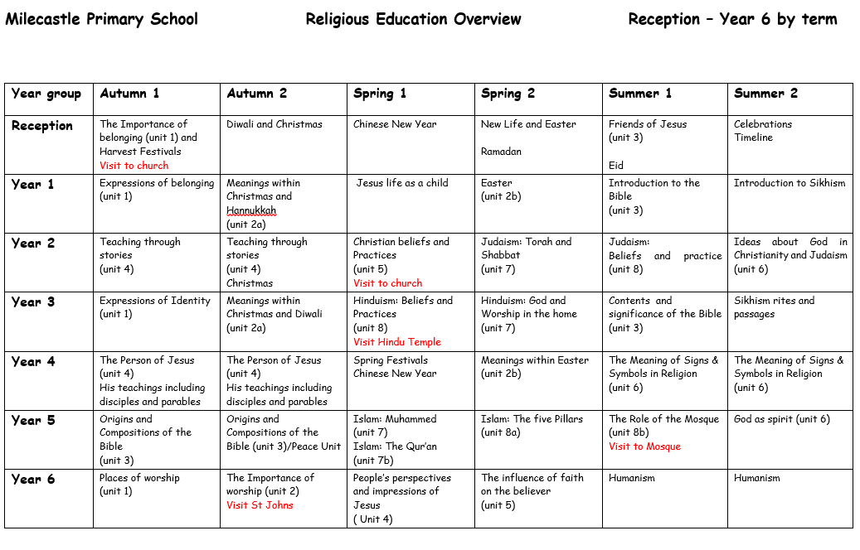

Religious Education in EYFS
Understanding the world involves guiding children to make sense of their physical world and their community. The frequency and range of children’s personal experiences increases their knowledge and sense of the world around them including visiting a local church and having the opportunity to explore, discuss their own identity and celebrate a range of religious festivals. Through the introduction of the concept of Religious Education children begin to understand that all religions have celebrations and this provides them with a foundation of understanding for their study in KS1. In addition, Religious Education develops a greater awareness of others which supports children to work and play cooperatively to form positive friendships with their peers. It also supports children to begin to demonstrate a degree of sensitivity to their own and to others’ needs.
How do we plan for Religious Education?
At Milecastle, the children have half an hour of taught Religious Education a week. We use the agreed Newcastle Council R.E. syllabus as the basis for our curriculum.
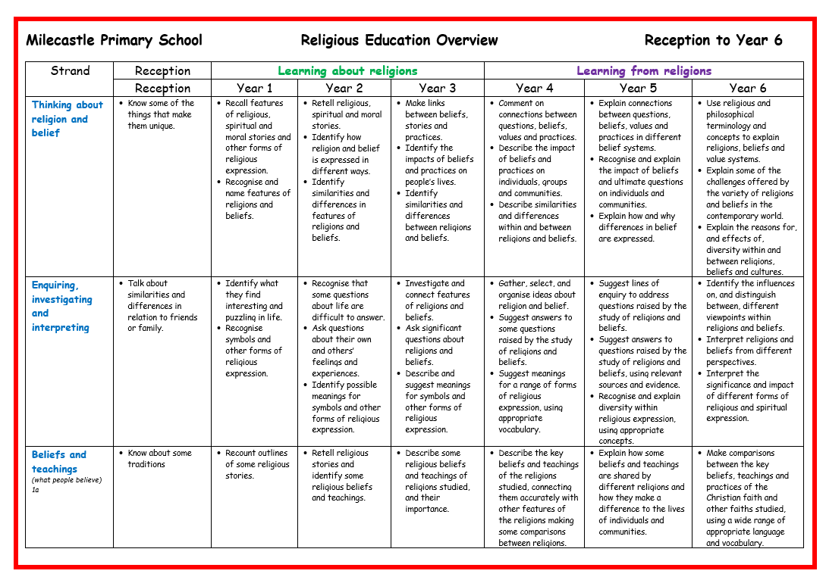
Progression documents

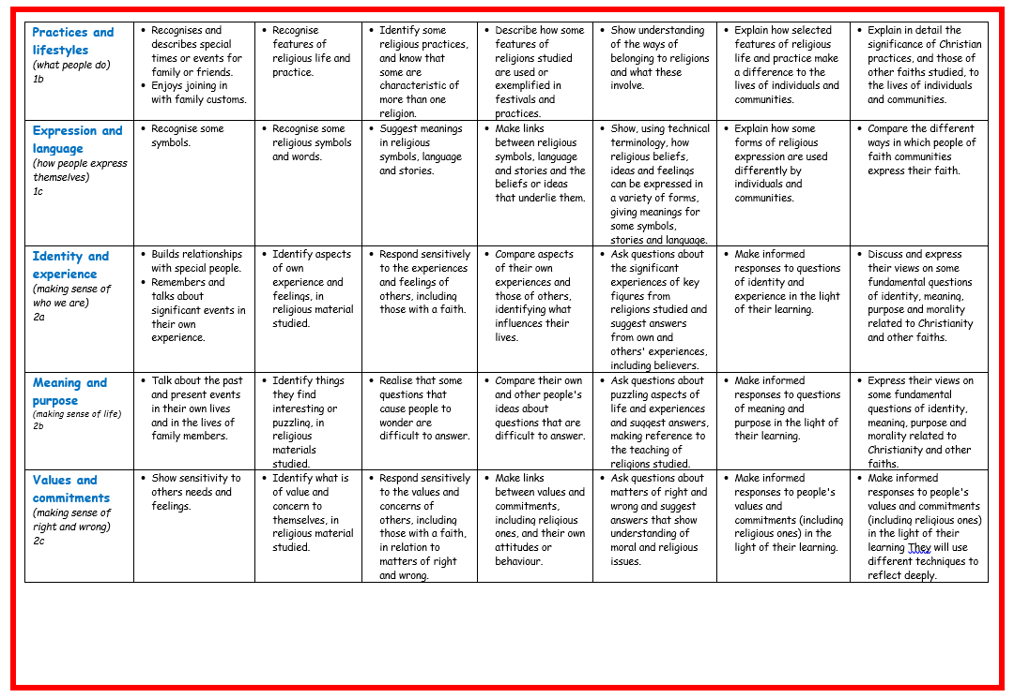
What does Religious Education look like in the classroom?
- Each lesson will refer to the main enquiry question.
- Previous work will be revisited.
- Teaching activities well matched to pupils’ prior knowledge. These activities are usually art, music, literacy, drama or discussion based.
- Particular interests are developed and explored.
- Artefacts may brought in from home may develop a lesson.
Pupils will integrate their new learning into their existing schema
How is Religious Education evidenced?
Blogs of whole school assemblies and activities and visits are used to show case evidence of R.E engagement and enjoyment. Many R.E. lesson will link activities are often linked to art, drama, music and literacy with the aim to answer a key enquiry question.
Impact and Assessment
- Children are formatively assessed throughout the course of a unit. At the end of the year evidence is gathered to formalise a summative judgement. Children are deemed to be either working towards the expected standard, working at the expected standard or working at greater depth within the expected standard. To support their judgements

teachers can refer to the progression of skills and content documents for their particular year group. These documents ensure that the skills and content being taught are built on year on year and that there is a clear progression of skills as a child passes through school. Different forms of assessment are deployed appropriately for different purposes.

- We have assessment AS learning: to embed key knowledge in memory e.g., through quizzing.
- Assessment FOR learning: formative assessment which is most useful in the lesson sequence to identify missing components/misconceptions.
- Assessment OF learning: summative assessment that samples from a domain of complex composites.
- The curriculum is the progression model. Assessments check that the necessary curriculum components have been learnt and remembered.
- Assessments check that pupils have learnt the most fundamental knowledge i.e. the knowledge that must be in place to enable future learning. This will involve assessing knowledge of: substantive concepts and procedures, disciplinary concepts and procedures, substantive knowledge, and disciplinary knowledge together.

Effective feedback is focused on the RE content. Results from assessments are used to inform teaching and curriculum development.

The children at Milecastle Primary enjoy learning about other religions and why people choose, or choose not to follow a religion. Through their R.E. learning, the children are able to make links between their own lives and those of others in their community and in the wider world. Religious Education acts as a hub, therefore, between social aspects of learning, science and geography. Through R.E. our children are developing a positive understanding of other people’s cultures and ways of life in an open, honest and engaging way, which they are then able to communicate to the wider community. This is evident in their work, in talking to pupils and in the classroom.

Religious Education offers our children the means by which to understand how other people choose to live and to understand why they choose to live in that way. As such, R.E. is invaluable in an ever changing and shrinking world.

