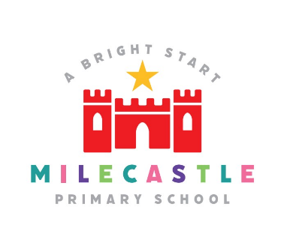
Science

Science provides the foundations for understanding the world through the specific disciplines of biology, chemistry and physics. Science has changed our lives and is vital to the world’s prosperity, and all pupils should be taught essential aspects of the knowledge, methods, processes and uses of science.
Our Intent
The 2014 National Curriculum for Science aims to ensure that all children:

- Develop scientific knowledge and conceptual understanding through the specific disciplines of biology, chemistry and physics.
- Develop understanding of the nature, processes and methods of science through different types of science enquiries that help them to answer scientific questions about the world around them.
- Are equipped with the scientific skills required to understand the uses and implications of science, today and for the future.

At Milecastle Primary School, we understand that children are naturally curious, and we encourage this inquisitive nature throughout their time with us and beyond. Science fosters a healthy curiosity in children about our universe and promotes respect for the living and non-living. We believe science encompasses the acquisition of knowledge, concepts, skills and positive attitudes. Through the programmes of study in the National Curriculum science document, children will acquire and develop these skills throughout their Primary years. We ensure that the ‘Working Scientifically’ skills are built-on and developed throughout pupils’ school career so that they can use equipment, conduct experiments, build arguments and explain concepts confidently and continue to ask questions and be curious about their surroundings.

Implementation
To ensure high standards of teaching and learning in Science, we implement a curriculum that is progressive throughout the whole school. We plan to ensure full coverage of, ‘The National Curriculum programmes of study for Science 2014’ and, ‘Understanding of the World’ in the Early Years Foundation Stage. Science teaching at Milecastle Primary School involves adapting and extending the curriculum to match all pupils’ needs. Where possible, Science is linked to class topics (for example, ‘Rainforests’ and ‘Electricity’ in Year 5).

We ensure that all children are provided with rich learning experiences that aim to:
- Prepare our children for life in an increasingly scientific and technological world today and in the future.
- Help our children acquire a growing understanding of the nature, processes and methods of scientific ideas.
- Help develop and extend our children’s scientific concept of their world.
- Build on our children’s natural curiosity and develop a scientific approach to problems.
- Encourage open-mindedness, self-assessment, perseverance, resilience
- Developing the skills of investigations – including: observing, measuring, predicting, hypothesising, experimenting, communicating, interpreting, explaining and evaluating.
- Work confidently both independently and collaboratively.
- Develop the use of scientific language, recording and techniques.
- Develop the use of computing in investigating and recording.
- Create sharing platforms for debates, where children can be open, honest and respectful to one another.
- Make links between science and other subjects.

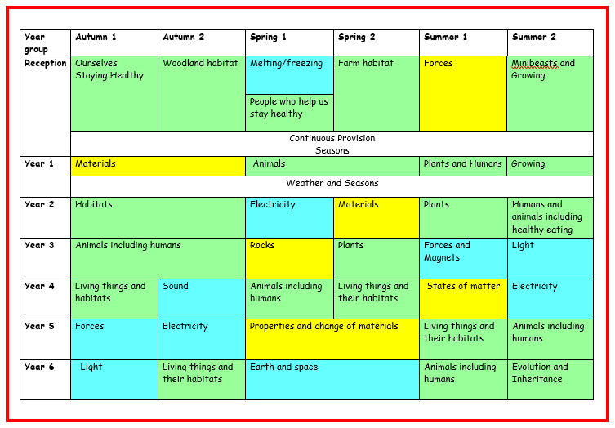
How is science organised across school?

Science in EYFS
At Milecastle, early years teachers introduce children to the foundational knowledge of science that they will need in order to be well-placed to access the science National Curriculum in England at Key Stage 1. Scientific areas of study are carefully linked to areas of learning in reception. This helps to facilitate learning, encourage scientific enquiry and introduce children to key vocabulary that is essential to develop their current and future learning. Science is delivered through specific lessons, continuous provision, stories and relevant careers are linked to scientific learner and also available to role-play.
How do we plan for science?
Science is taught consistently, once a week for up to two hours. We have planned the curriculum based on: National Curriculum requirements, scientific skills and enquiry types which are progressive and transferrable and will be built upon each year.

At Milecastle Primary School we aspire to promote children’s independence and for all children to take responsibility in their own learning. We also enrich the science curriculum at Milecastle Primary School by offering various opportunities, such as after school clubs, science-based trips and opportunities to explore STEM centred careers.

Knowledge organisers
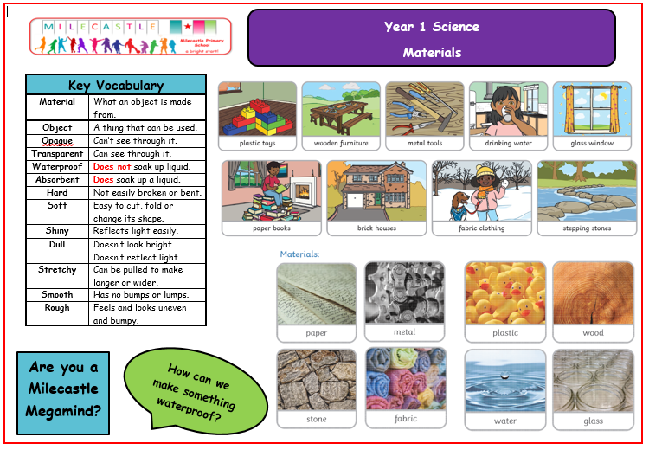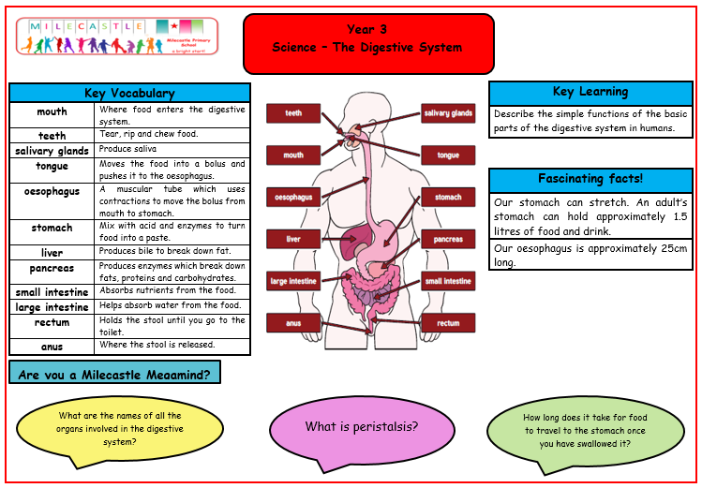
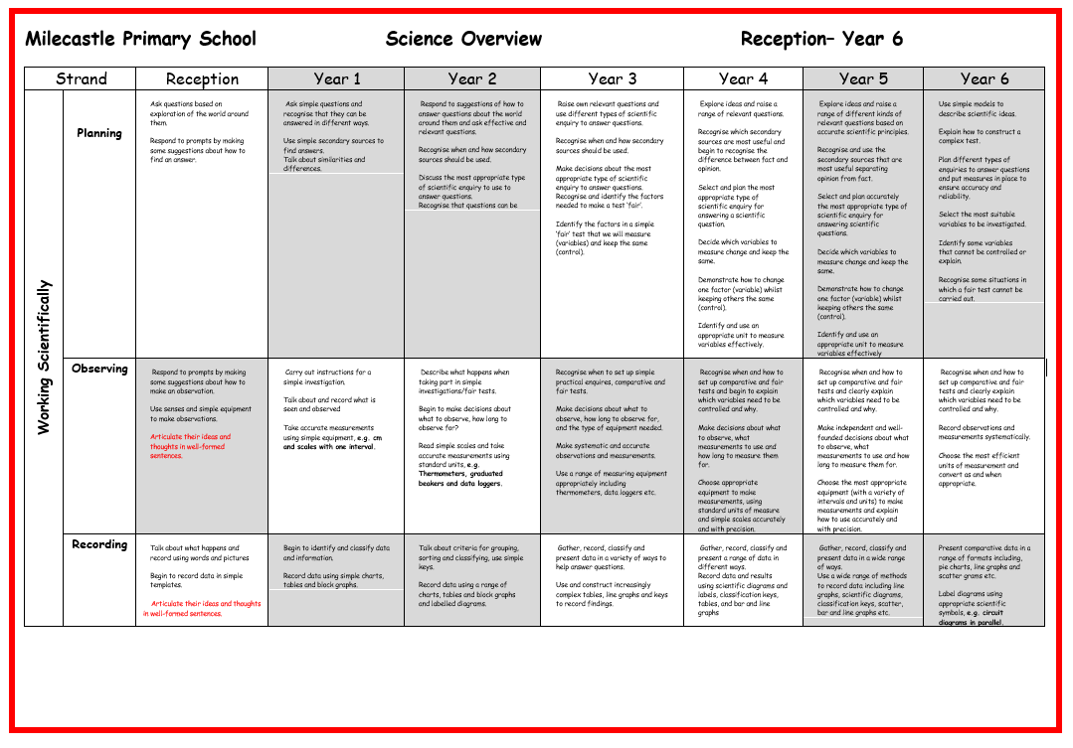
Progression documents

What does science look like in the classroom?
A lesson typically begins with a prompt for discussion. For example, teachers may use the following strategies/resources: ‘Zoom in, Zoom Out’, ‘Odd One Out’, ‘What’s Going On?’, ‘What if?’
Lessons will often end with an extension activity in the form of a challenge question. Children respond to these questions applying their knowledge from the lesson. Children are encouraged to write and talk as scientists and give opportunities to do so, using appropriate vocabulary and phrases.

How is science evidenced?
Science is celebrated around the school through classroom displays, in our Seesaw journals, through our class blogs, use of our outdoor areas and opportunities for children to engage in STEM activities during our topics. We also hold an annual, whole-school celebration of everything STEM. Each year, the theme changes but the foundation of the week centres on celebrating and fostering the love of science, technology, engineering and mathematics. We invite a range of visitors and parents, who are involved in the STEM industry, to come in to school and deliver a range of workshops to broaden the children's Science Capital.

Impact
- The overall objectives of the National Curriculum form the basis against which assessments are made and are used to inform future planning for activities in science.
- Staff will assess the children on their understanding of both knowledge and working scientifically. Subject knowledge and working scientifically is assessed at the end of each area of study and a formative decision is made at the end of the year.
- Teachers will carefully plan opportunities for children to use and apply their scientific skills and knowledge – skills should be revisited regularly in order to see progress and this is evidenced in books.
- Formative assessment is constantly used to inform planning and teaching.
- Teacher assessment is a continuous process. Teachers assess regularly throughout the lesson and adapt their lessons and tasks as appropriate. At the end of each unit taught, staff make note of the children who are working towards, at or above the expected level for that unit. This information is used to adapt future planning and also to inform the next class teacher of the children with will require additional support or further challenge.

The successful approach to the teaching of Science at Milecastle results in a fun, engaging, high-quality science education, that provides children with the foundations for understanding the world.

Our engagement with the local environment ensures that children learn through varied and first hand experiences of the world around them. So much of science lends itself to outdoor learning and so we provide children with opportunities to experience this. Due to the strong links developed between learning and science careers this inspires children to pursue future STEM interests. Additionally, through various workshops, trips and interactions with experts and local charities, children have the understanding that science has changed our lives and that it is vital to the world’s future prosperity. We want children to enjoy science and believe that this ultimately results in motivated and passionate learners.

The science lead uses regular and robust monitoring including learning walks, book looks and pupil voice to gauge the impact of our science curriculum and review the curriculum to ensure that it meet the needs of all learners.

