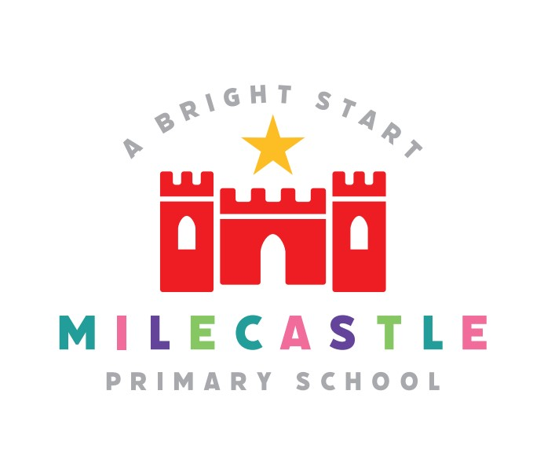

Our Curriculum at
Milecastle
Primary
Our Mission:
For everyone to be excited about and love learning.

Our Vision:
At Milecastle we provide a safe, vibrant and exciting learning environment, where everyone is included and all successes are celebrated. We provide outstanding care and support as well as high quality learning experiences which challenge the children to be their best. We accept we are all different and we are grateful for the variety that brings.

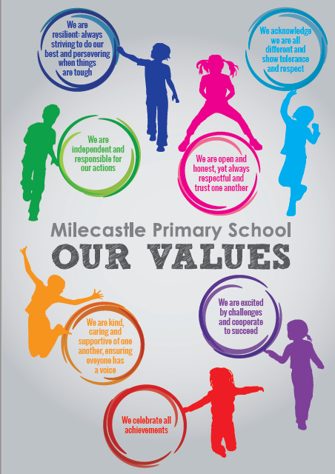

Intent
We are resilient: always striving to do our best and persevering when things are tough.
At Milecastle, we support our learners to develop resilience and show perseverance because they are essential life skills needed to be able to tackle any challenges they may face, not only in their learning, but also in every area of life as they grow up. We support our children to believe in themselves so that they push themselves to always do their best, recognising that sometimes we are not successful at first but this is okay and learning from their mistakes.
We are open and honest, yet always respectful and trust one another.
We believe honesty is the best policy in all walks of life, but with that comes the responsibility to be respectful. We support our school community to develop trust in one another so they feel they can be open and honest in a supportive and caring way.
We acknowledge we are all different and show tolerance and respect.
Our children are part of a diverse society, so we support our school community to be able to show tolerance towards each other and have respect for everyone, regardless of faith, culture, beliefs, gender, sexual orientation or disability.
We are independent and responsible for our actions.
Alongside building resilience, we support our children to develop their independence both academically and socially. Learning that we are responsible for every action we take helps to develop a strong sense of right and wrong, and instils an understanding of the impact our actions have on others around us.
We are kind, caring and supportive of one another ensuring everyone has a voice.
Through a safe, supportive and nurturing environment our children will recognise that they are all special and unique and that everyone is entitled to a voice. We also want them to realise how they can have a positive impact on others and in the wider community.
We are excited by challenges and cooperate to succeed.
We support our children to aim high and be aspirational so they can fulfil their potential. We want to provide challenging learning experiences in which children work together confidently, recognising their own and others’ strengths.
We celebrate all achievements.
It is extremely important to not only acknowledge, but celebrate the achievements of all our children: academic, sporting, personal and creative.

Implementation
At Milecastle we recognise the importance of staying up to date with current thinking about curriculum and always consider new practice recommended. We take a pragmatic approach to new initiatives and aim to ensure that anything we put in place is founded on evidence based research and practice to enhance teaching and learning for the benefit of our pupils.
Whilst the National Curriculum forms the basis of learning and teaching, ensuring the acquisition of basic skills, there are a number of contextual factors which drive the Milecastle Curriculum. Our curriculum is designed to create a balance between the National Curriculum statutory requirements and a range of opportunities which give our pupils the chance to broaden their life experiences and meet their learning and development needs.
The acquisition of knowledge and the development of skills is carefully planned to create meaningful, memorable and monumental learning experiences for every child.
The drivers of Milecastle’s curriculum are our Super 7.

Aim High

Active Healthy Lifestyles

Community

Environment

Emotional and Social Awareness

Creativity and Enrichment
Understanding the world

The Milecastle Super 7
Aim high (aspiration, enquiry, challenge, collaboration, possibilities)

Environment (eco-friendly, responsibility, green team, WOW, bikeabilty, smart pedestrian, school travel plan, locality, OPAL, school orchard, wildlife area, outdoor learning, enchanted story garden).
Understanding the world (diversity – local and global community British values, equal opportunities, respect, cultural capital)

Creativity and Enrichment (enterprise, creative approach, arts, thinking, extra-curricular clubs enrichment weeks, visits/vistors, residential)

Emotional and social awareness (community, independence, collaboration, resilience, identity)

Community (family learning, parental/grandparent engagement, Everyday Magic, links with church, Outer West Learning Trust)

Active Healthy Lifestyles (fundamentals, healthy school, healthy school plus, Golden mile, Tiny Tasters, OPAL)

Impact
The impact of this is that our curriculum is meaningful, memorable and monumental.

MEANINGFUL – it has purpose and value and is in the right place/sequence at the right time.
MEMORABLE – it is special or interesting and something which will help our pupils remember more and make links in their learning.
MONUMENTAL – it has lasting value and prepares the pupils for their next educational journey and fosters their excitement and love of learning.

Pupils leave Milecastle with transferable life skills, ready for the next stage of their journey in education.

