
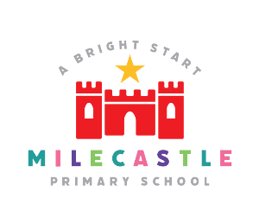
WEEK AHEAD DIARY

Week Beginning Monday 18th May 2026
Monday |   12.15am – Colouring Club    12.30pm – Computing Club  . | Movie Club  (Main Hall)  3.20pm – 5pm    (Pre-booked children only)
Tuesday |   PM – Y5 Basketball | Baking Club  (Technology Room)  3.20pm – 5pm    (Pre-booked children only)
Wednesday |  | Irish Dance  After School Club  Y1 – Y6    3.20pm – 4.20pm
Thursday |     PM - Ukulele / Guitar Front Row Music.  2PM – Reception Class Family Afternoon  5pm Local Governing Body Meeting
Friday | 12.15pm – Clay Club      12.30pm – Art & Craft Club
Have a lovely half term holiday everyone!
Remember school is closed on Monday 1st June 2026 for staff training and re-opens to all pupils on Tuesday 2nd June 2026.

